2019/11/3

## 深度学习理论学习

### 第一部分：神经网络和深度学习

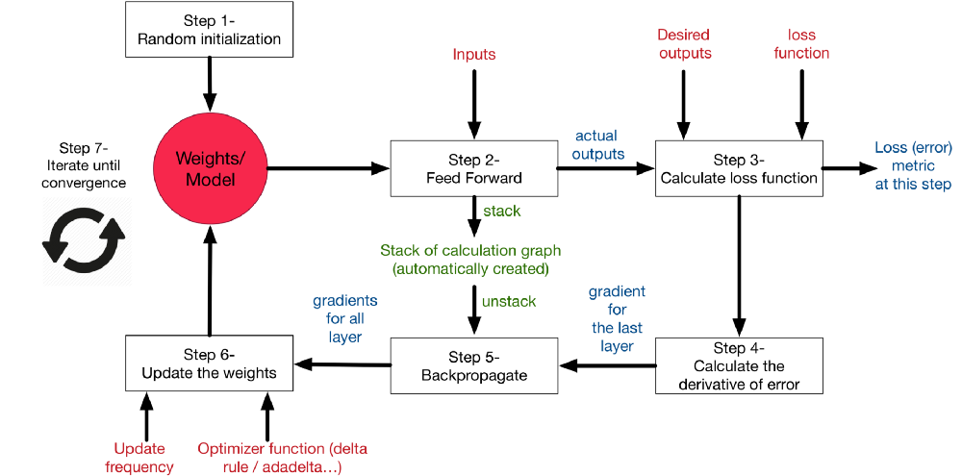

#### 1.交叉熵loss function

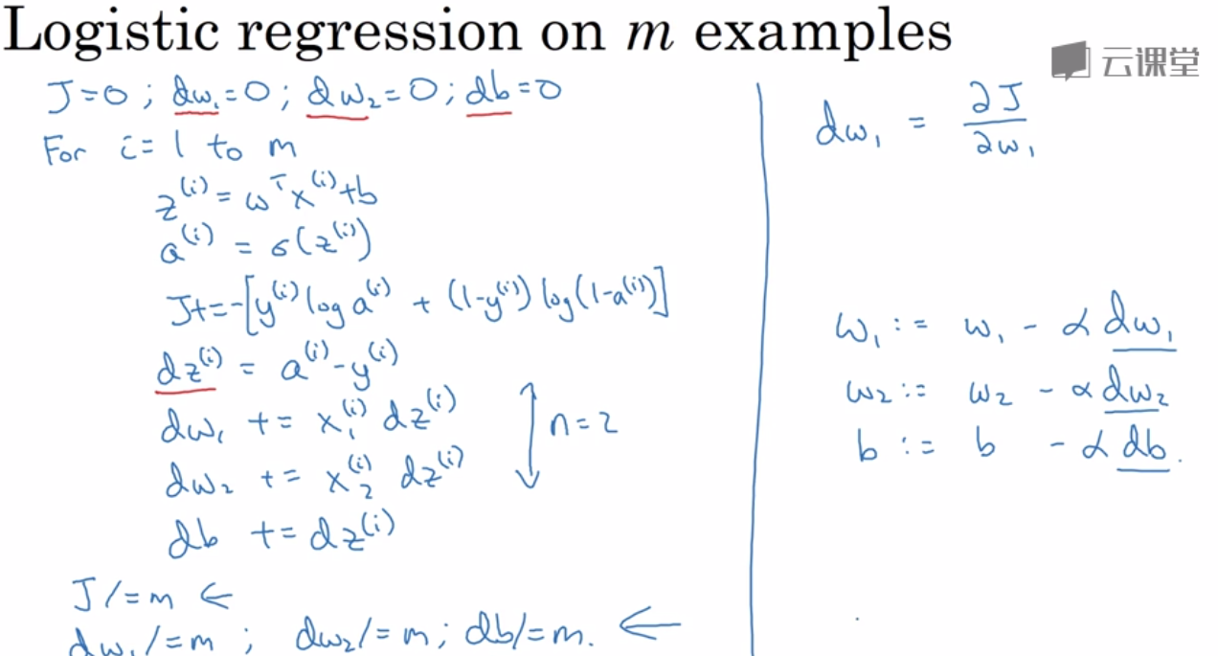

公式

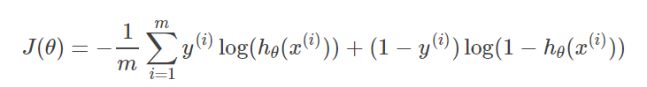

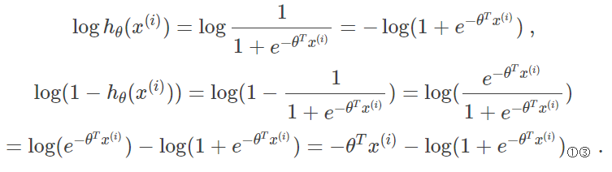

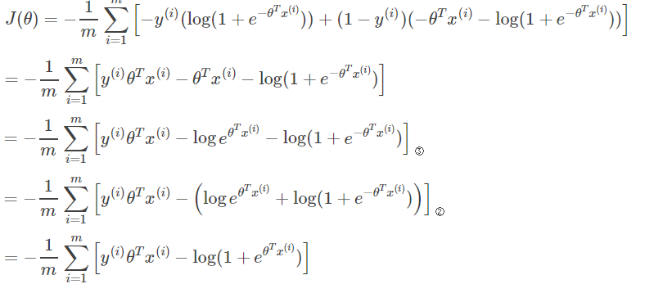

2.2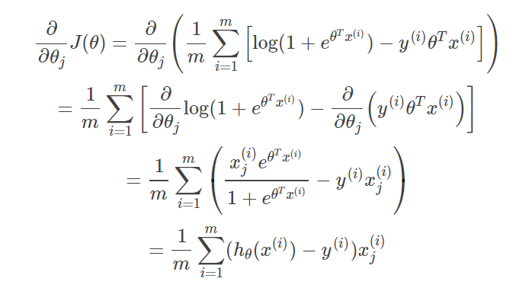

#### 2.LR偏导

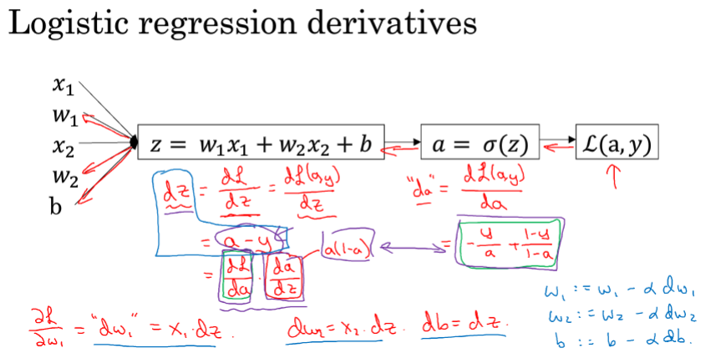

#### 3.Logistic Regression向量化表示

每个样本同一特征的值乘以每一样本的dz

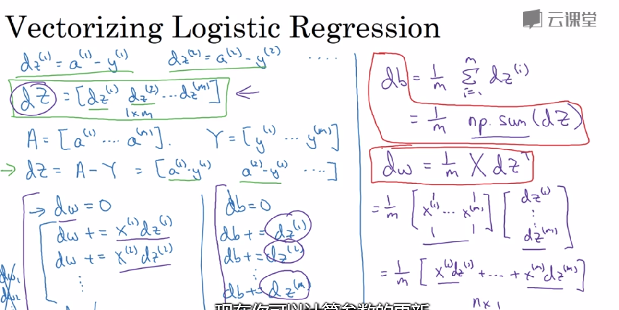

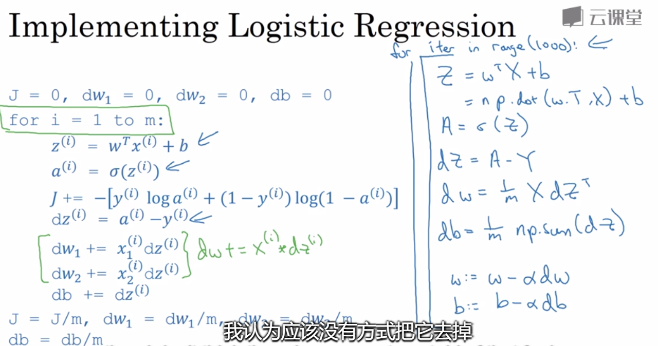

#### 4.神经网络向量化

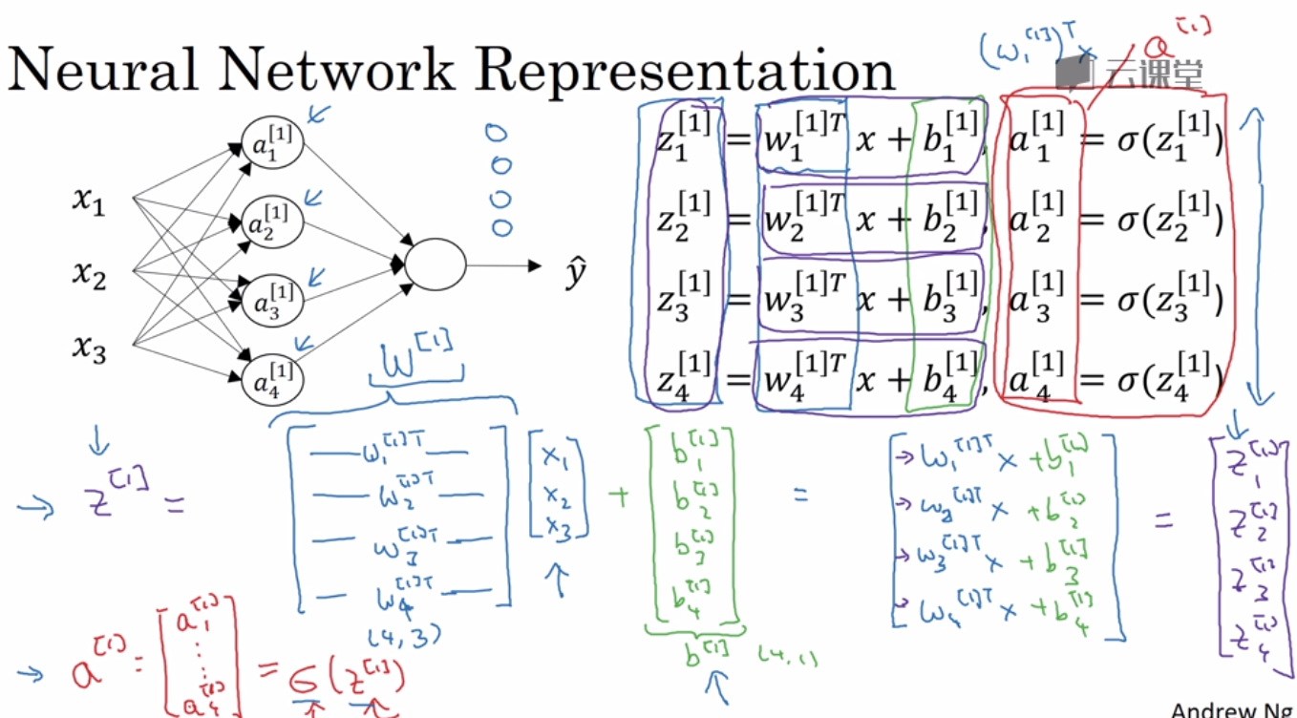

多样本向量化表示

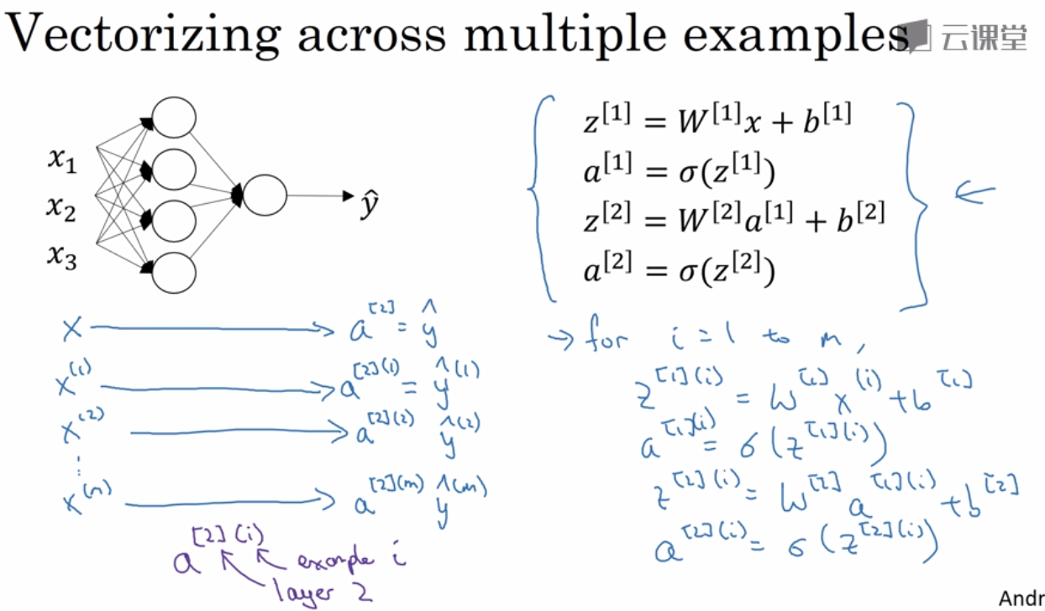

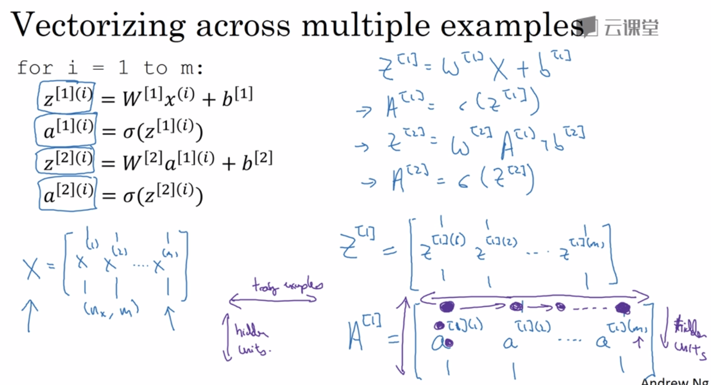

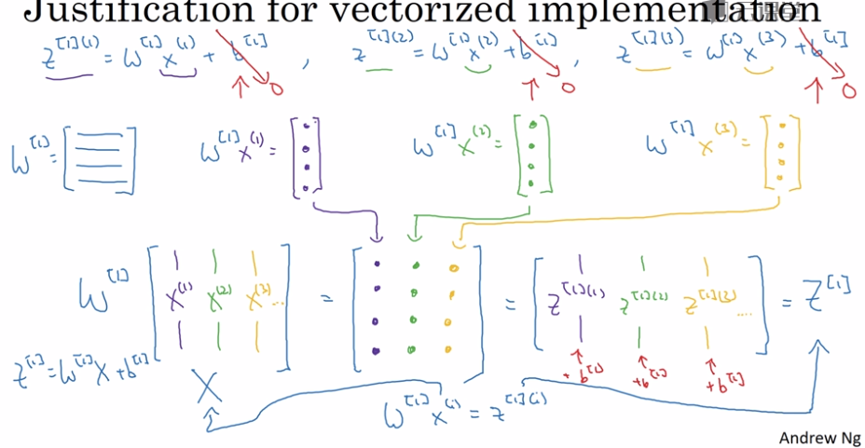

#### 5.activation function

<https://medium.com/the-theory-of-everything/understanding-activation-functions-in-neural-networks-9491262884e0>

第一，对于神经网络来说，网络的每一层相当于f(wx+b)=f(w'x)，对于线性函数，其实相当于f(x)=x，那么在线性激活函数下，每一层相当于用一个矩阵去乘以x，那么多层就是反复的用矩阵去乘以输入。根据矩阵的乘法法则，多个矩阵相乘得到一个大矩阵。所以线性激励函数下，多层网络与一层网络相当。比如，两层的网络f(W1*f(W2x))=W1W2x=Wx。

第二，非线性变换是深度学习有效的原因之一。原因在于非线性相当于对空间进行变换，变换完成后相当于对问题空间进行简化，原来线性不可解的问题现在变得可以解了。

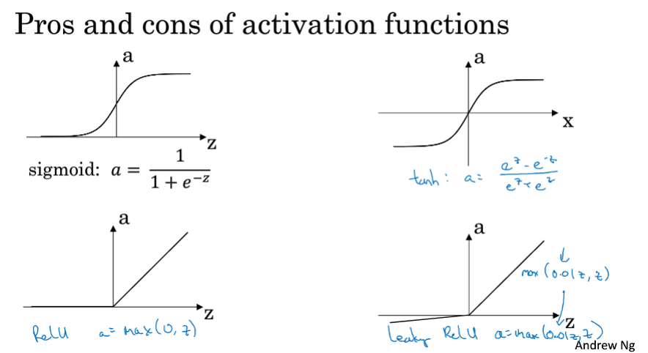

导数：a（1-a） 1-a2  0，1 0.01，1 （0初不可导）

反向传播的activation function 如果是线性会如何？

tanh 与 sigmoid 的不同

https://www.zhihu.com/question/50396271/answer/220408619

#### 6.back propagation

<https://towardsdatascience.com/activation-functions-and-its-types-which-is-better-a9a5310cc8f>

<https://medium.com/the-theory-of-everything/understanding-activation-functions-in-neural-networks-9491262884e0>

Loss function active function weight

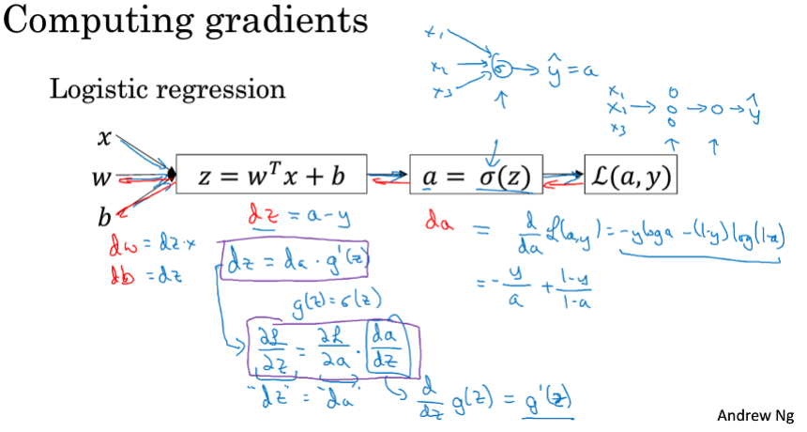

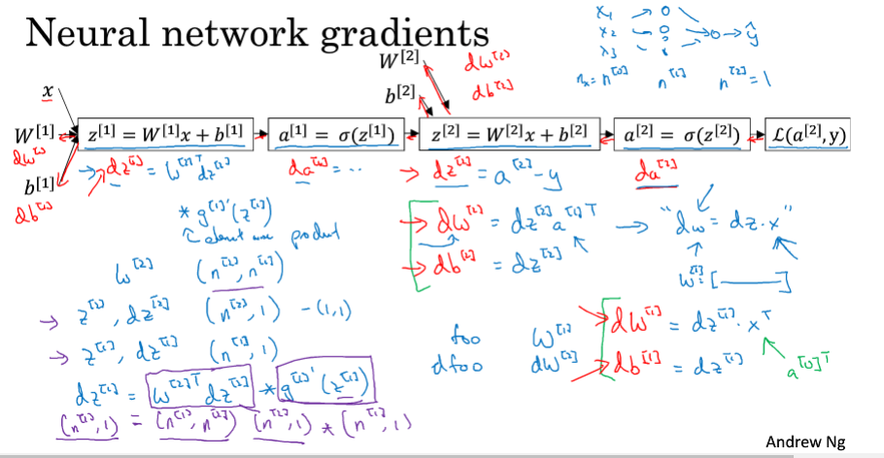

每一个class的loss对应所有weight的一种调整，将all class 的loss 各自对应的weight求和得到xi（输入向量）对应的weight调整，将batch 中所有x对应的weight求平均得到该批数据对应的weight调整。

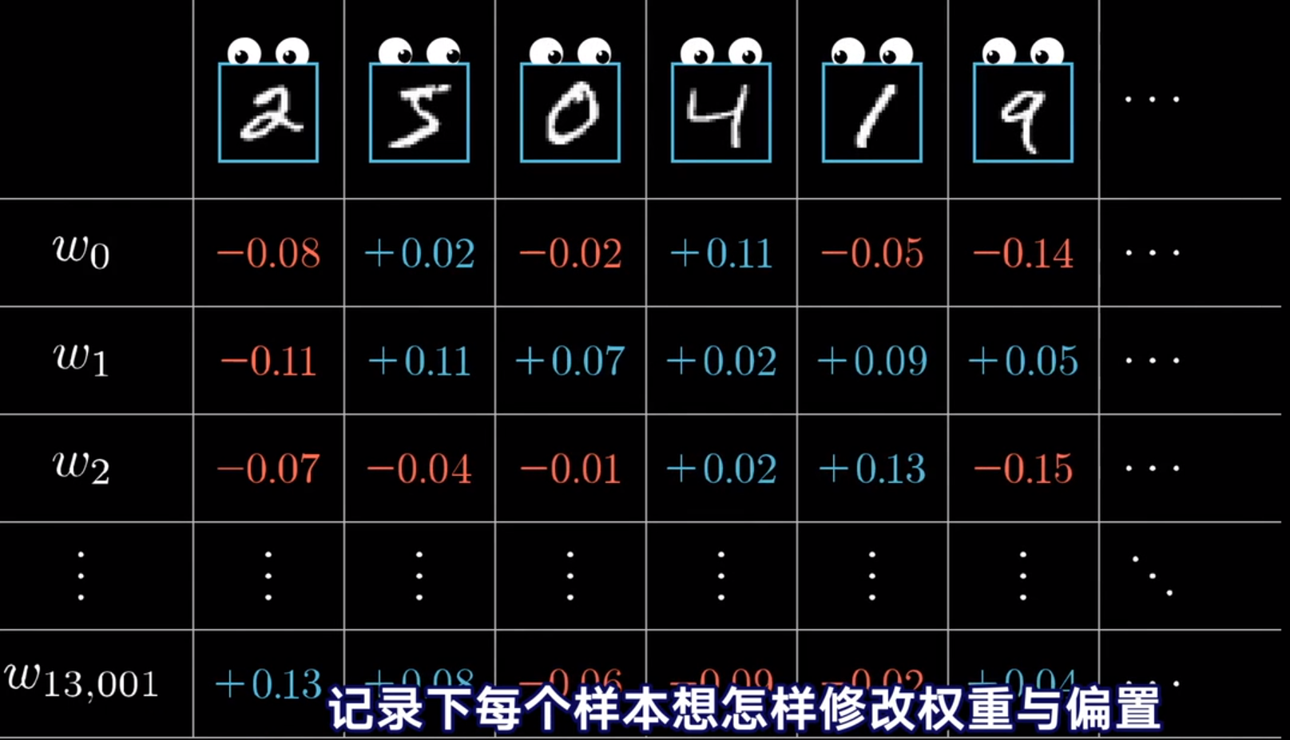

#### 连同矩阵反向传导详解

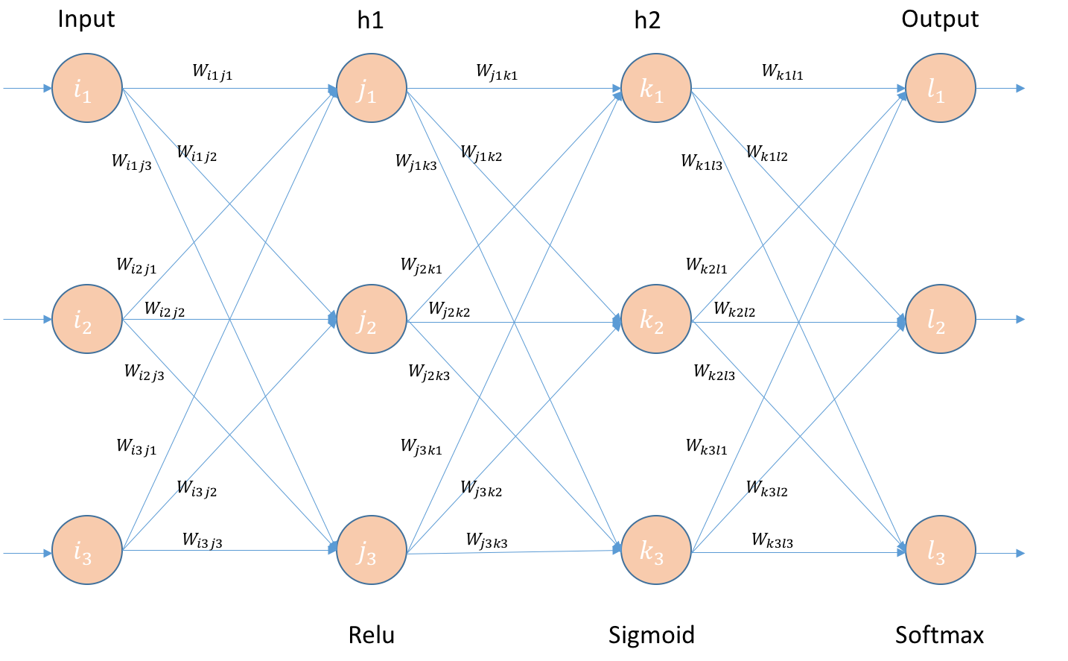

H2->output对应的矩阵求导：

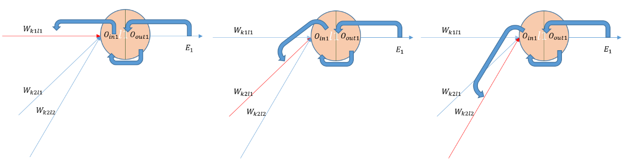

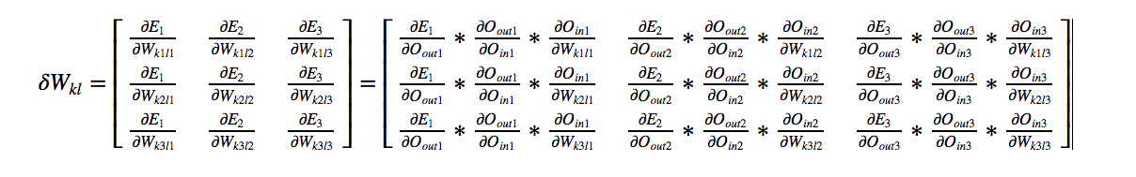

Weight 更新

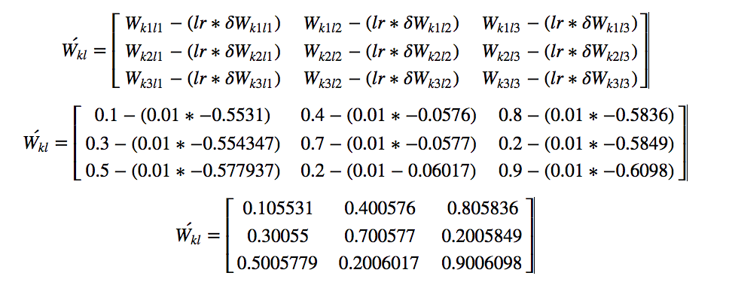

H1->H2层：

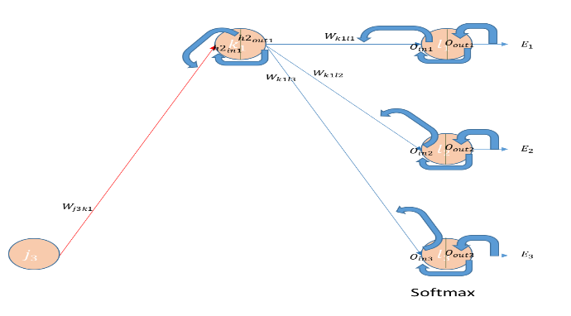

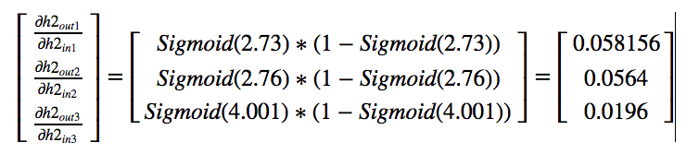

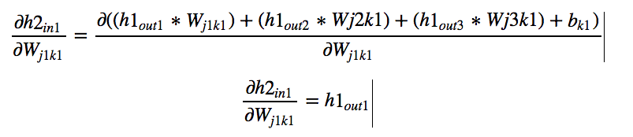

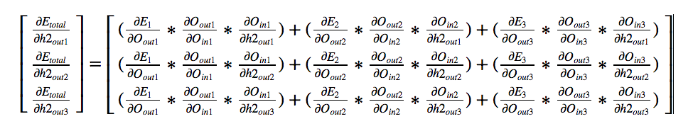

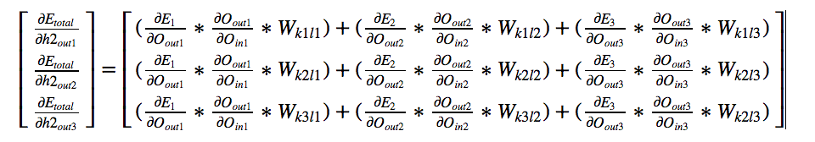

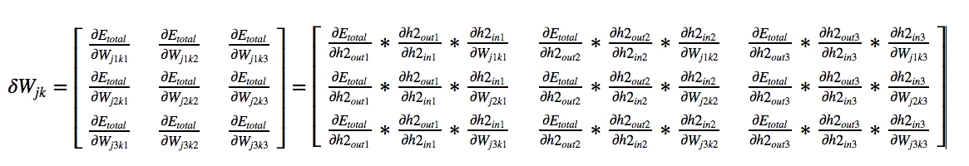

Weight 更新

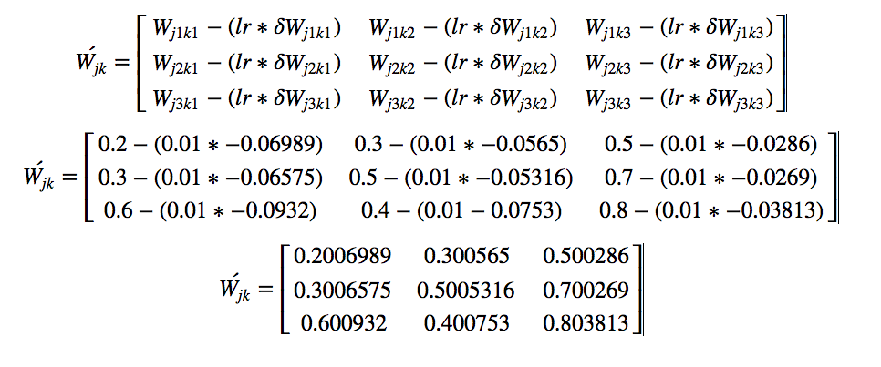

Input->L1层：

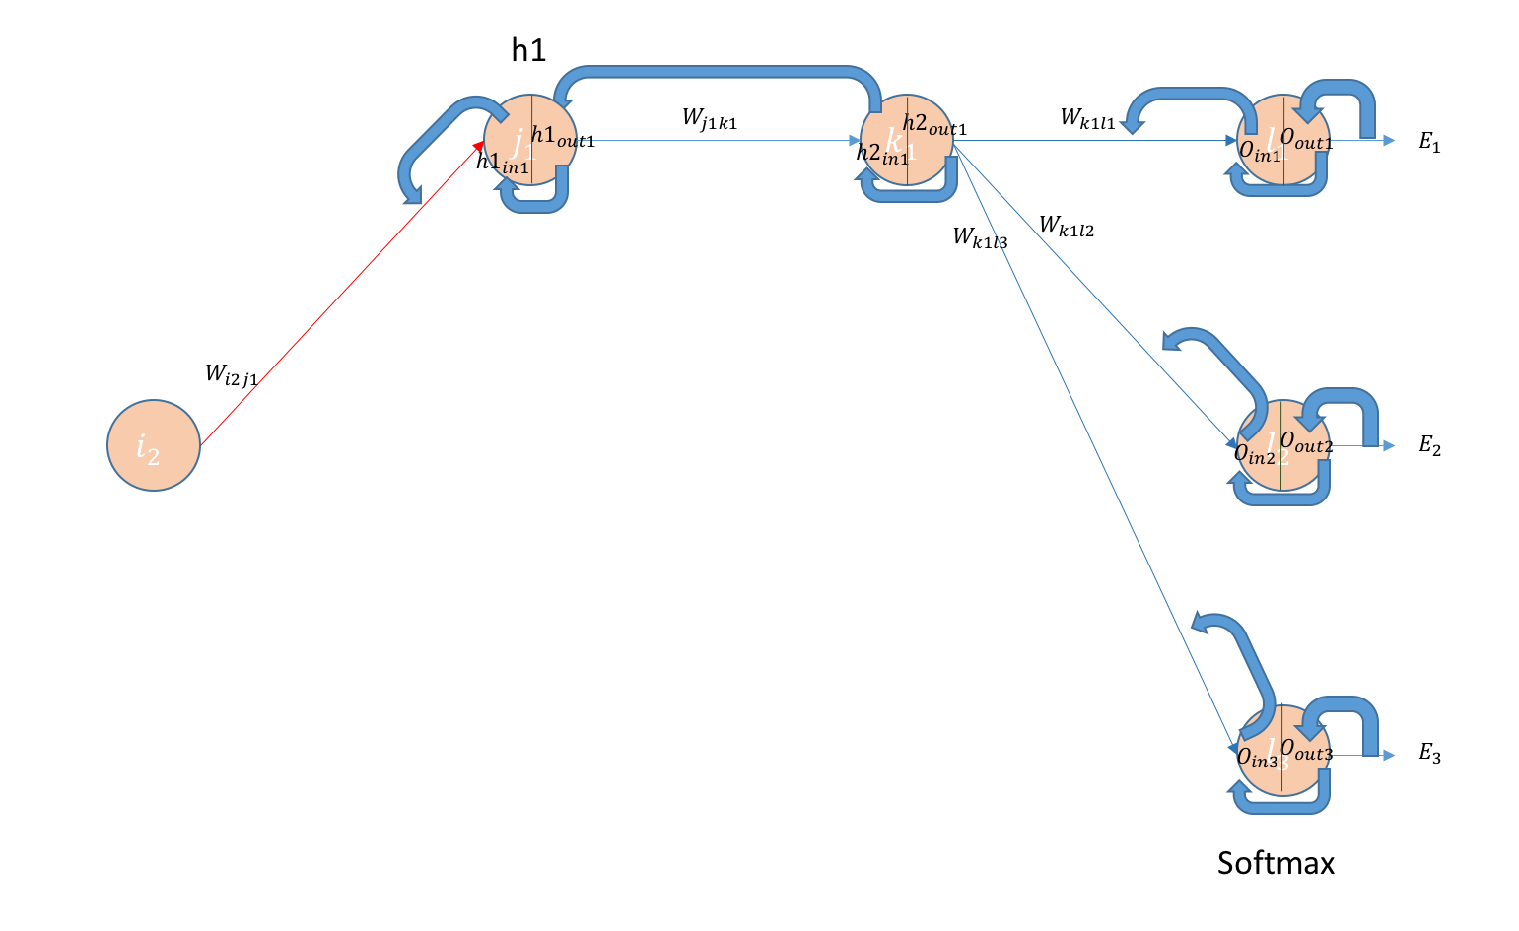

对应矩阵：

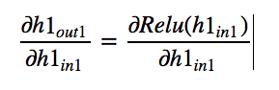

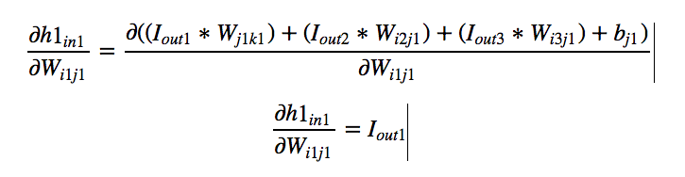

Summary：

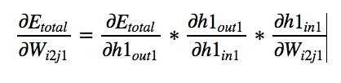

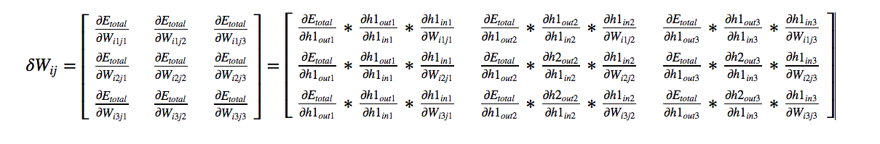

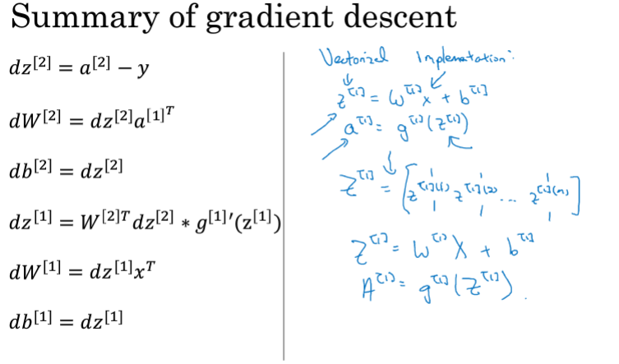

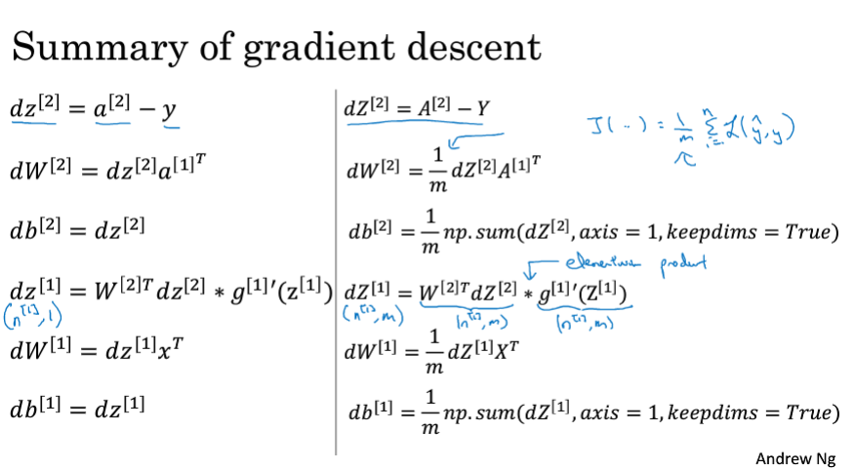

2019/11/3

### 第二部分：改善神经网络和深度学习

#### Bias（准） and variance（稳）

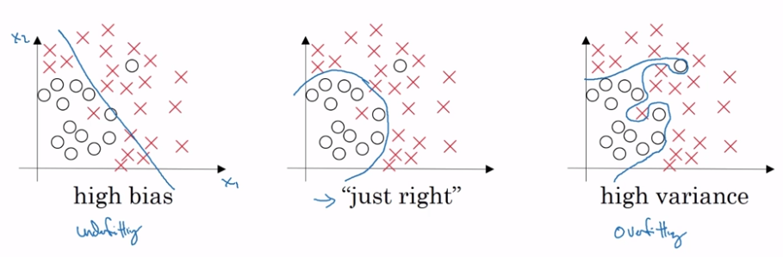

更复杂的模型 更多数据，正则化，好的模型

#### 正则化

Frobenius范式：就是对应元素的平方和再开方 权重衰减

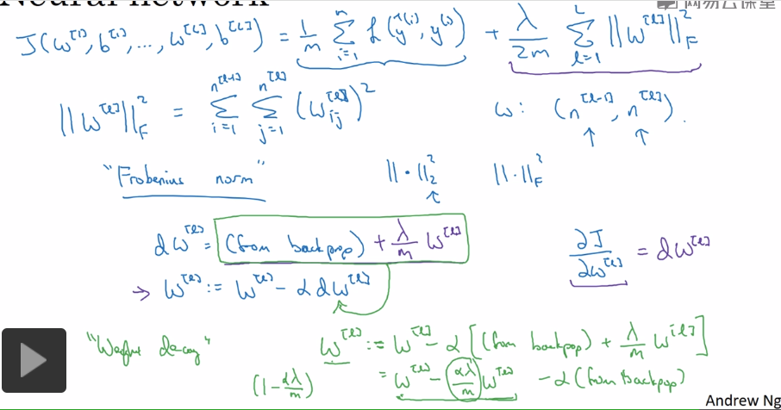

Lambda：相当于神经元开关，越大w越小active function成线性，模型越简单。

Drop out：keep prob

将图像数据翻转，裁剪加入数据集， early stoping

输入归一化：提升梯度下降的速度

？？？？？

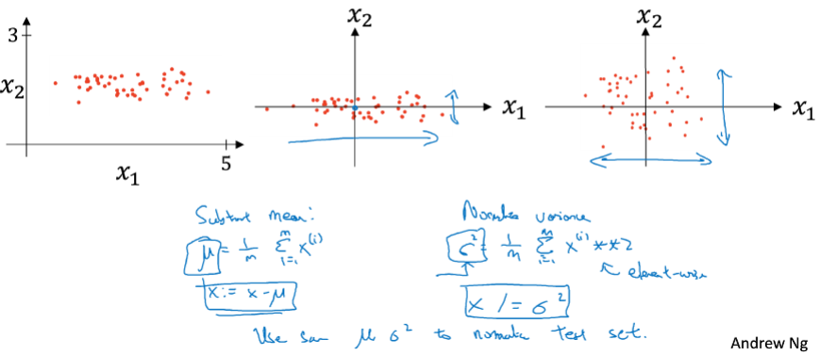

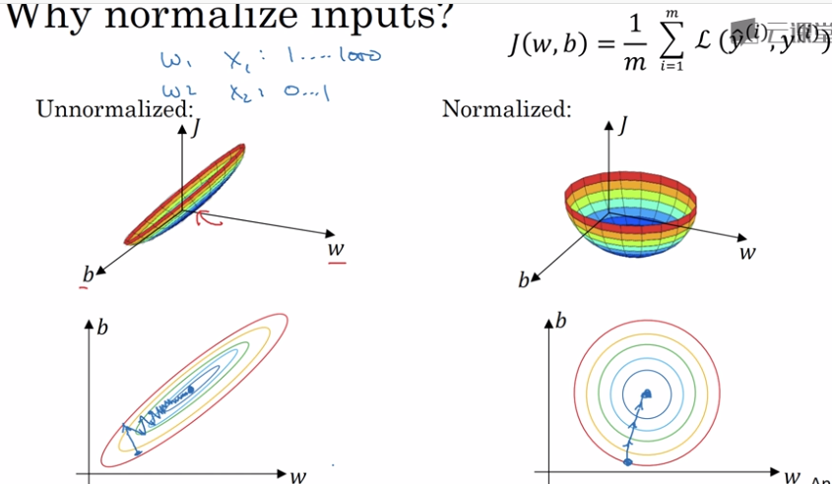

#### 梯度消失与梯度爆炸

当loss对w求偏导时中间会涉及到多个activation function 的导数(a1,a2,a3…an)，当activatoin function的导数总是小于1时：a1*a2*…*an≈0，梯度则不会再下降（梯度消失）。当activation function的导数总是大于1时：a1*a2*…*an≈+∞,w调整过头导致loss不收敛。

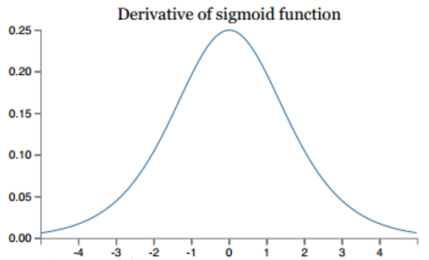 总小于0.25

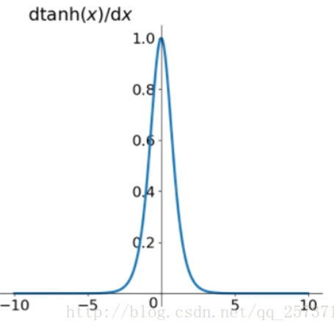总小于1

解决方法：为梯度设置阈值，使用rule lakerelu elu

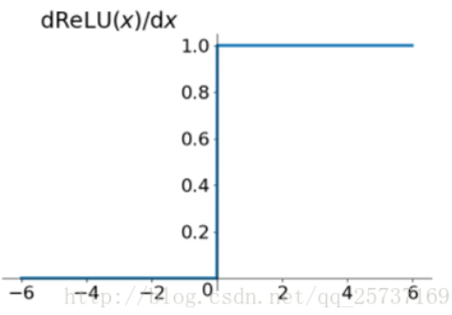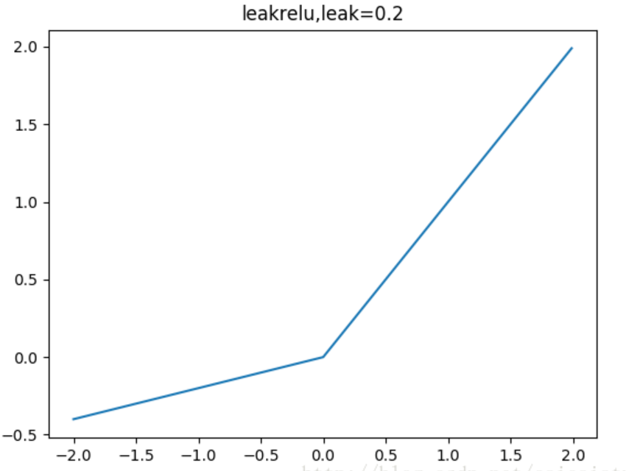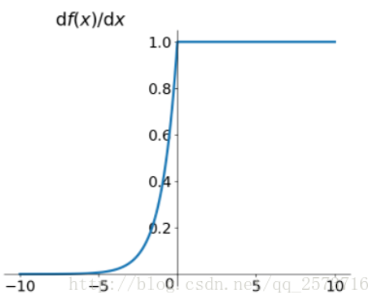

#### Weight初始化

Xavier initialization：保持输入和输出的方差一致，这样就避免了所有输出值都趋向于0



He initialization

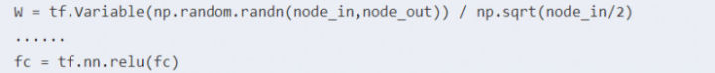

Batch Normalization：

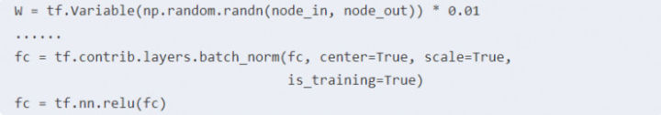

#### Gradient Checking？？？？？

#### Batch，mini-batch，Stochastic

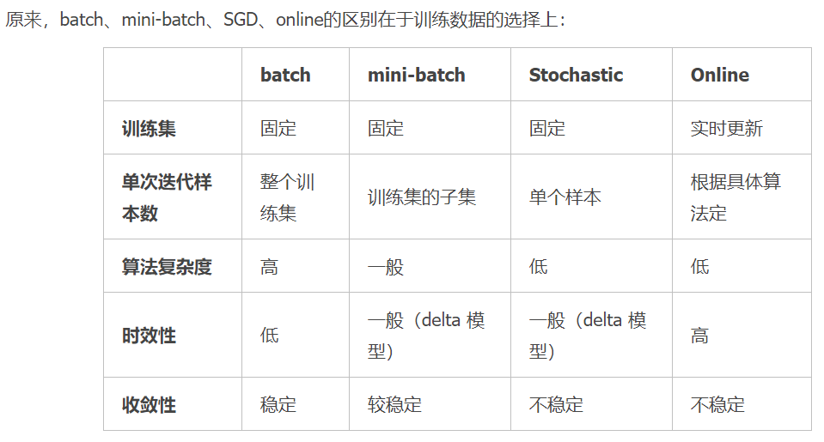

#### 指数加权平均

β越大过去均值所占比重越大，越平稳。β越小过去均值所占比重越小，越抖动。

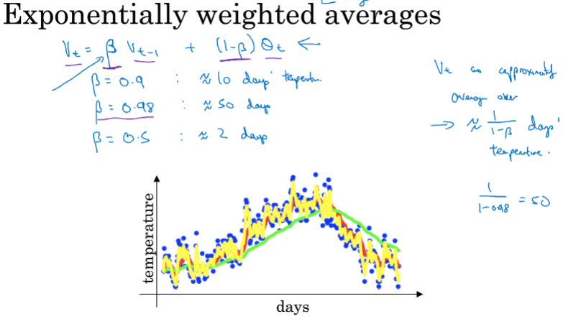

修正偏差：v0 = 0，导致前期偏差较大，于是修正下：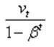

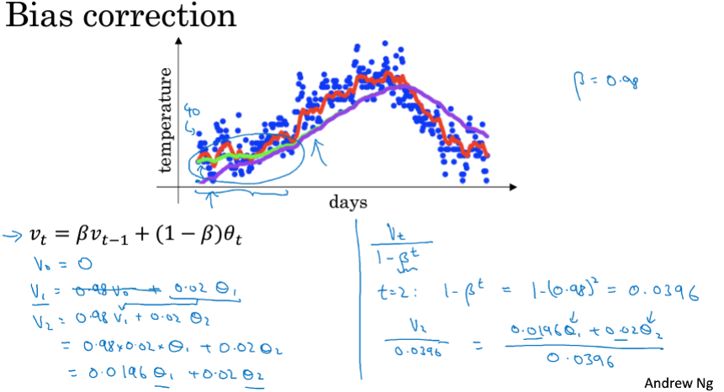

#### 梯度下降的优化

Momentum：将过去的梯度与当前的梯度结合起来

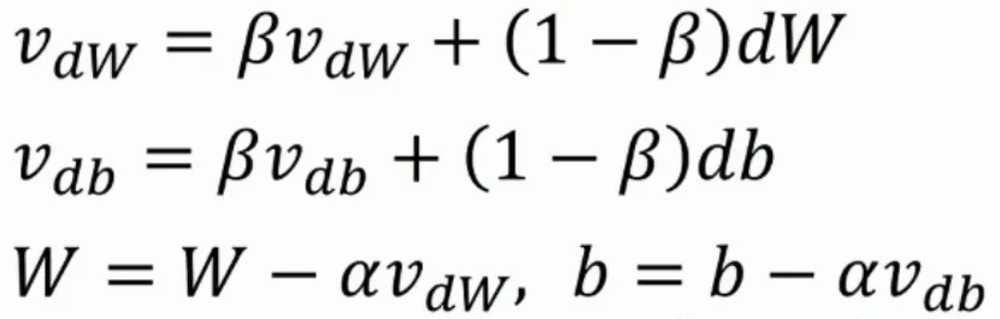

RMSprop

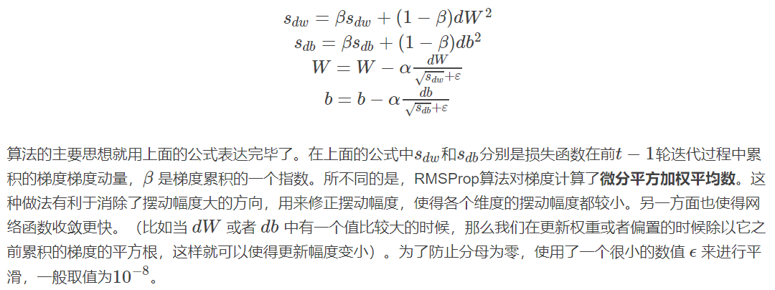

Adam：

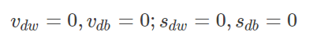

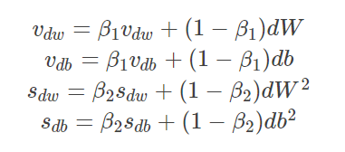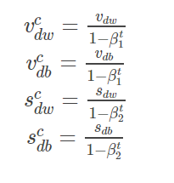

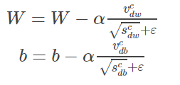

学习率衰减 ：随着训练的批次学习率越来越小，使得loss最后收敛在最小值附近。

#### 超参数调节

Learning rate，指数权重，mini-batch，hidden units，layers，learning rate decay。

#### Batch norm

This change in the distribution of data contained in train and test file is called dataset shift。

能不能自动学习分布差异？

每个batch：有N个数据，每层有一个z对应的均值和方差。

整个训练集：每层有一对学习的参数γ，β

实际的BN操作中会把bias忽略，由BN要学习的参数β所代替

自主学习适合的γ（scale），β（shift）

在预测时只有一个数据：均值，方差为所有batch均值，方差的期望。

-> CONV/FC -> BatchNorm -> ReLu(or other activation) -> Dropout -> CONV/FC ->

<https://shomy.top/2017/12/05/Feature-Scaling-Batch-Norm/>

<https://www.learnopencv.com/batch-normalization-in-deep-networks/>

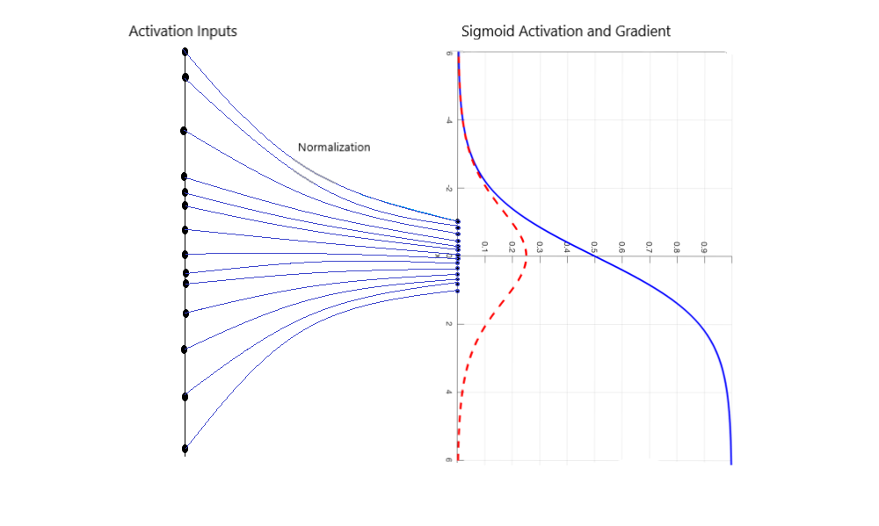

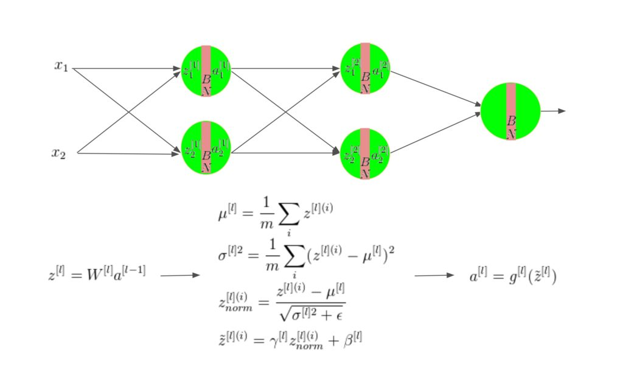

### 第四部分卷积神经网络

#### Filter

不同的Filter提取的特征不同，Filter会随着梯度下降提取出主要特征。

Flilter 的channel 与 image的channel保持一致。Filter的个数决定feature map 的channel

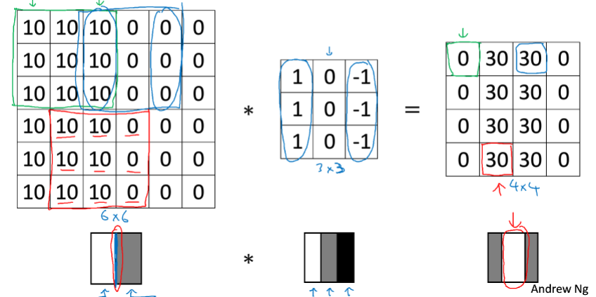

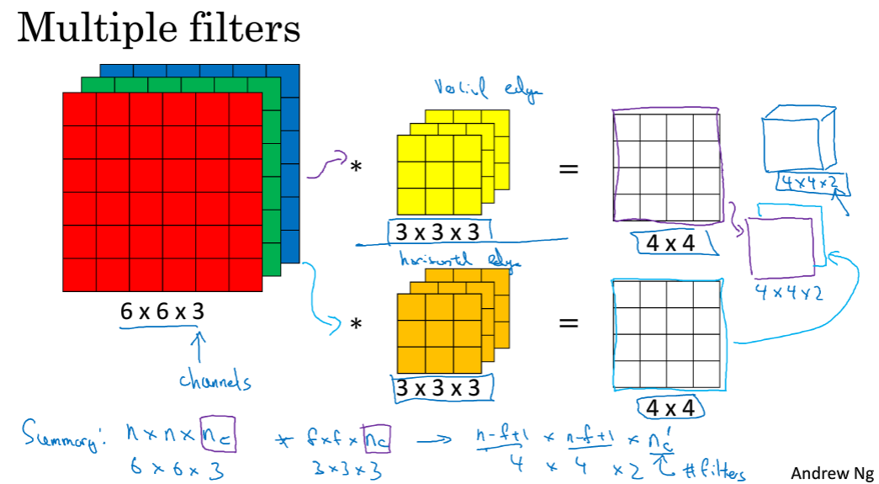

#### Padding

原因：1、图像缩小。2、边缘像素点只读一次，在输出中较少采用。意味着边缘信息丢失。

Valid：不填充 p=0。Same：保持输入输出尺寸一致。

Filter size 一般为奇数 （f-1）/ 2 = p

#### Stride

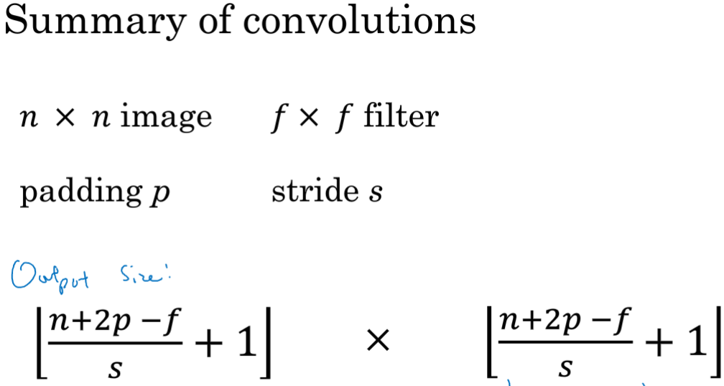

#### receptive filed

<https://medium.com/mlreview/a-guide-to-receptive-field-arithmetic-for-convolutional-neural-networks-e0f514068807>

receptive field 随着卷积的进行不断放大渐渐覆盖全图

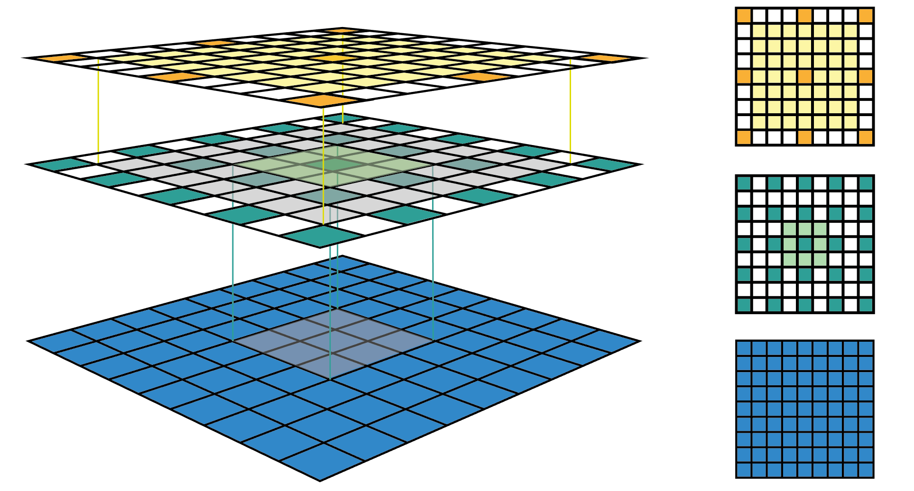

灰色的就是receptive field

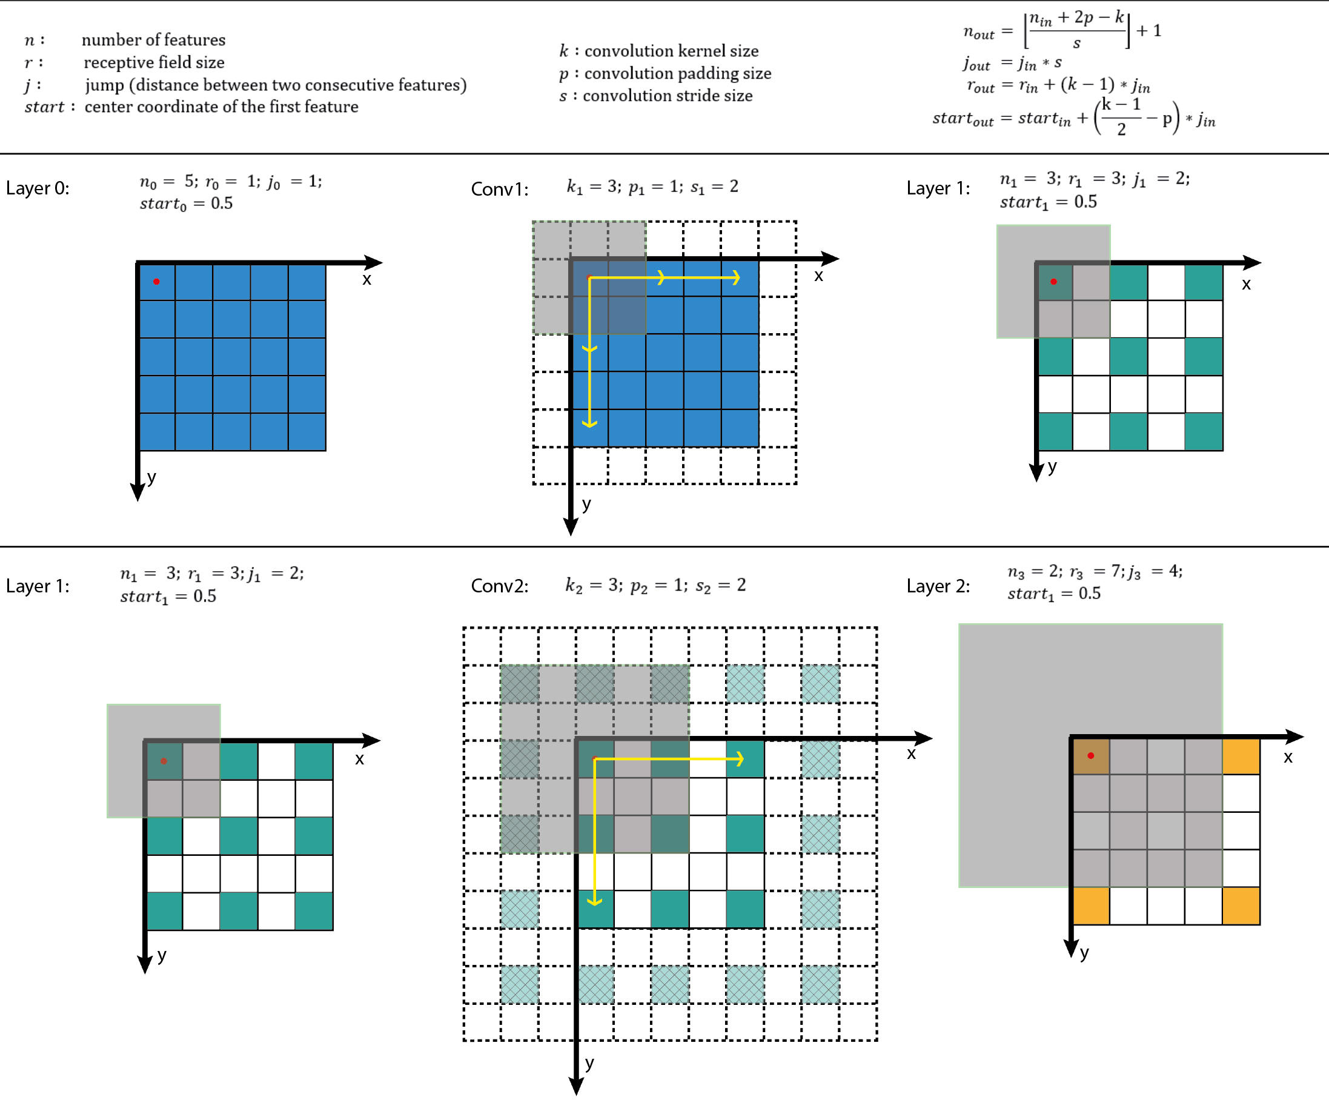

#### Summary

层数增加 width and light will decrease，channel will increase。

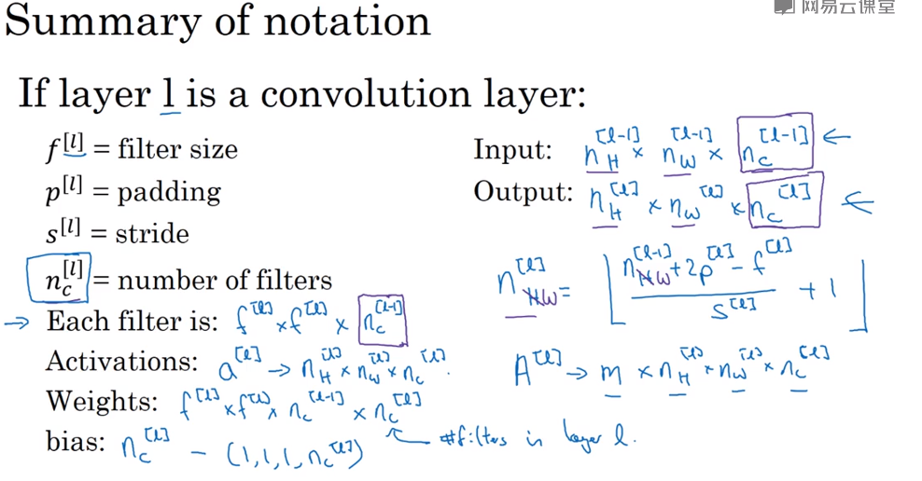

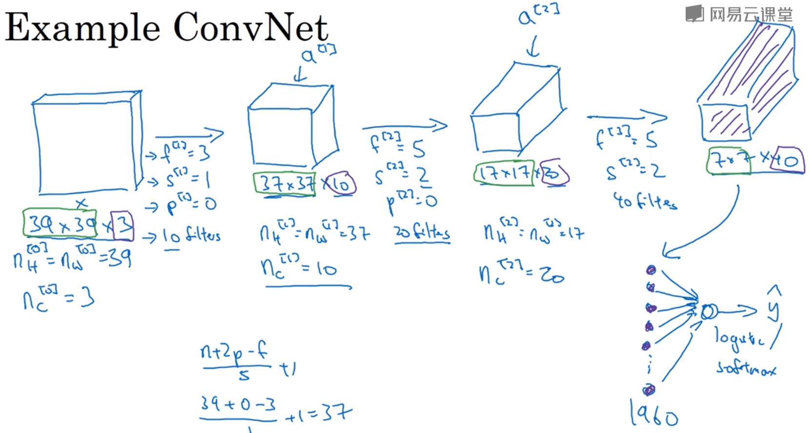

#### Pooling

Pooling 的超参数与GD无关

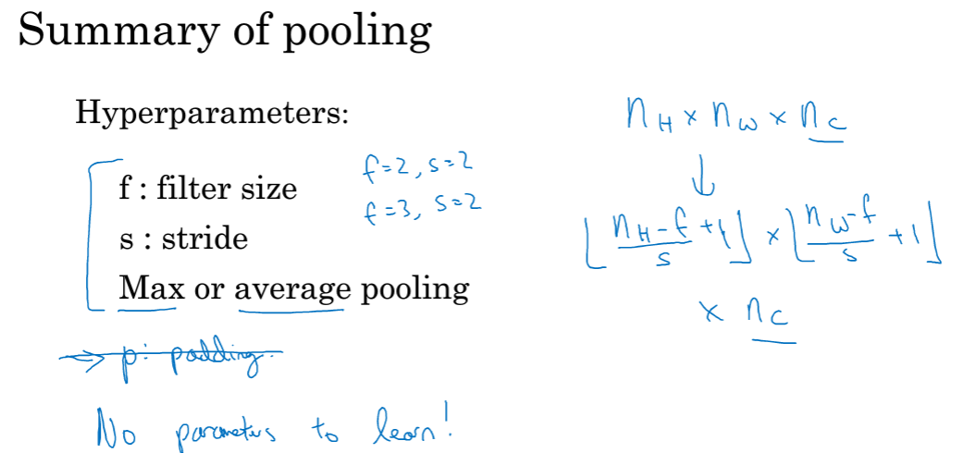

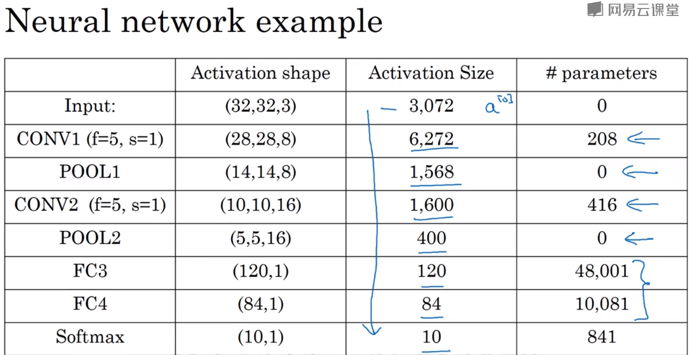

#### Conv 作用？？？

1. 参数共享（平移不变性，减少参数，识别某特征f，无论f在图像中的什么位置）。

2.稀疏连接（输出只与部分输入相关）

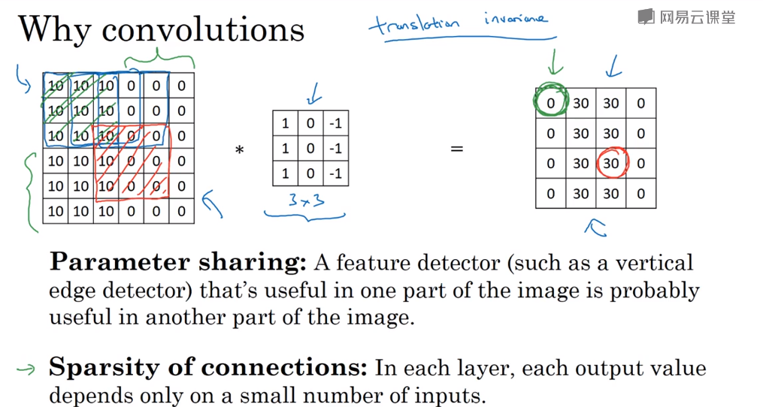

为什么可以探测到边缘？？

#### Fully connet layer

<https://zhuanlan.zhihu.com/p/33841176>

Feature map 3x3x5 Filter 3x3x5x4096

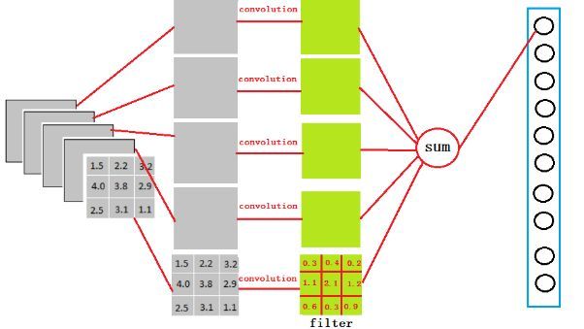

#### 1*1 conv

将channel数转变成filter个数（变薄）

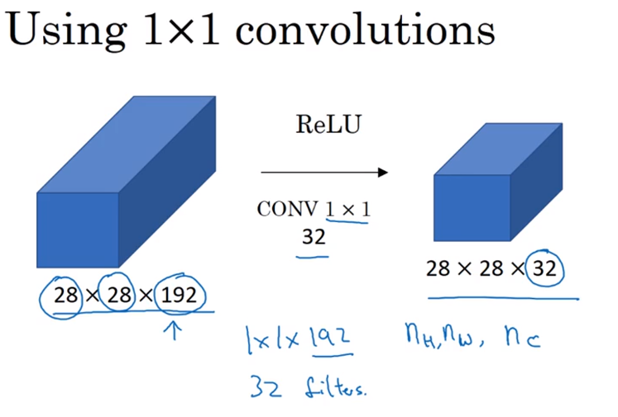

#### Inception

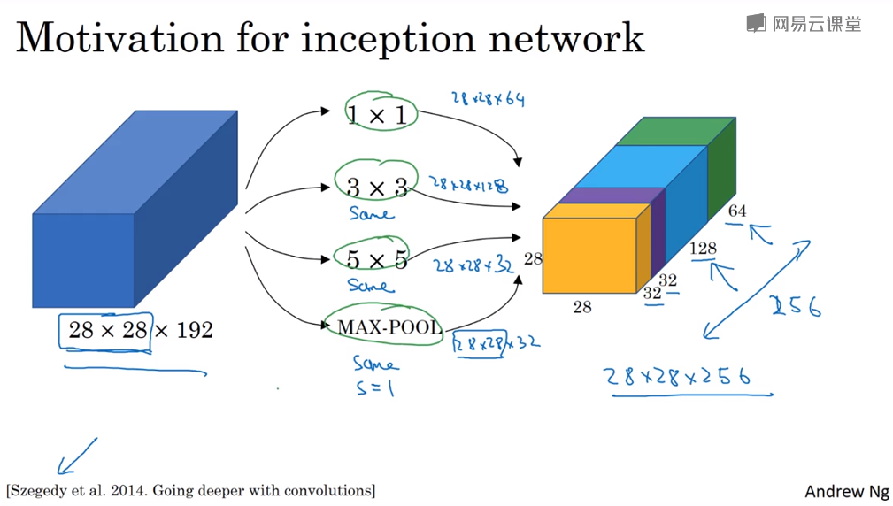

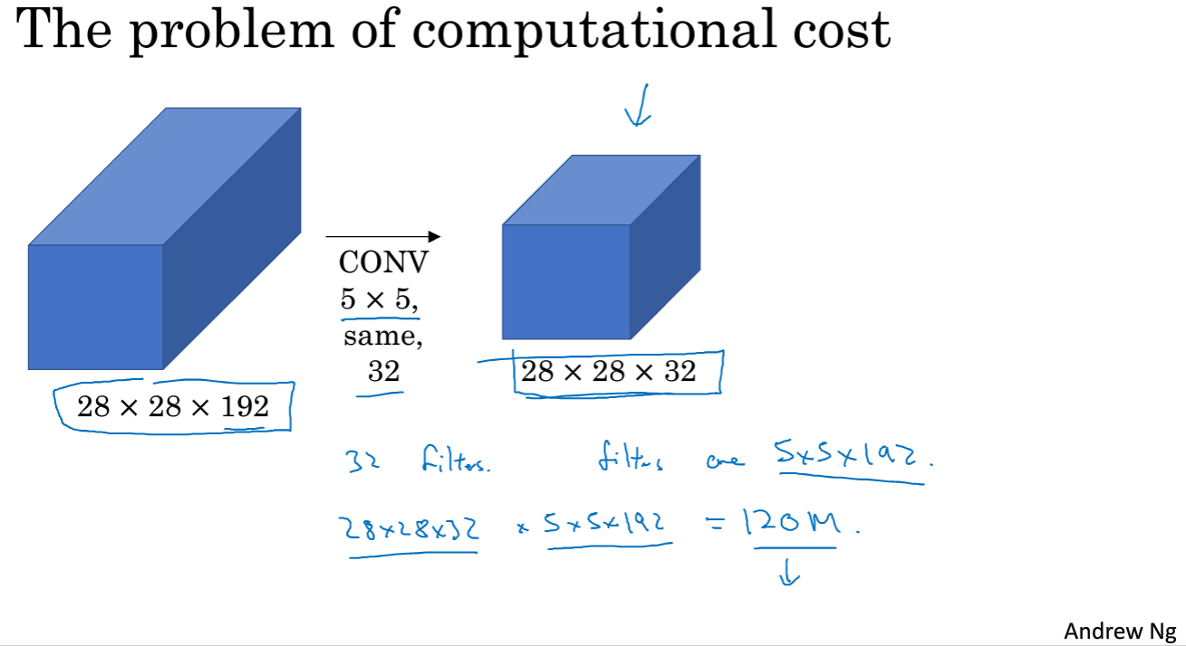

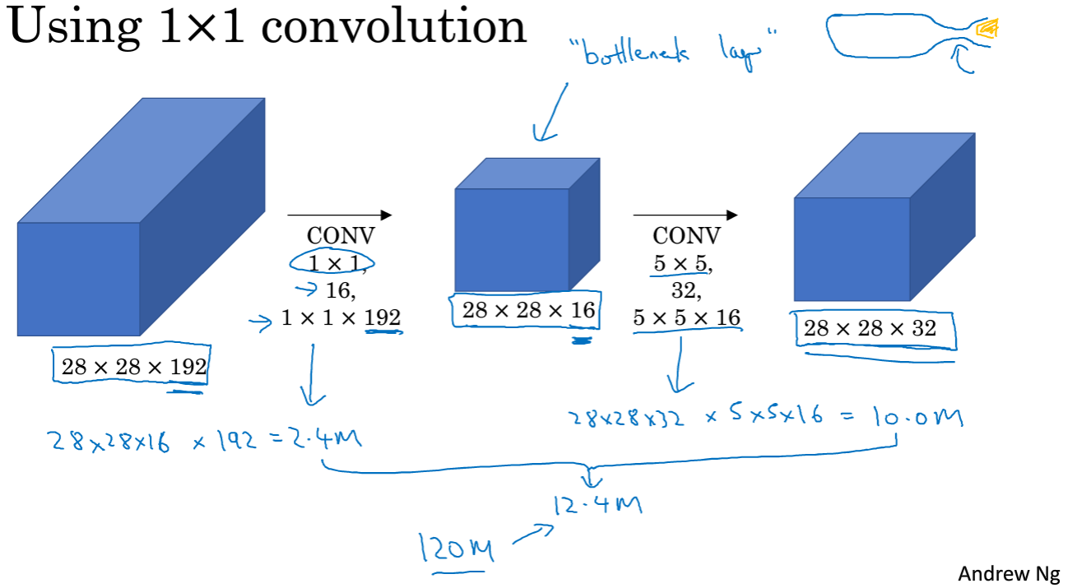

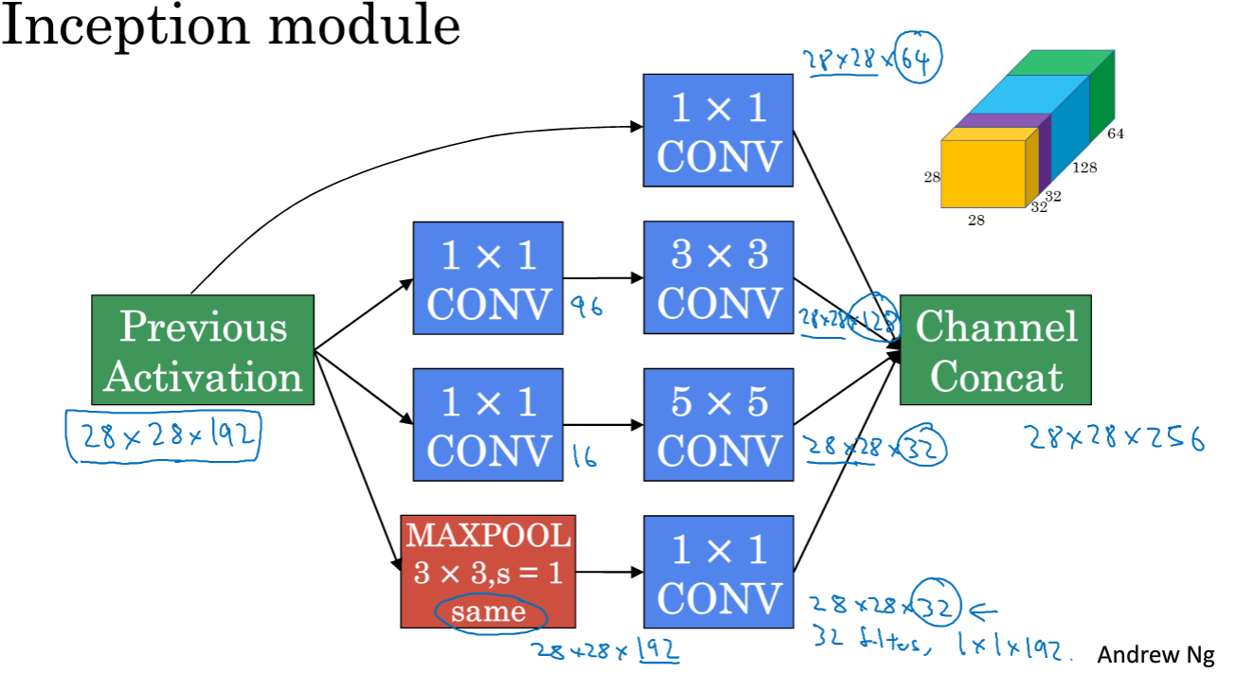

#### 数据扩充

镜面对称，随机裁剪

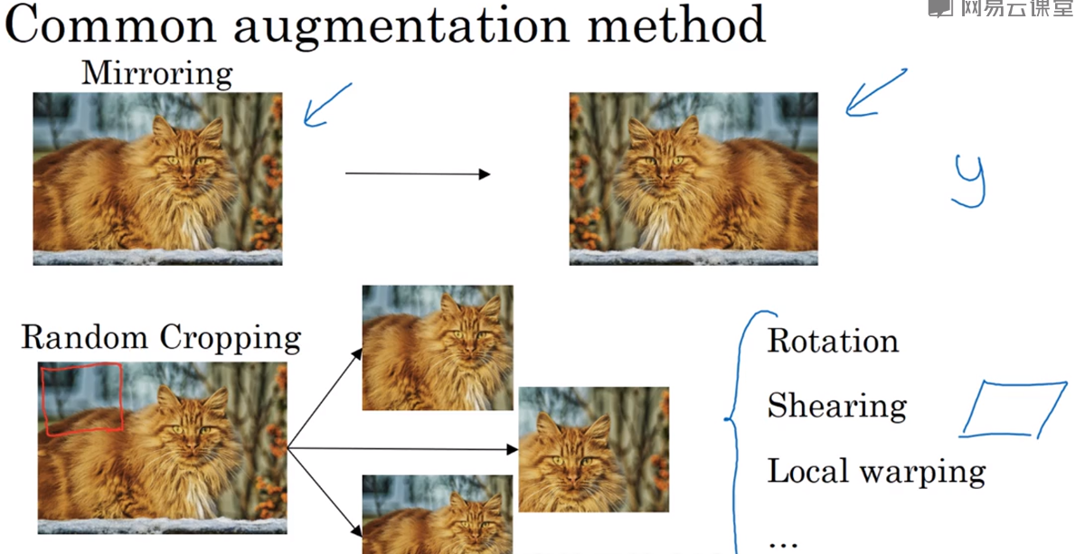

颜色增强

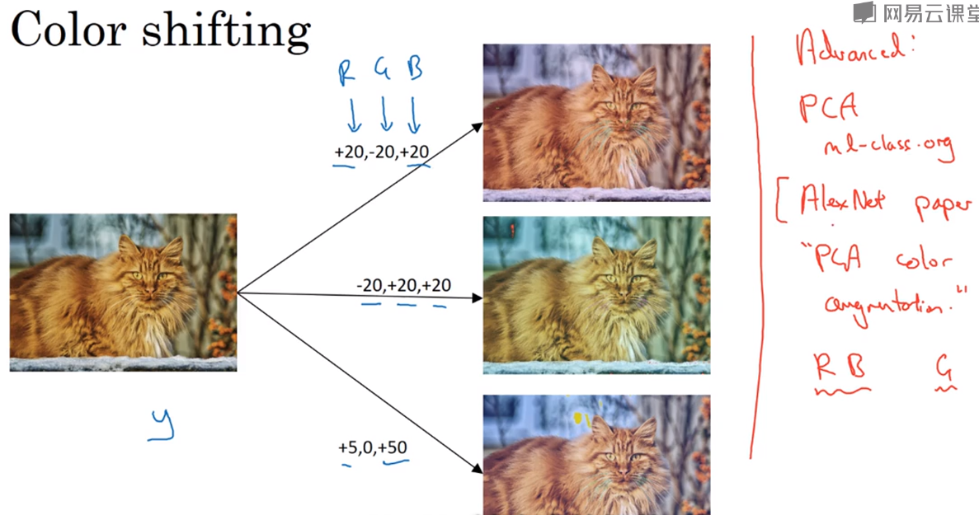

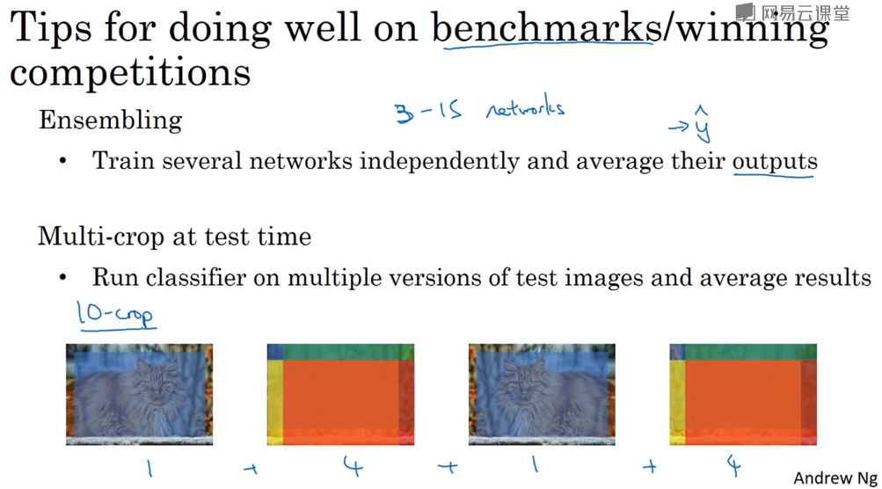

#### 目标定位

是否有物体，物体位置，物体类别。（分类，定位）

当有物体：物体分类准确率，物体位置准确率。无物体：物体分类准确率。

分类：softmax。位置：mse。物体准确位置需要人工标注。

y:物体是什么，物体的准确位置。

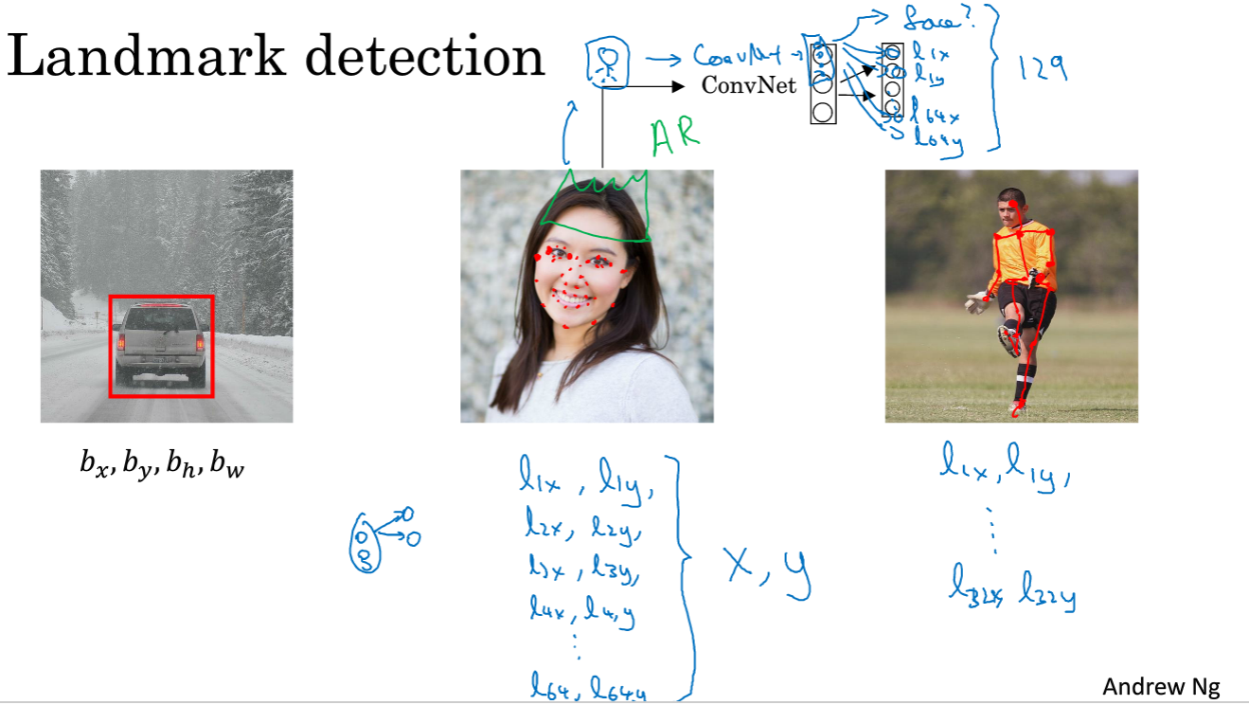

#### 目标检测算法

滑动窗口目标检测，窗口大小调整（由小到大），步长，结合**非极大值抑制(Non-Maximum Suppression, NMS)**选择得分最大框**。**问题：使用神经网络计算成本大

IOU：交互比

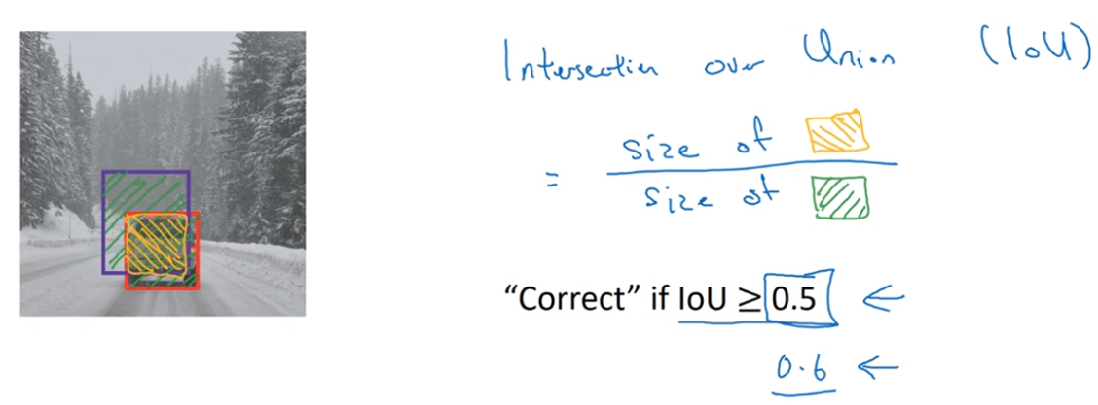

非极大抑制<https://blog.csdn.net/shuzfan/article/details/52711706>

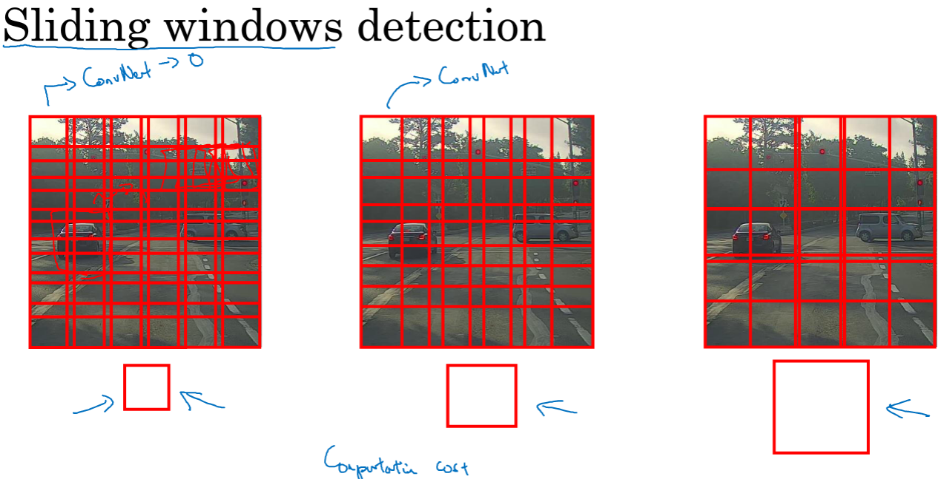

anchor box：解决多物体重叠在同一框内。不同的anchor box 检查不同的物体

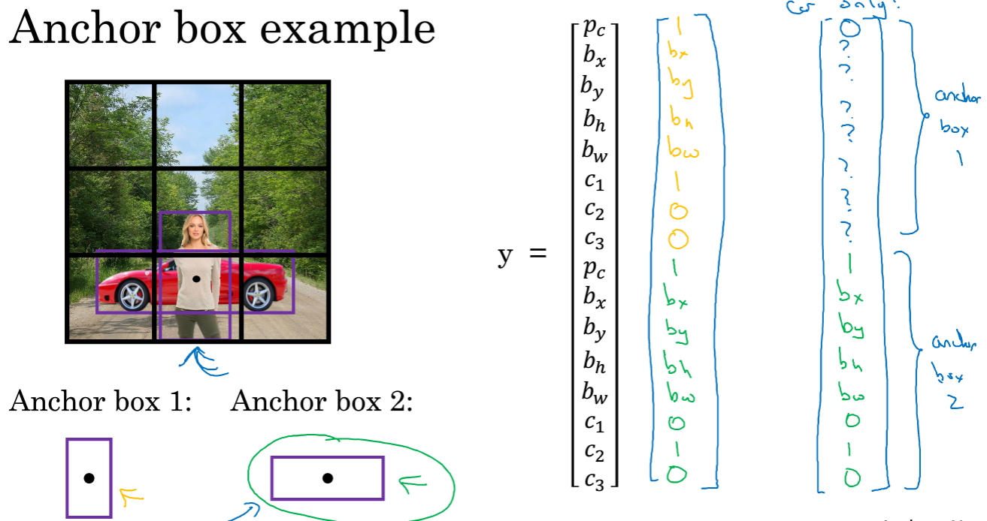

#### 利用conv代替 FC

FC只能输出一个结果，用conv代替可以输出多个结果

Model中FC的数量是固定的，这样就限制了输入的size，改用conv可以输入任意size

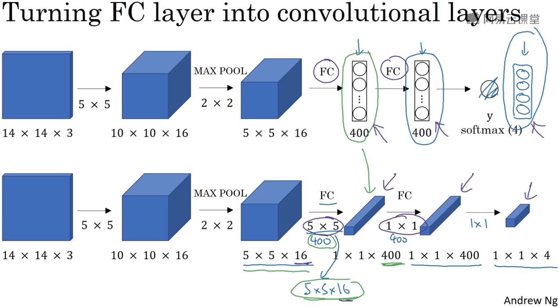

用大窗口滑动卷积

利用卷积操作实现滑动窗口：不需要多次输入裁剪后的图像分别计算，直接输入整张图片，利用卷积输出全部计算结果，但是边界无法探测。

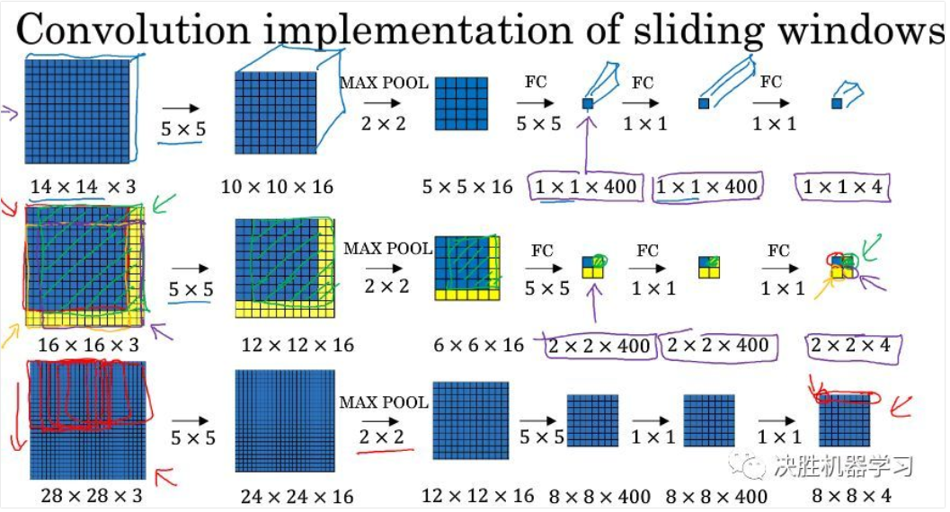

#### YOLO

物体框的中心在原始框中的位置向量使用的是百分比

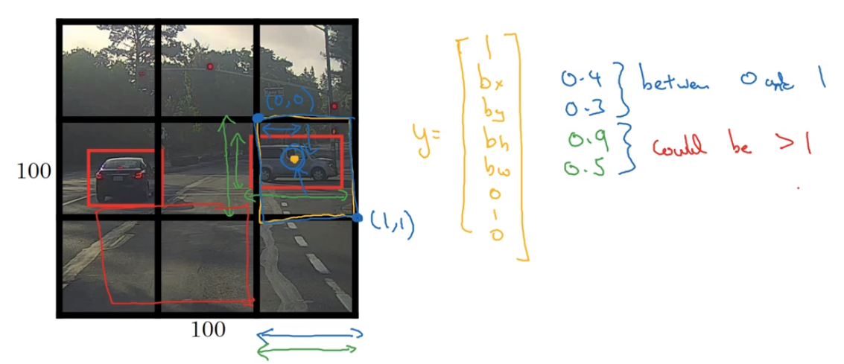

### CNN框架

#### LetNet-5

无重叠max pooling

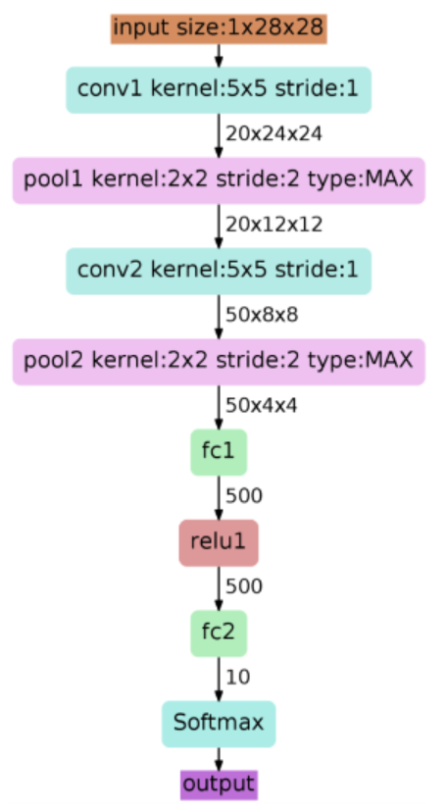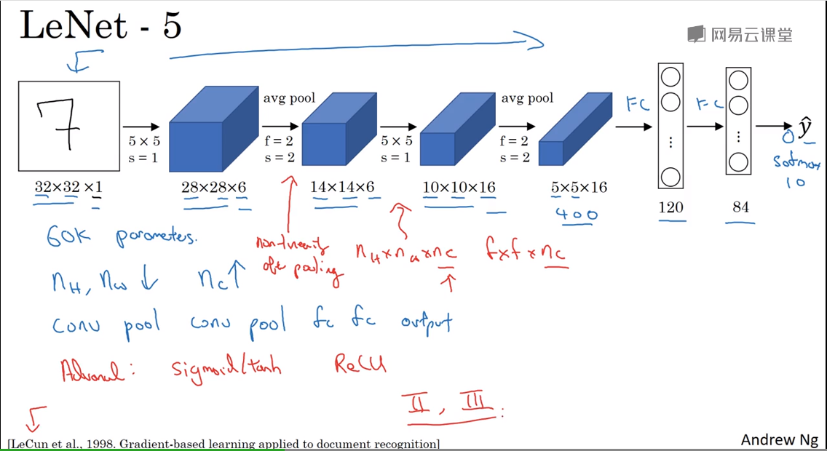

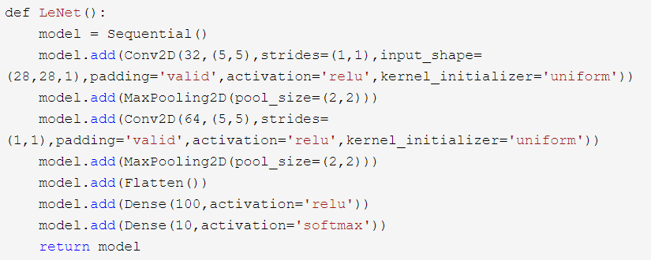

#### AlexNet

Conv1 原图224*224*3 padding成 227*227*3

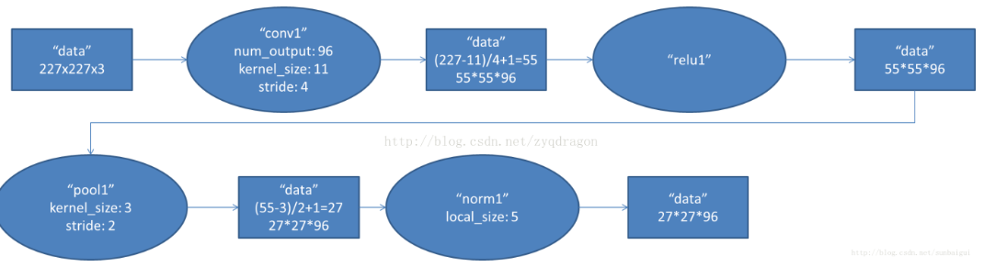

Conv2

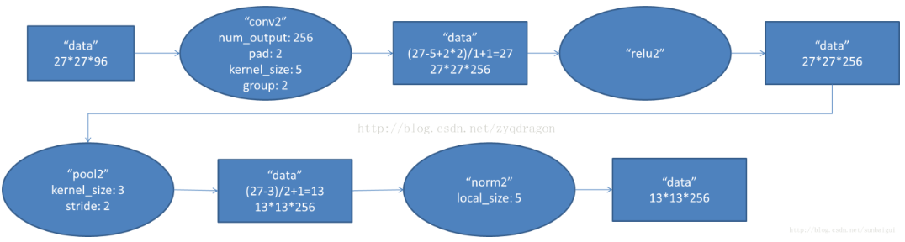

Conv3

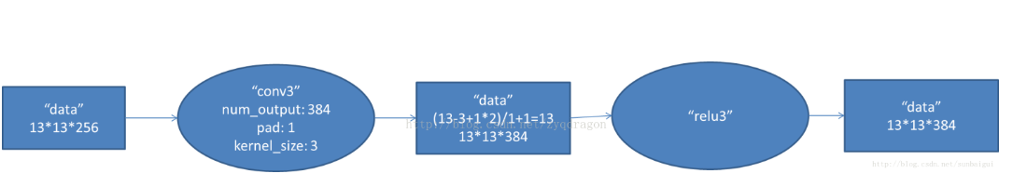

Conv4

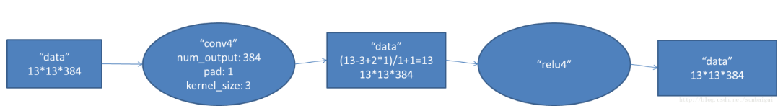

Conv5

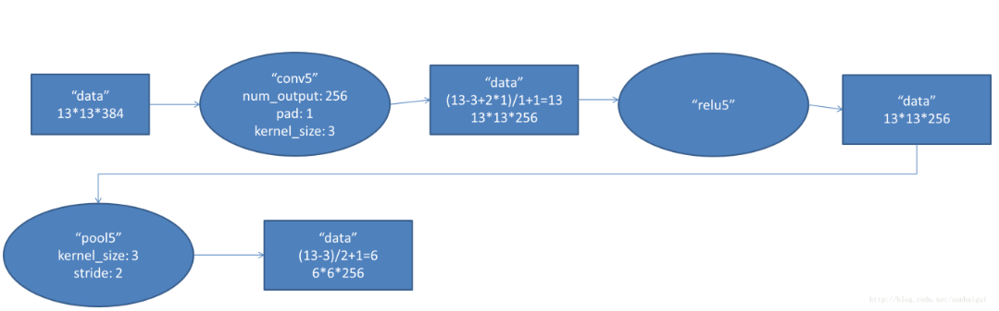

Conv6

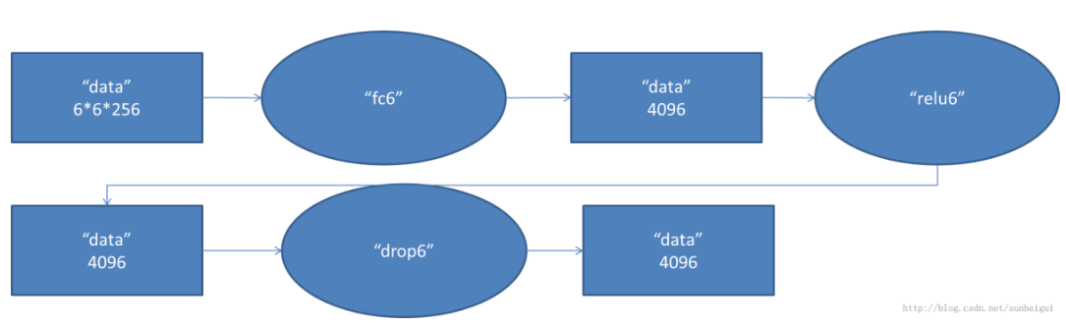

Conv7

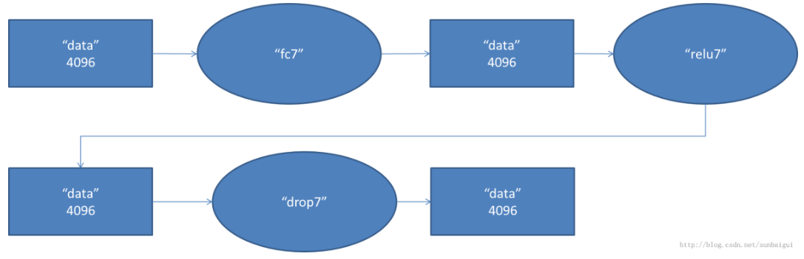

Conv8

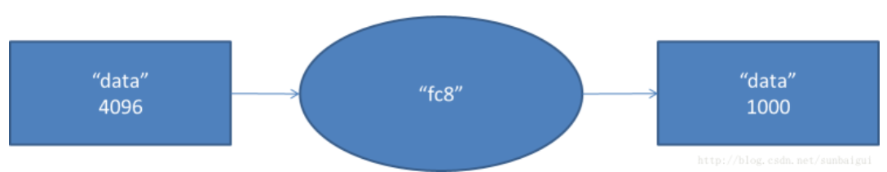

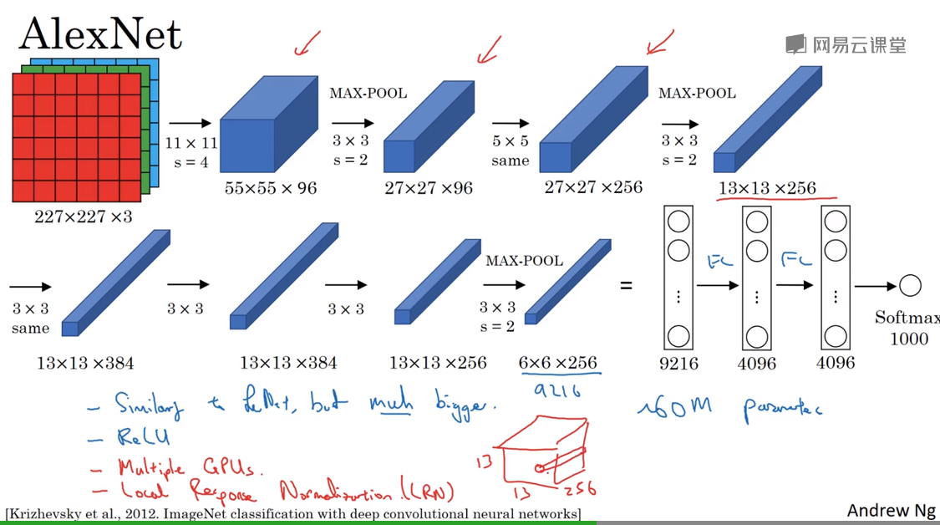

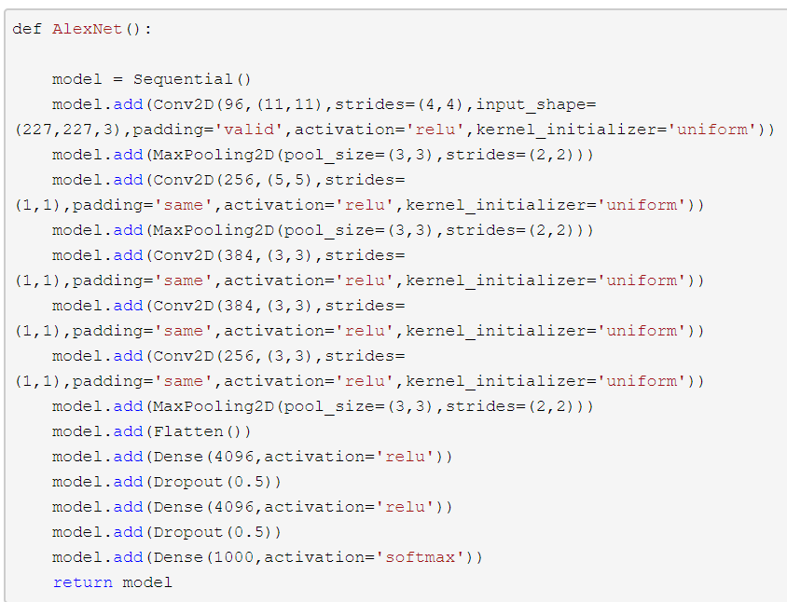

#### ZF-Net

不能整除需加1：（110-3+1）/2+1 = 55

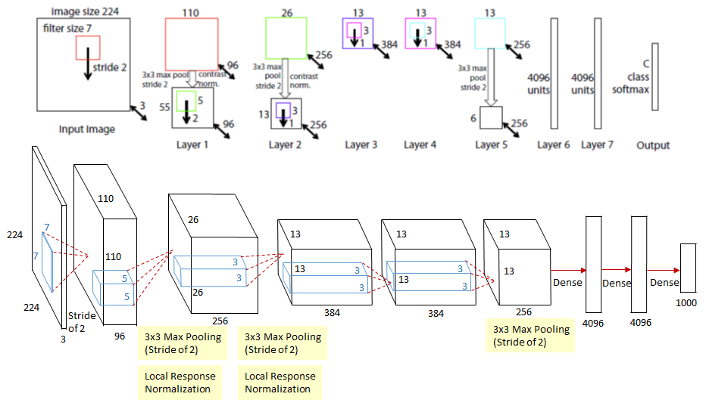

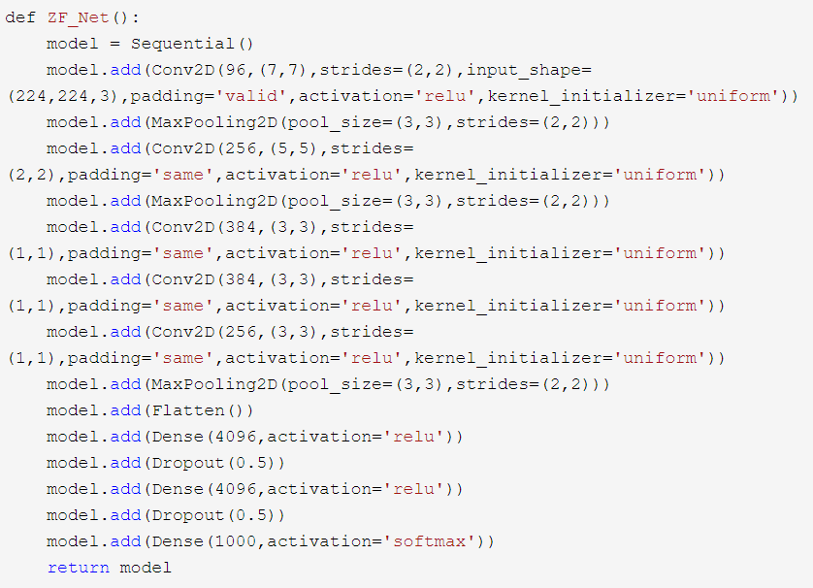

#### VGG

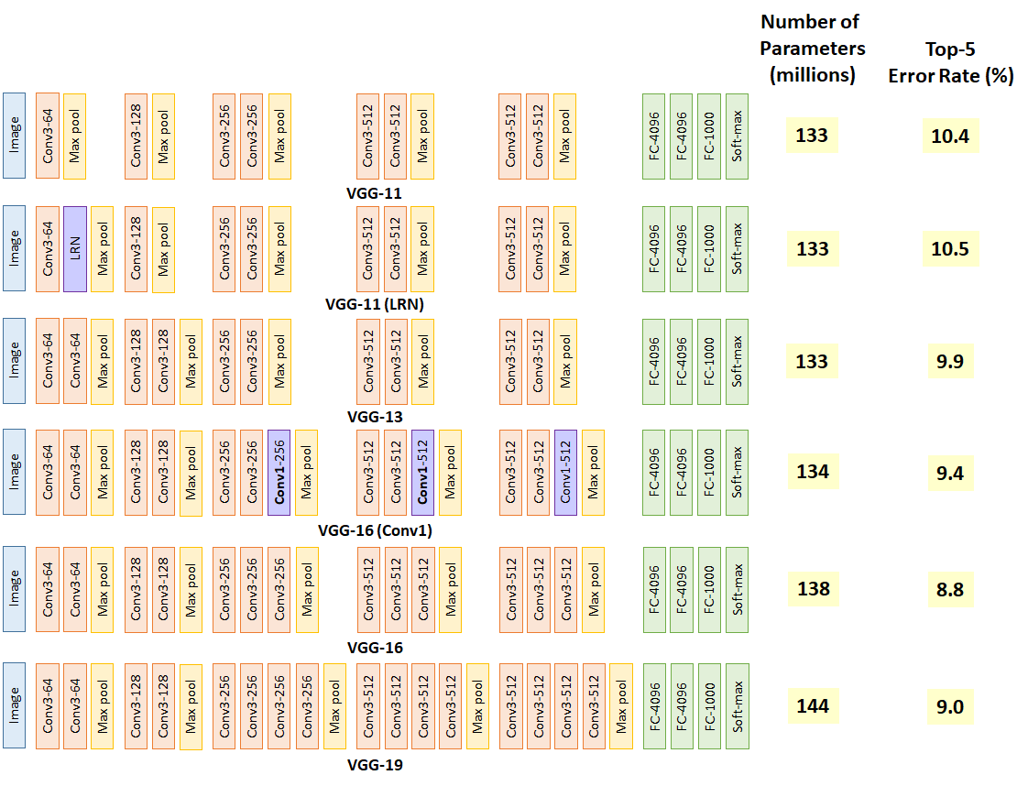

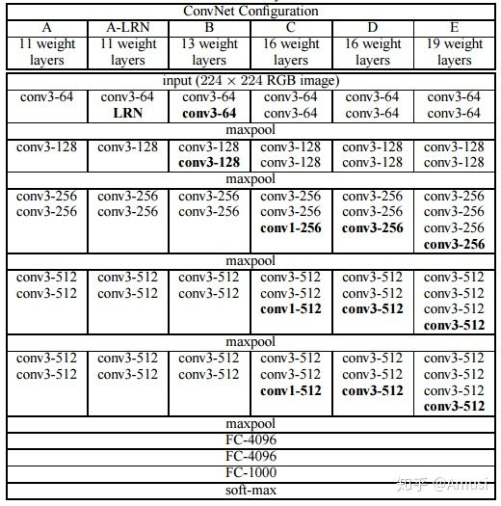

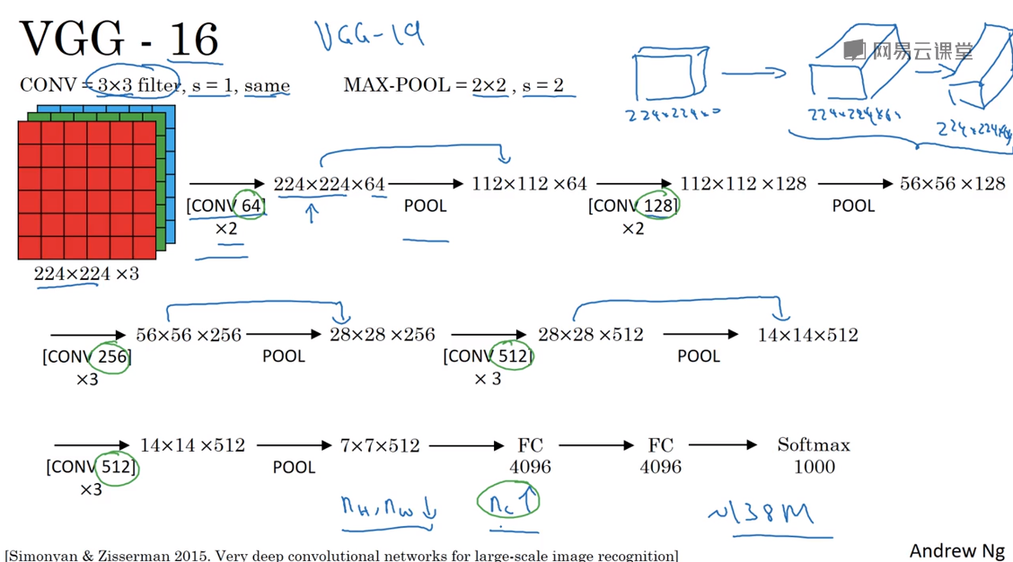

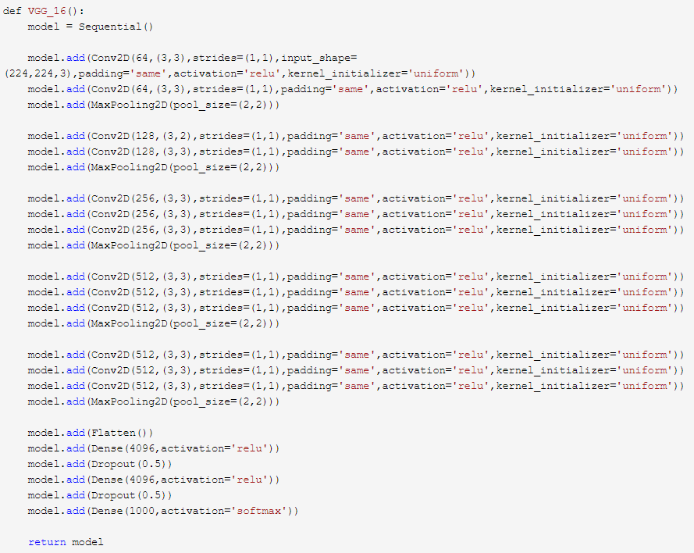

#### GoogleNet

<https://my.oschina.net/u/876354/blog/1637819>

<https://www.cnblogs.com/Allen-rg/p/5833919.html>

#### Resident Net

<https://blog.csdn.net/lanran2/article/details/79057994>

<https://medium.com/@14prakash/understanding-and-implementing-architectures-of-resnet-and-resnext-for-state-of-the-art-image-cf51669e1624>

<https://towardsdatascience.com/an-overview-of-resnet-and-its-variants-5281e2f56035>

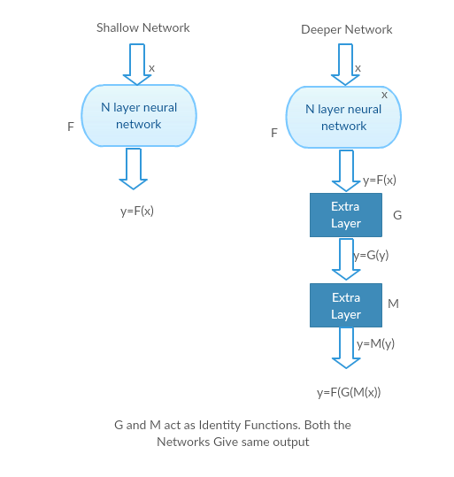

2.4没太听懂

## 概率统计知识

### 现验，后验，似然估计

<https://blog.csdn.net/qq_23947237/article/details/78265026>

已知事件的因果

后验概率：根据已知的结果去估计原因

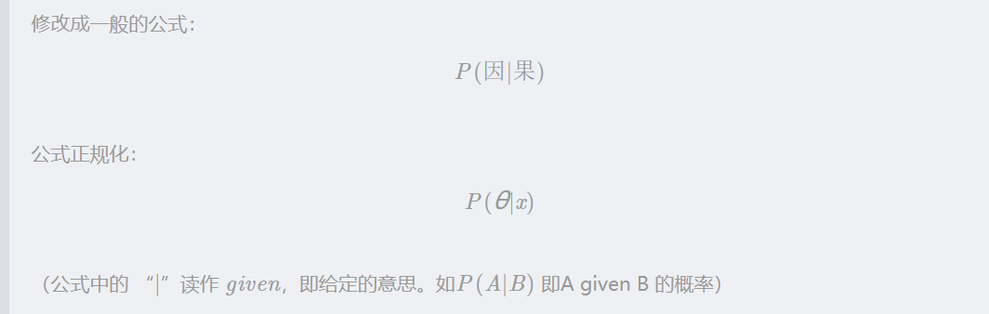

先验概率：根据历史规律确定原因



似然估计：先定下原因，根据原因来估计结果



evidence：结果的概率



贝叶斯公式：



最大似然估计（ML，Maximum Likelihood）与最大后验估计（MAP，Max A Posterior）

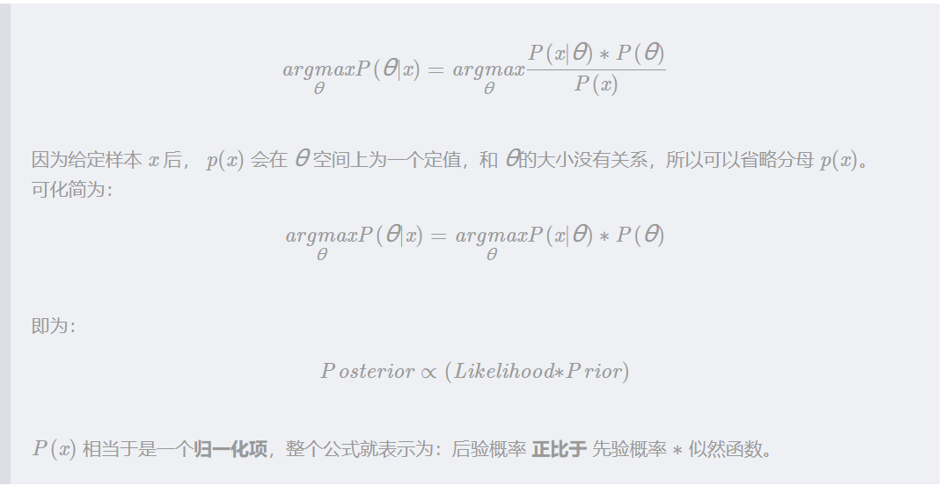

### Introduction to probability

#### 8 bayesian statistical inference

概率和统计的区别：

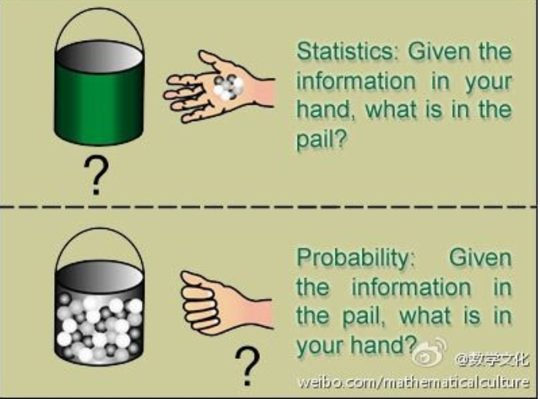 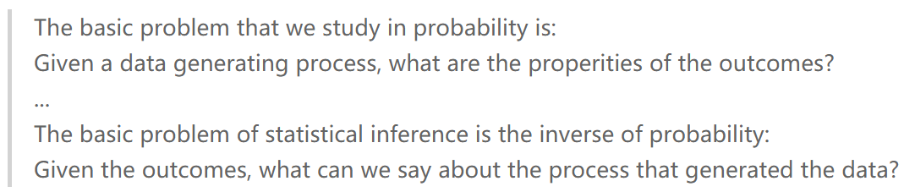

## neural network design

### cp2 Neuron Model and Network Architectures

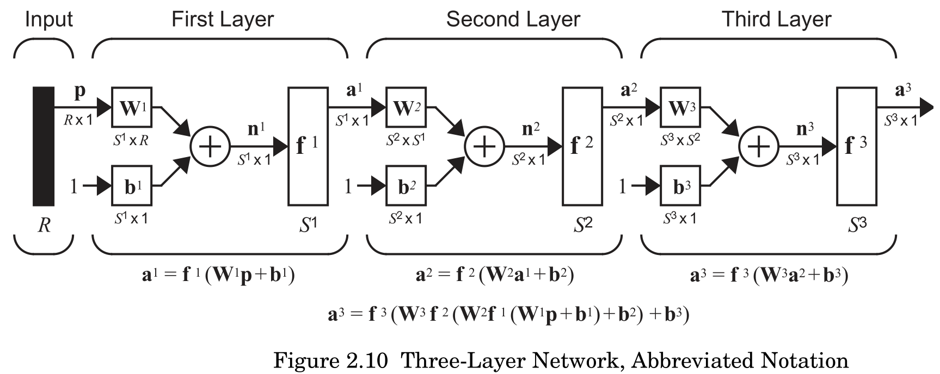

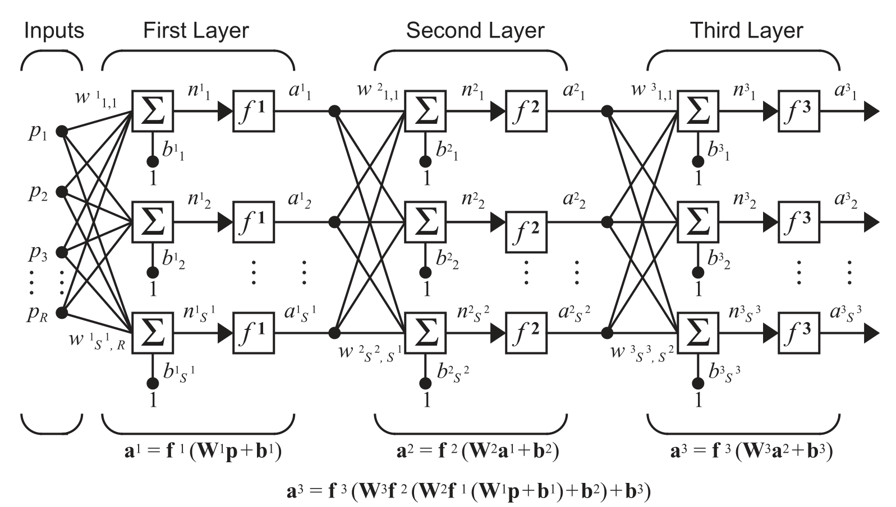

### cp3 An Illustrative Example

Hamming Network

<https://slideplayer.com/slide/4878222/>

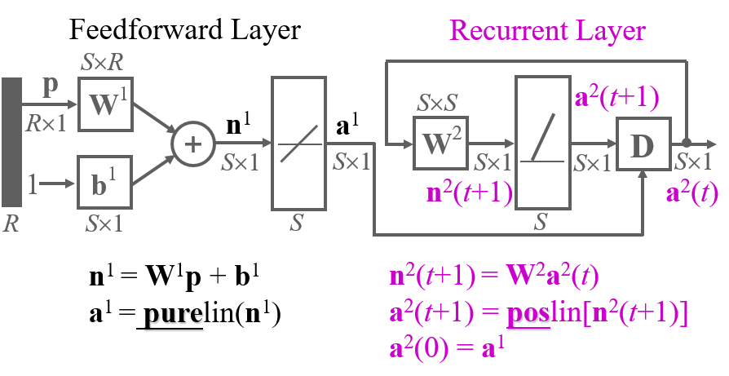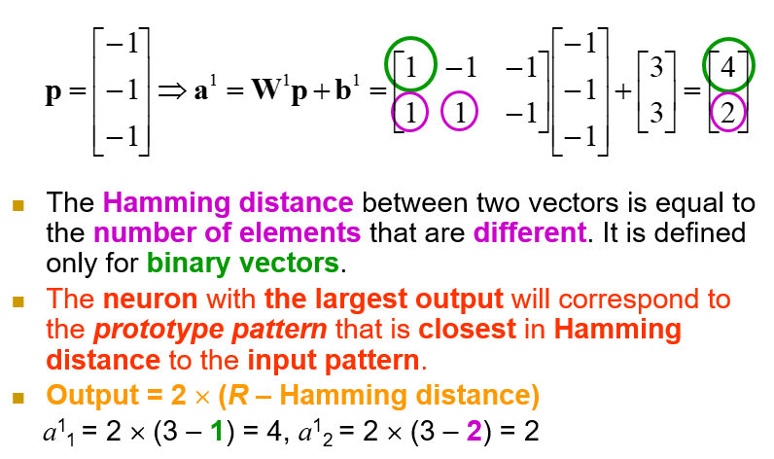

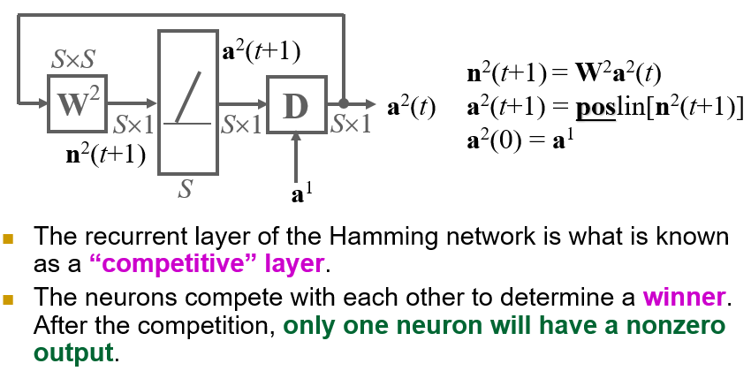

Hopfield Network

<https://www.slideserve.com/quon-barnes/hopfield-neural-network-hnn>

### cp4 perceptron learning rule

根据e调整decision boundary，不断向p方向（e=1）or p的反方向（e=-1）移动直到将p正确分类（e=0）

问题：找到的decision boundary 很有可能不是最优的。

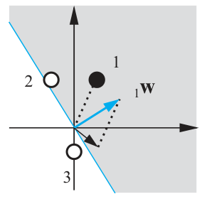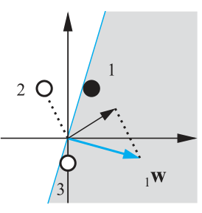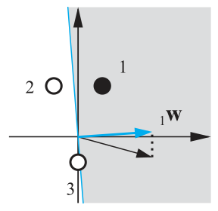

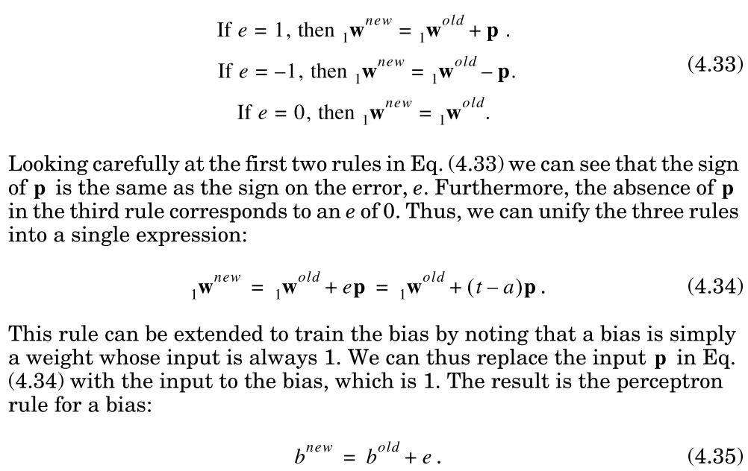

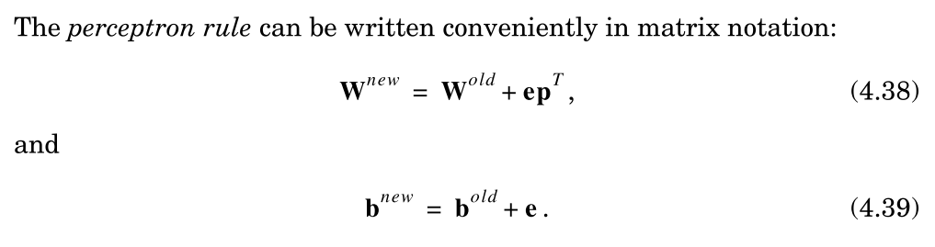

convergence proof？？？？？

### CP5 Signal and Weight vactor space

Reciprocal Basis Vectors？？？？

### CP6 Linear Transformations for Neural Network

linear：变换后再加和加后再变换是一样的，放缩后变换和变换后放缩是一样的

矩阵乘法为什么代表线性变换：

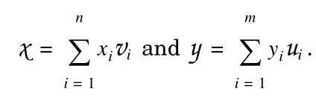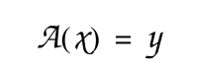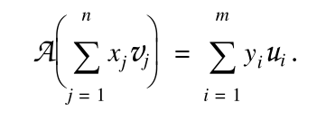

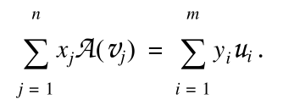 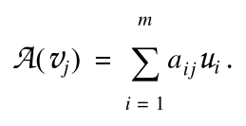 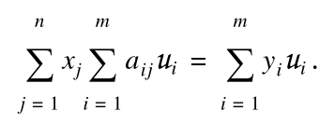 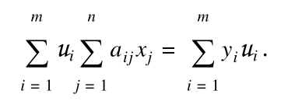 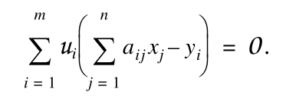 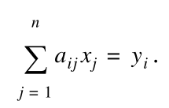

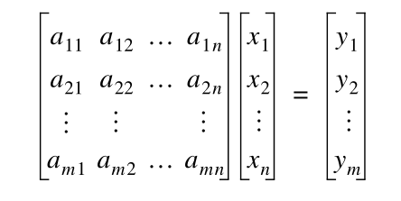

基变换：

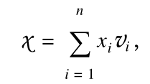 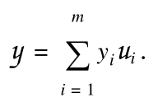 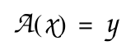 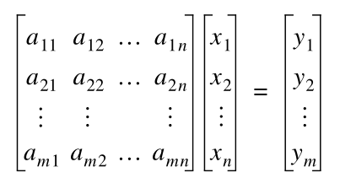

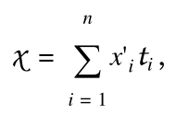 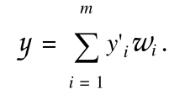 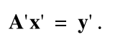 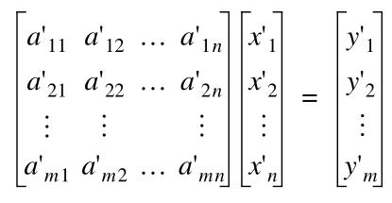

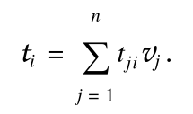 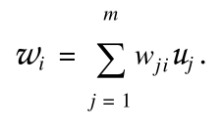 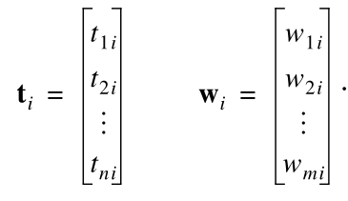

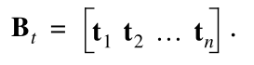 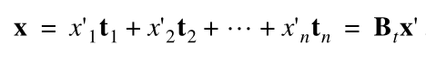

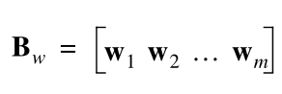 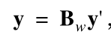

两组基之间的关系：

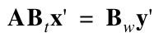 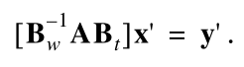 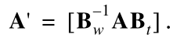

## Tensorflow

#### 简单模型

输入为（样本数，row，column）

model = tf.keras.Sequential([

tf.keras.layers.Flatten(input_shape = (28,28)),

tf.keras.layers.Dense(512,activation = tf.nn.relu),

tf.keras.layers.Dropout(0.2),

tf.keras.layers.Dense(10,activation = tf.nn.softmax)

])

model.compile(optimizer='adam',loss = 'sparse_categorical_crossentropy',

metrics =['accuracy'] )

model.fit(x_train,y_train,epochs= 5)

model.evaluate(x_test,y_test)

#### 预测

predictions = model.predict(test_images)

predictions[1]

np.argmax(predictions[1])

# 单一图片预测

img = (np.expand_dims(test_images[1],0))

np.argmax(model.predict(img))

#### 3.划分数据

train_dataset = dataset.sample(frac=.8,random_state=0)

test_dataset = dataset.drop(train_dataset.index)

#### 4.onehot

origin = dataset.pop('Origin')

#将Origin onehot编码

dataset['USA'] = (origin == 1)*1.0

dataset['Europe'] = (origin == 2)*1.0

dataset['Japan'] = (origin == 3) * 1.0

#### 5.standard scala

train_stats = train_dataset.describe()

train_stats = train_stats.transpose()

def norm(x):

return (x - train_stats['mean']) / train_stats['std']

normed_train_data = norm(train_dataset)

normed_test_data = norm(test_dataset)

#### 6.NN Regression

model = keras.Sequential([  
    layers.Dense(64, activation=tf.nn.relu, input_shape=[len(train_dataset.keys())]),  
    layers.Dense(64, activation=tf.nn.relu),  
    layers.Dense(1)  
  ])  
  
optimizer = tf.keras.optimizers.RMSprop(0.001)  
  
model.compile(loss='mean_squared_error',  
                optimizer=optimizer,  
                metrics=['mean_absolute_error', 'mean_squared_error'])

early_stop = keras.callbacks.EarlyStopping(monitor='val_loss', patience=10)

history = model.fit(  
  normed_train_data, train_labels,  
  epochs=EPOCHS, validation_split = 0.2, verbose=0,  
  callbacks=[early_stop])

test_predictions = model.predict(normed_test_data).flatten()

#### Save and restore models

#一边训练，一边保存模型

checkpoint_path = "training_1/cp.ckpt"  
checkpoint_dir = os.path.dirname(checkpoint_path)  
  
# Create checkpoint callback  
cp_callback = tf.keras.callbacks.ModelCheckpoint(checkpoint_path,   
                                                 save_weights_only=True,  
                                                 verbose=1)  
  
model = create_model()  
  
model.fit(train_images, train_labels,  epochs = 10,   
          validation_data = (test_images,test_labels),  
          callbacks = [cp_callback])  # pass callback to training  
#载入训练好的weight

model = create_model()

model.load_weights(checkpoint_path)

#训练好的模型 直接存weight

model.save_weights('my_checkpoint')

model = create_model()

model.load_weights('my_checkpoint')

model.evaluate(test_images,test_labels)

#保存整个模型

model = create_model()

model.fit(train_images,train_labels,epochs = 5)

model.save('my_model.h5')

new_model = keras.models.load_model('my_model.h5')

new_model.summary()

## blibli tensorflow

#### 第二章． Tensorflow的基础使用，包括对图(graphs),会话(session),张量(tensor),变量(Variable)的一些解释和操作。

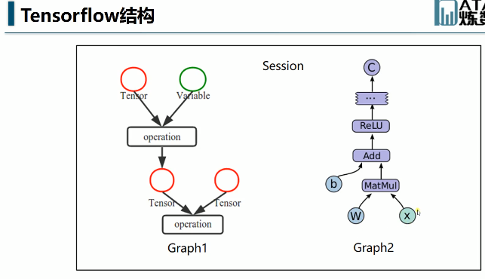

#### 第四章：

Activation function 准则：差值越大，梯度越大，调整越迅速。

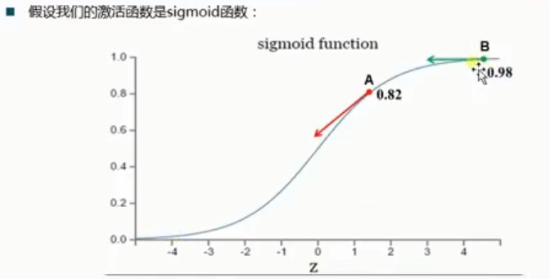

交叉熵：梯度与导数无关，只与label与预测值之差成正比。

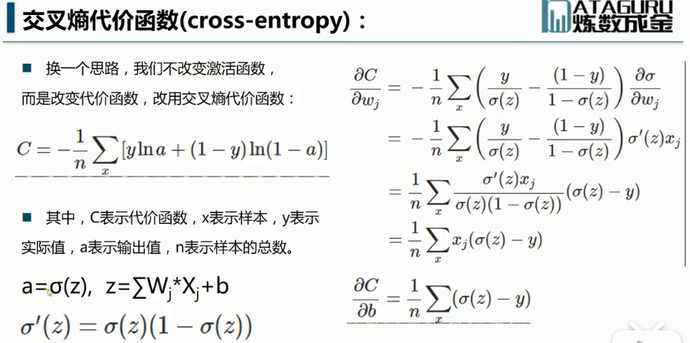

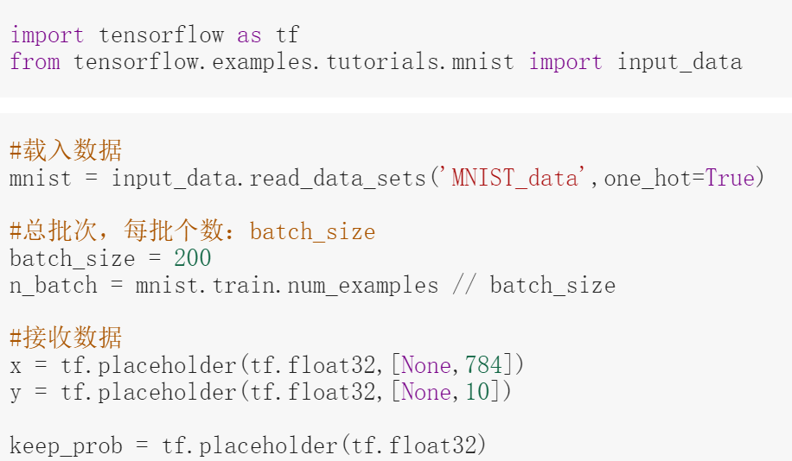

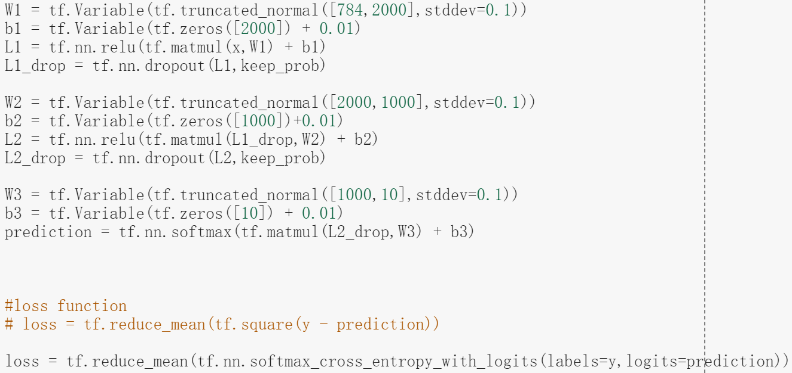

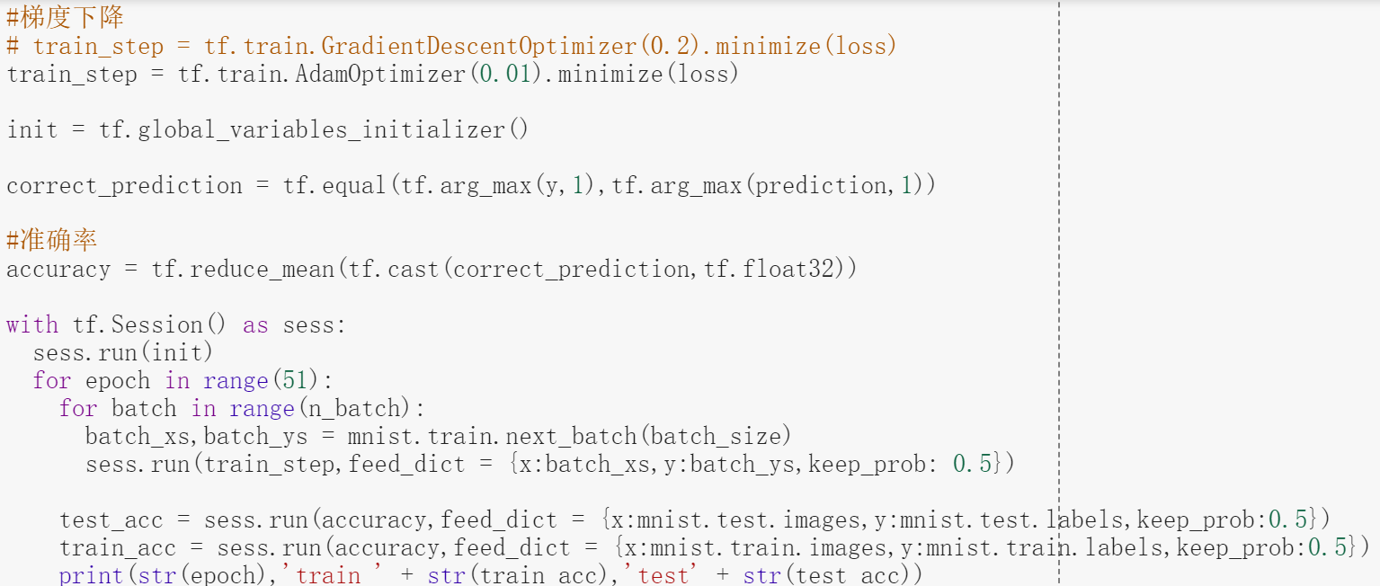

## 机器学习

### K-means

划分类的方法：

聚类中心的选择方法：means，medoids

两者对比<https://blog.csdn.net/databatman/article/details/50445561>

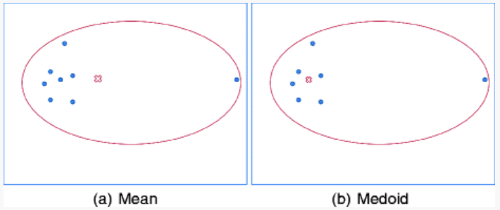

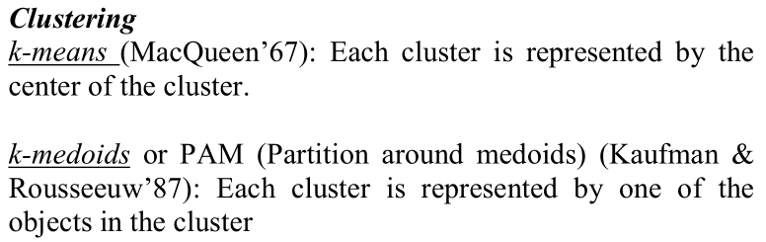

K-Medoids (also called as Partitioning Around Medoid)

<https://www.geeksforgeeks.org/ml-k-medoids-clustering-with-example/>

<https://www.cnblogs.com/king-lps/p/7775108.html>

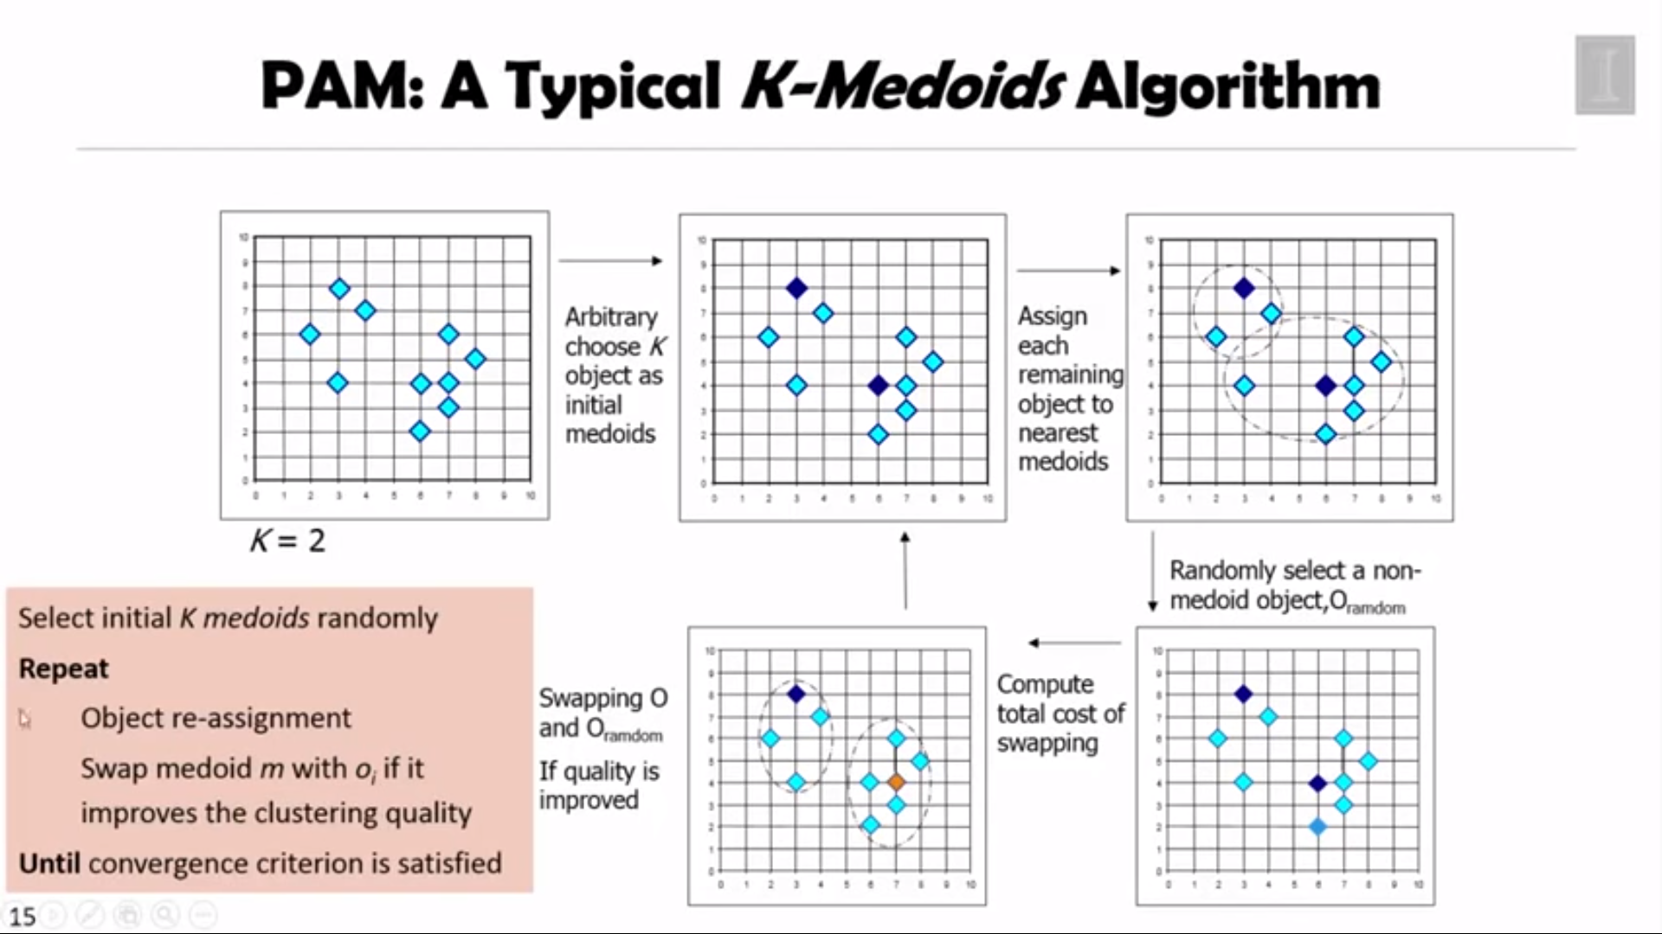

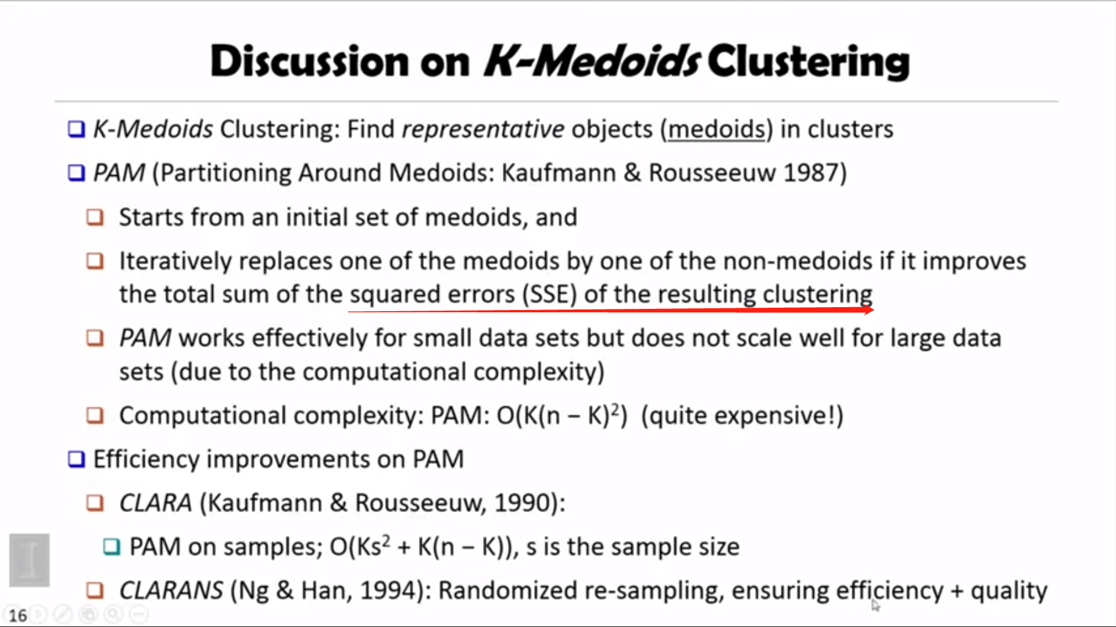

Dissimilarity Measure 相异度测量

<https://www.cnblogs.com/pphy1884/p/4593805.html>

# Opencv-python

视频：

<https://www.bilibili.com/video/av24998616?from=search&seid=6540990465922332173>

<https://github.com/Betterming/opencv_exercises>

<https://www.youtube.com/watch?v=V1aMDD5583k&list=PLS1QulWo1RIa7D1O6skqDQ-JZ1GGHKK-K&index=6>

## 阈值处理函数：

<https://blog.csdn.net/on2way/article/details/46812121>

cv2.THRESH_BINARY  
cv2.THRESH_BINARY_INV  
cv2.THRESH_TRUNC  
cv2.THRESH_TOZERO  
cv2.THRESH_TOZERO_INV

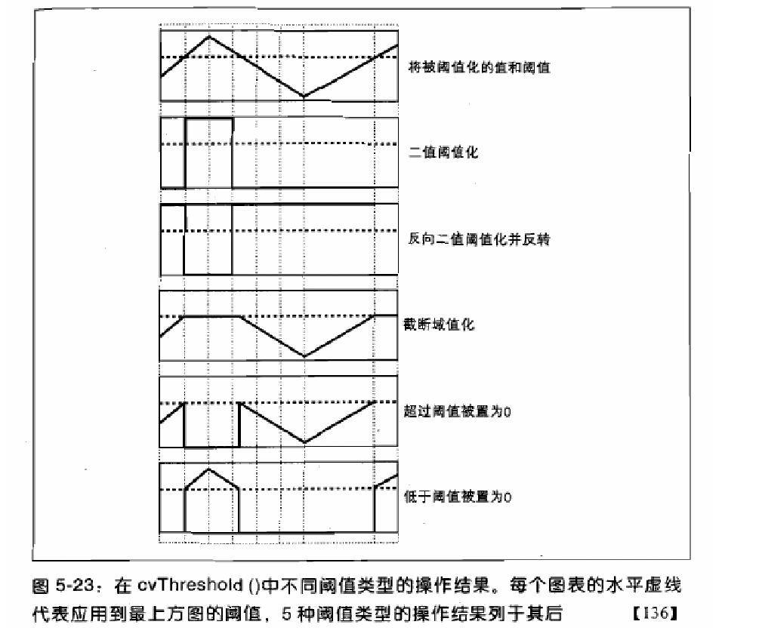

## 椒盐噪点

<https://zh.wikipedia.org/wiki/%E6%A4%92%E7%9B%90%E5%99%AA%E5%A3%B0>

## 中值滤波器

一点的输出值可以用这点的某个大小的邻域内（窗window）的所有值的统计中值（窗内数据个数为奇数）来代替。

## 常用滤波技术

均值滤波，中值滤波，高斯滤波（标准差越大图像越糊），双边滤波

<https://www.jianshu.com/p/451c52a74ddb>

<https://blog.csdn.net/on2way/article/details/46828567>

双边滤波：<https://blog.csdn.net/Jfuck/article/details/8932978>  
自适应阈值大津法

<https://blog.csdn.net/sinat_21258931/article/details/61418681>

## 图像变换

<https://blog.csdn.net/on2way/article/details/46801063>

尺寸变换：<https://blog.csdn.net/JNingWei/article/details/78218837>

旋转：<https://blog.csdn.net/TOM_00001/article/details/62054572>

平移，旋转，错切，放缩：<https://blog.csdn.net/Jarlen/article/details/44877961>

# Object detection 论文

## RCNN

<https://www.analyticsvidhya.com/blog/2018/06/understanding-building-object-detection-model-python/>

### Selective search

<http://jermmy.xyz/2017/05/04/2017-5-4-paper-notes-selective-search/>

### NMS

non maximum suppression 非极大抑制

<https://blog.csdn.net/shuzfan/article/details/52711706>

<https://medium.com/@chih.sheng.huang821/%E6%A9%9F%E5%99%A8-%E6%B7%B1%E5%BA%A6%E5%AD%B8%E7%BF%92-%E7%89%A9%E4%BB%B6%E5%81%B5%E6%B8%AC-non-maximum-suppression-nms-aa70c45adffa>

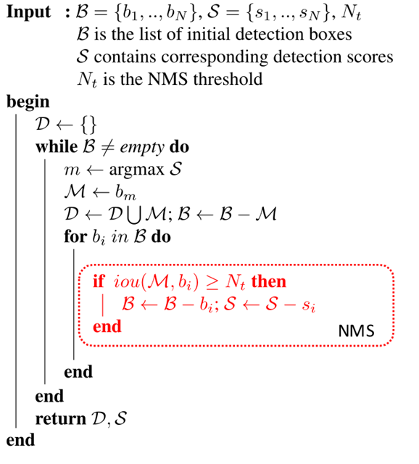

### IoU

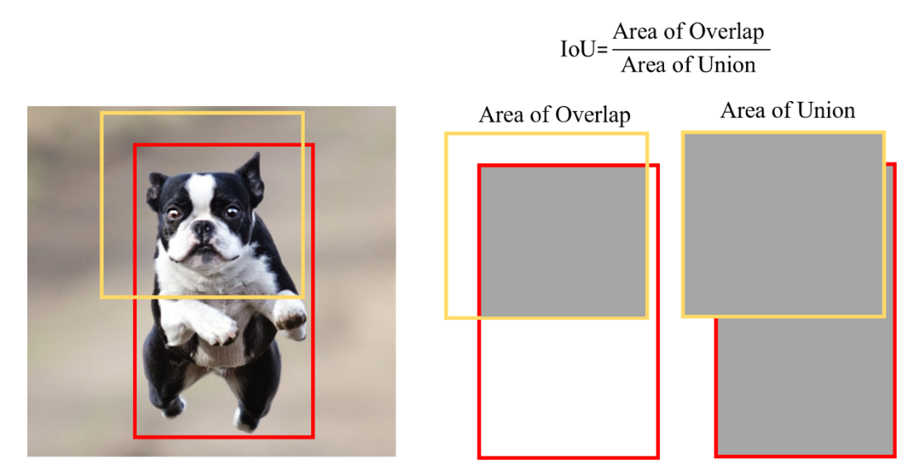

### Bounding Box Regression

<https://blog.csdn.net/zijin0802034/article/details/77685438>



### Summary

<https://www.cnblogs.com/hellocwh/p/8431802.html>

1. We first take a pre-trained convolutional neural network.
2. Then, this model is retrained. We train the last layer of the network based on the number of classes that need to be detected.
3. The third step is to get the Region of Interest for each image. We then reshape all these regions so that they can match the CNN input size.
4. After getting the regions, we train SVM to classify objects and background. For each class, we train one binary SVM.
5. Finally, we train a linear regression model to generate tighter bounding boxes for each identified object in the image.

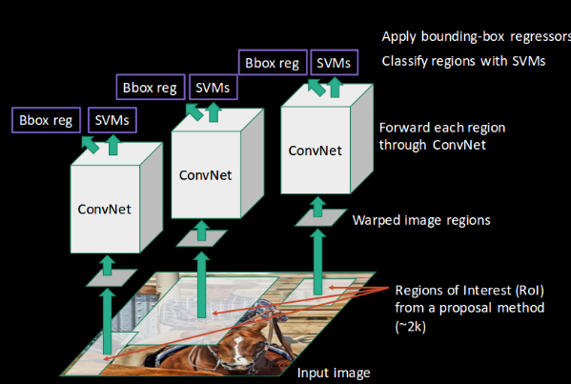

## FAST RCNN

<https://blog.csdn.net/shenxiaolu1984/article/details/51036677>

多个Ground truth 与 多个region proposal 是如何对应的？

计算单个RoI 与 每个GT的IoU，高分者为学习目标。

### Spatial Pyramid Pooling

* <https://oidiotlin.com/sppnet-tutorial/> [oidiotlin@gmail.com](mailto:oidiotlin@gmail.com)
* <https://blog.csdn.net/u011534057/article/details/51219959>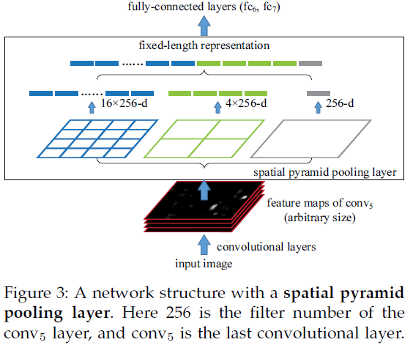

最后进行softmax和bbox regression 的 FC是一个proposal 还是全部的proposal？

### RoI pooling

<https://www.cnblogs.com/wangyong/p/8523814.html>

<https://deepsense.ai/region-of-interest-pooling-explained/>

### summary

<https://blog.csdn.net/shenxiaolu1984/article/details/51036677>

<http://shartoo.github.io/RCNN-series/>

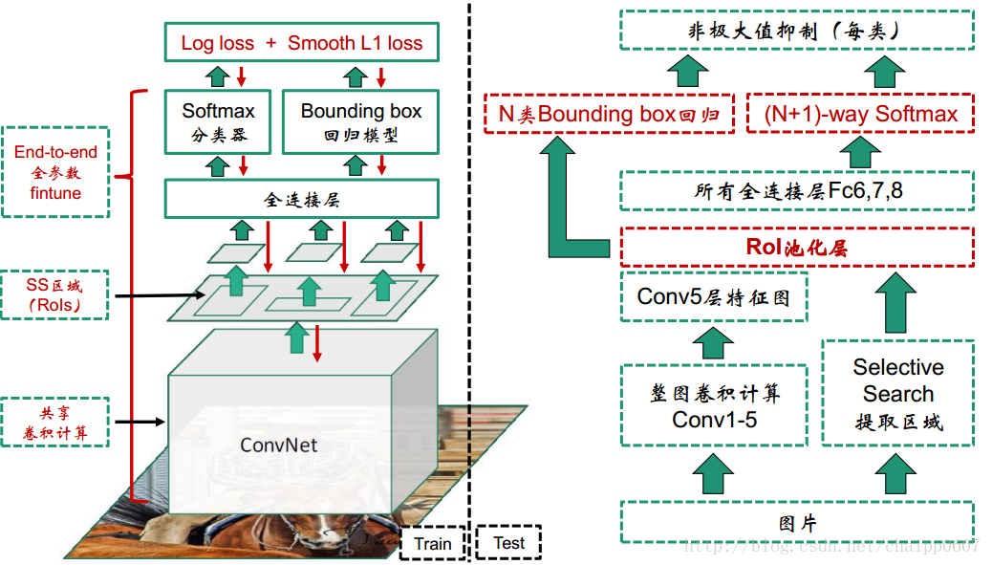

### 如何用固定参数数量的网络接收不同尺寸的输入？

<https://www.zhihu.com/question/56688854>

**Spatial Pyramid Pooling**，RoIpooling，RigPooling。

## FASTER RCNN

<https://www.zybuluo.com/rianusr/note/1315377>

<https://blog.csdn.net/shenxiaolu1984/article/details/51152614>



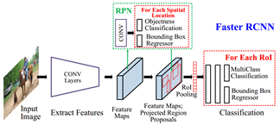

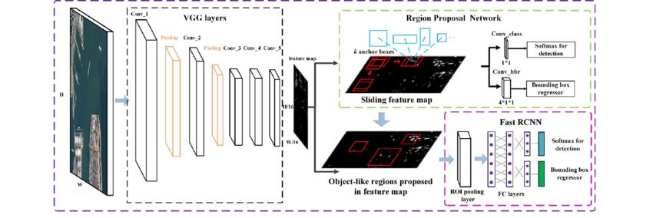

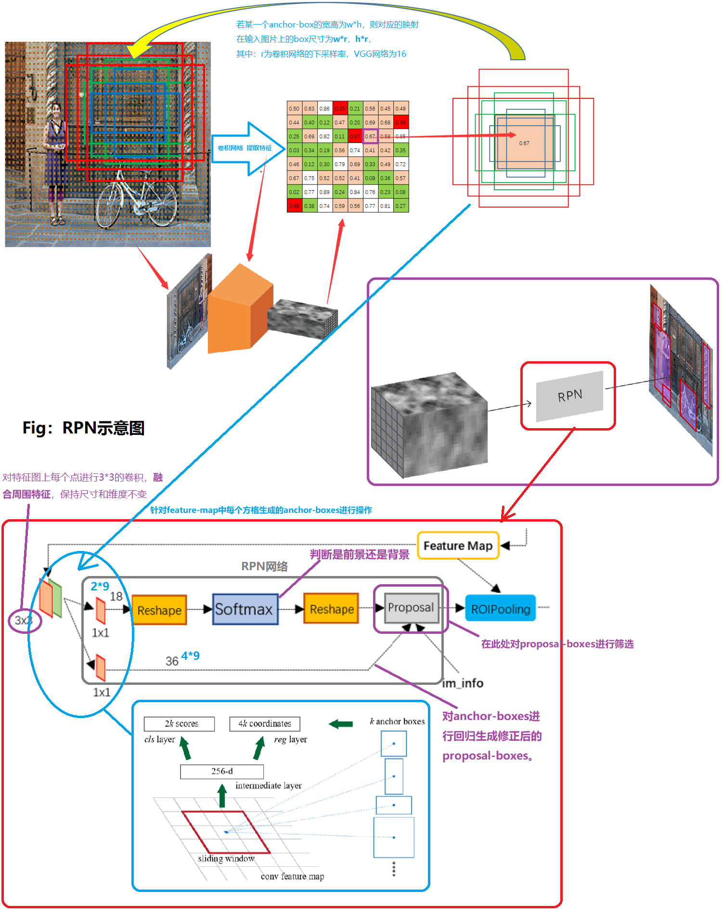

### RPN

在 feature map 上进行操作

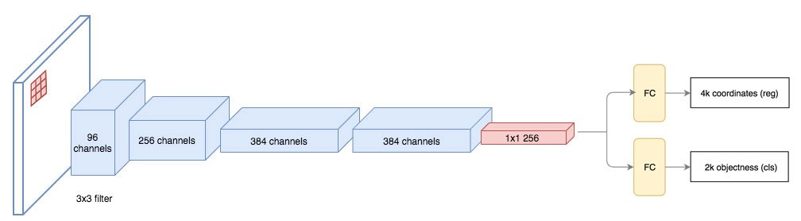

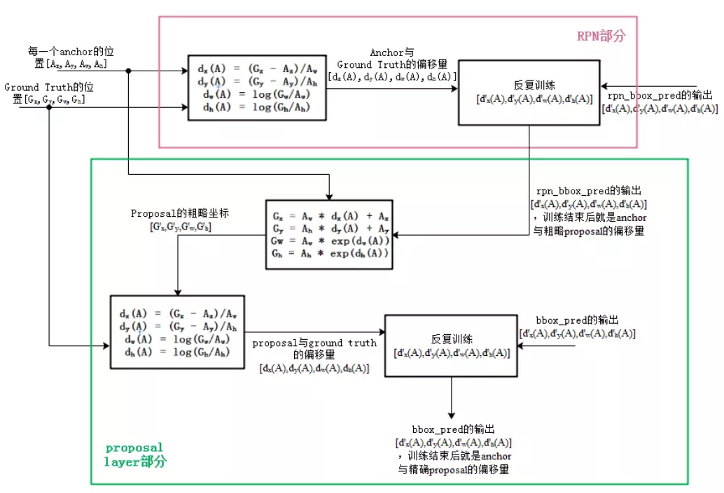

## http://img.wandouip.com/crawler/article/2019215/433ecf1ee8bec300abdb03223889917dMASK RCNN

<http://befree2008.github.io/archives/>

## YOLO v1

<https://www.zybuluo.com/rianusr/note/1417734>



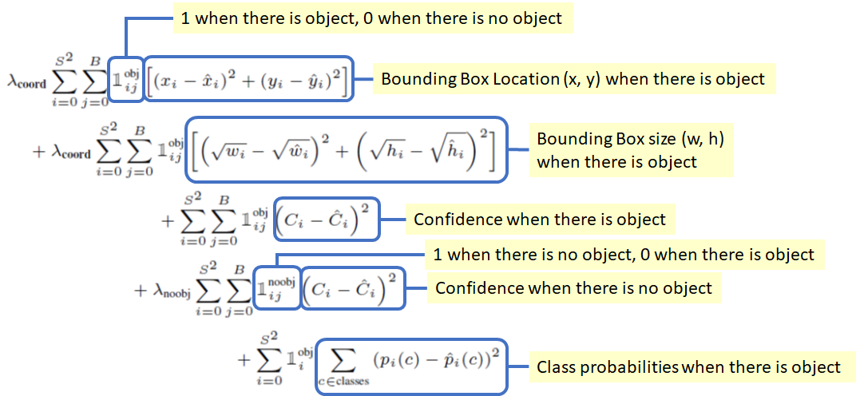

## SSD

<https://docs.google.com/presentation/d/1rtfeV_VmdGdZD5ObVVpPDPIODSDxKnFSU0bsN_rgZXc/pub?start=false&loop=false&delayms=3000&slide=id.g1781416dc6_0_5449>

<https://blog.csdn.net/qianqing13579/article/details/82106664>

<https://arleyzhang.github.io/articles/786f1ca3/>

### pyramidal feature hierarchy

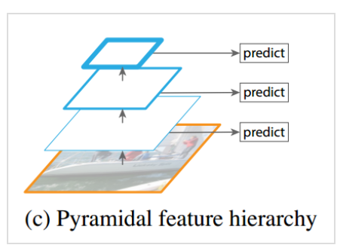

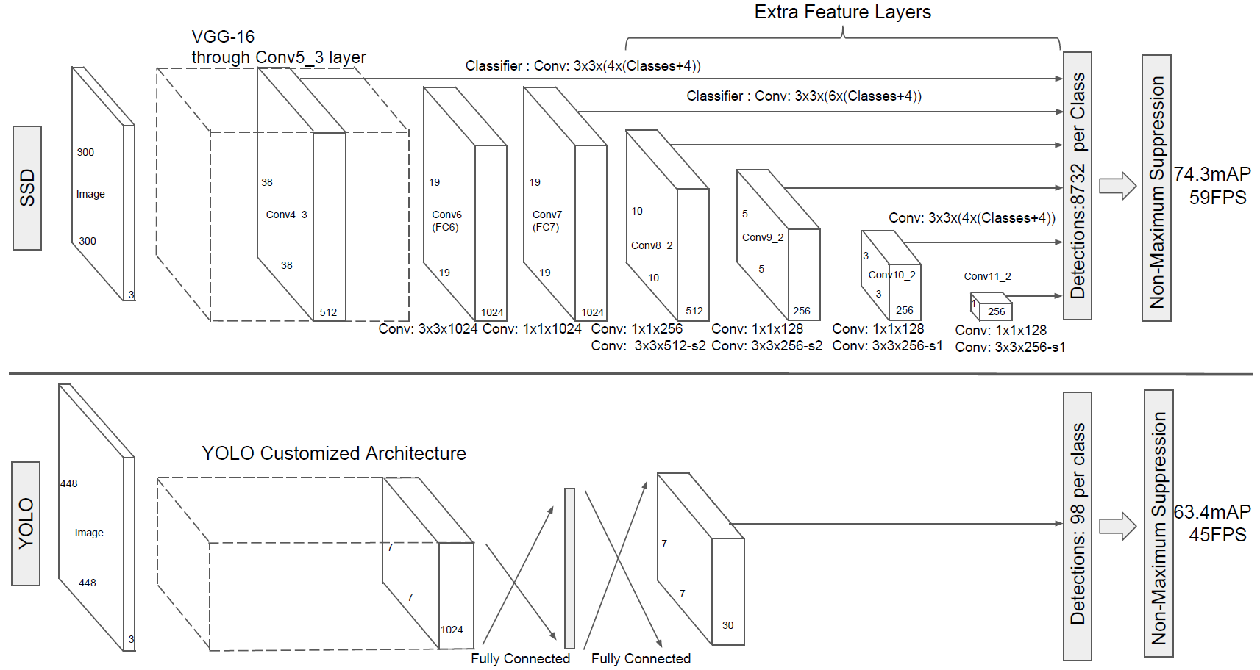



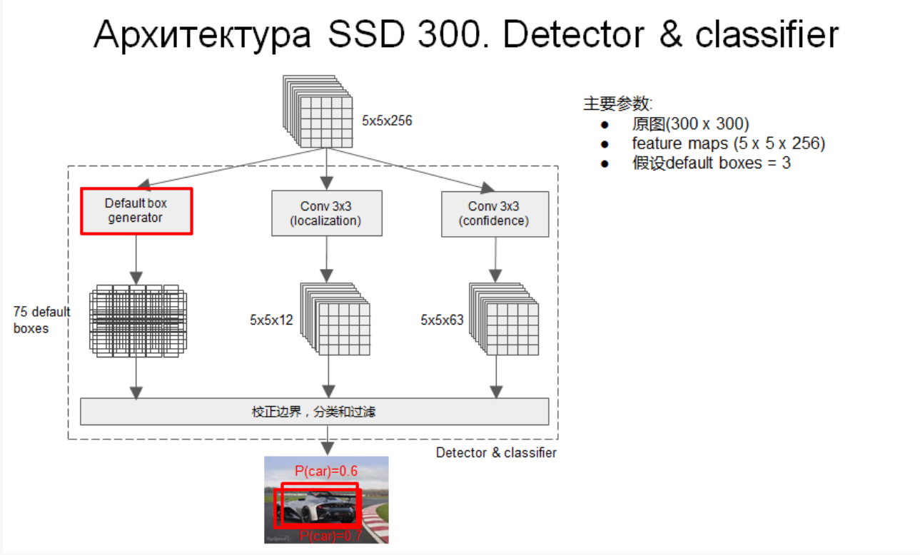

## R-FCN

<https://arleyzhang.github.io/articles/7e6bc4a/>

<https://www.jianshu.com/p/409fd61db9db>

<https://www.cnblogs.com/lillylin/p/6277094.html>

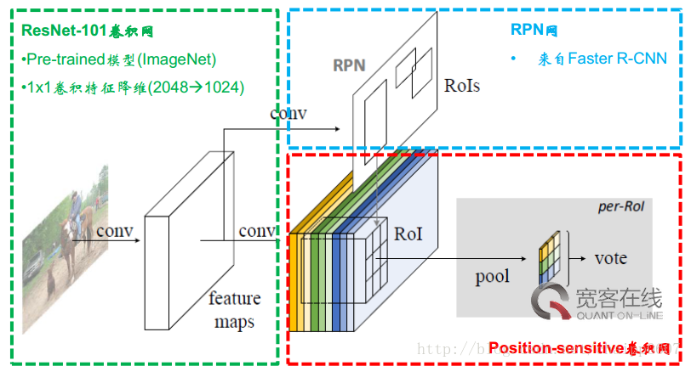

### Position sensitive ROI Pooling

K： ROI pooling filter size KxK pooling后feature mapKxK

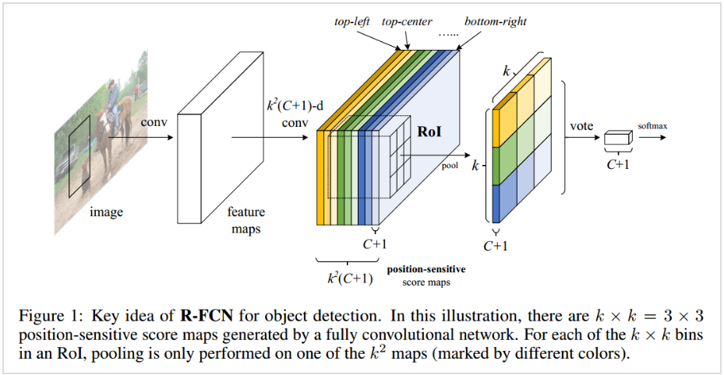

每个c+1 channel RoI pooling 后取对应的块

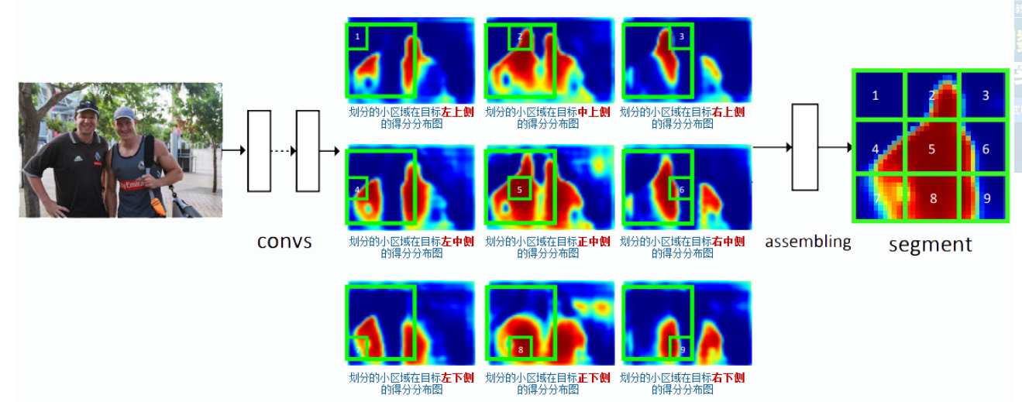

## YOLOv2

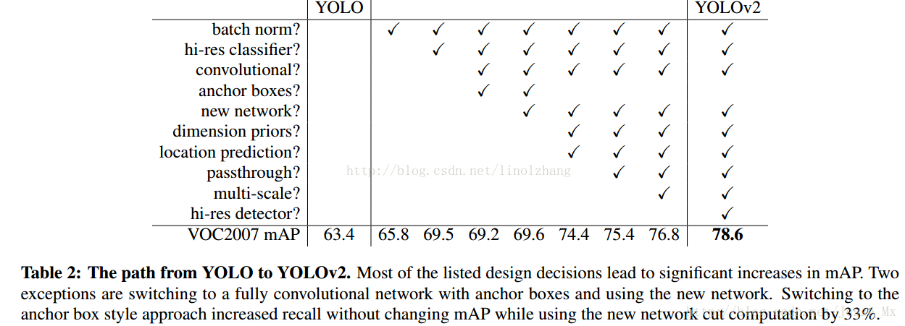

<https://blog.csdn.net/m0_37192554/article/details/81102716>

<https://blog.csdn.net/leviopku/article/details/82588959>

<http://shartoo.github.io/yolo-v123/>

## FPN

提取特征的一种方式

<https://zhangting2020.github.io/2018/05/06/FPN/>

<https://nicehuster.github.io/2018/04/11/FPN/>

<https://medium.com/@jonathan_hui/understanding-feature-pyramid-networks-for-object-detection-fpn-45b227b9106c>

### top-down

上层进行2倍upsample 平行层1x1卷积 然后对应各pixel相加融合 最后3x3卷积产生feature map {P2，P3，P4，P5}

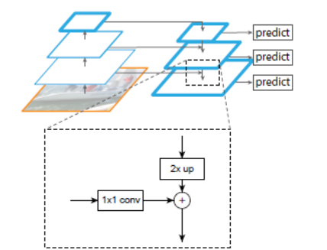

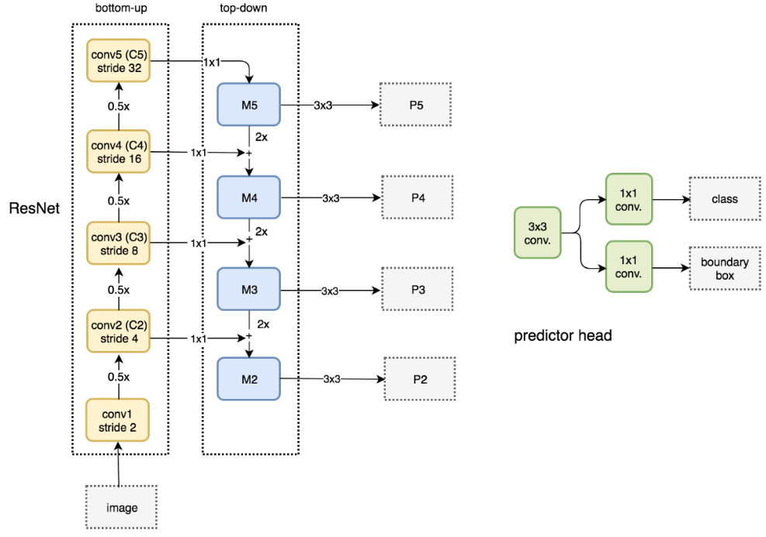  
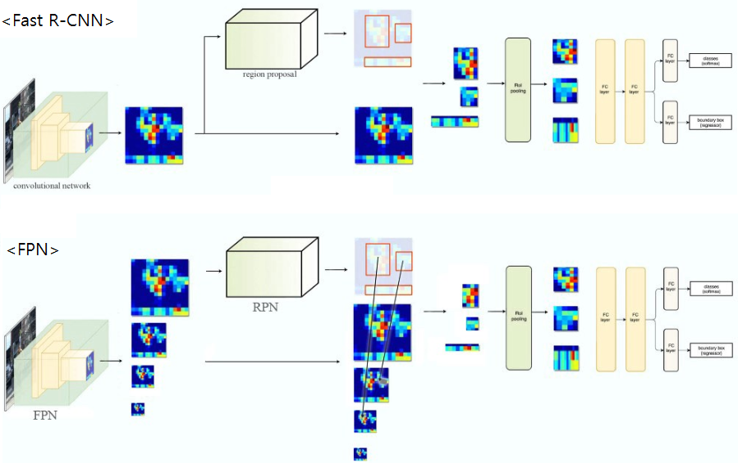

## Retina net

<https://medium.com/@14prakash/the-intuition-behind-retinanet-eb636755607d>

<http://www.treeney.com/2019/04/23/focal-loss-retinanet/>

<https://blog.csdn.net/JNingWei/article/details/80038594>

### Focal loss

解决 object box 和 noobject box 的分类不平衡问题

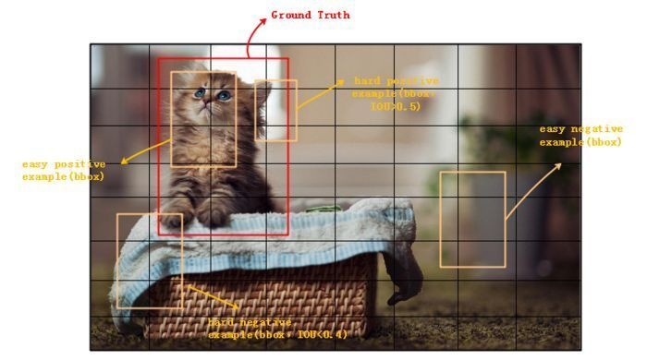

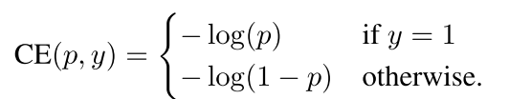

Balanced CE：

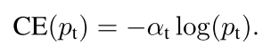

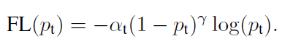

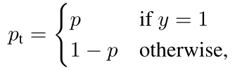

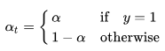

Focal loss add very less weight to well classified examples and large weight to miss-classified or hard classified examples.

### retina网络结构？？？？

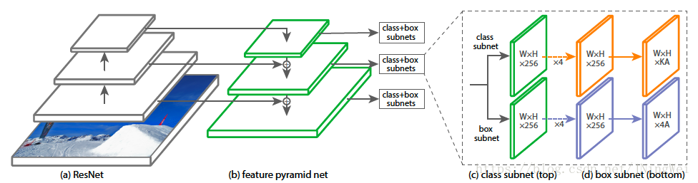

## 如何解决过量background而引起的类别不平衡？？？？

## Mask rcnn

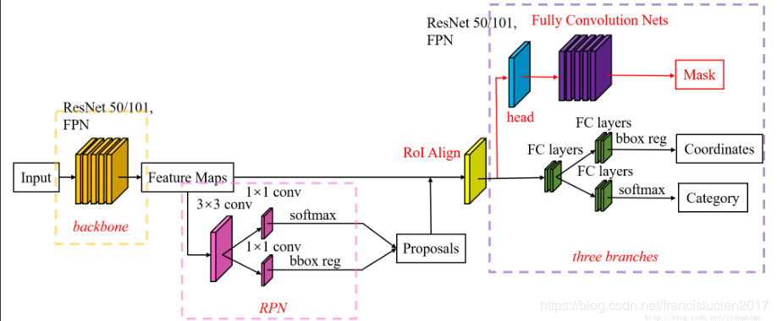

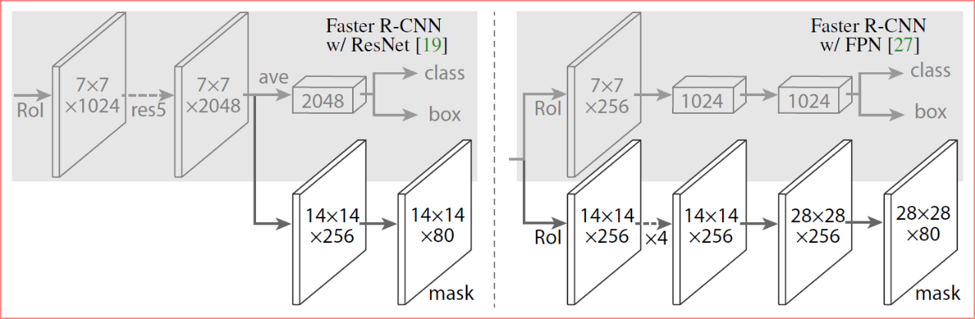

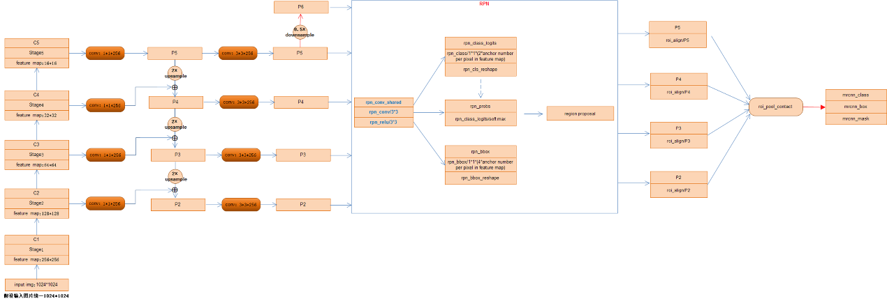

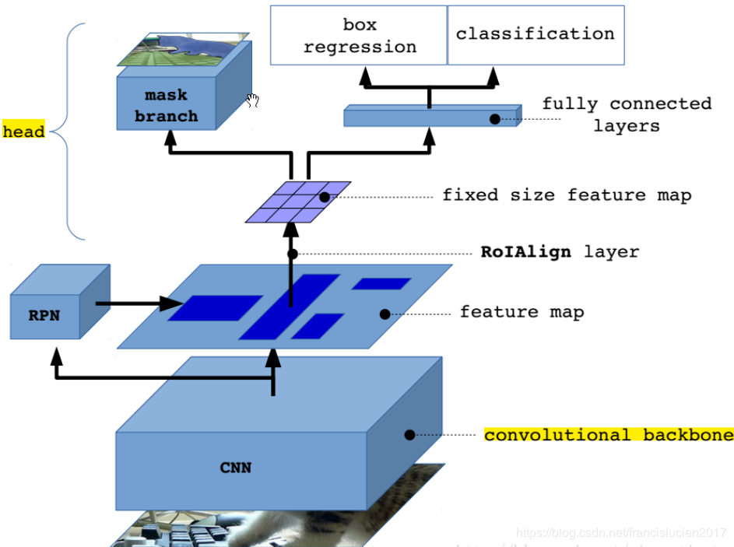

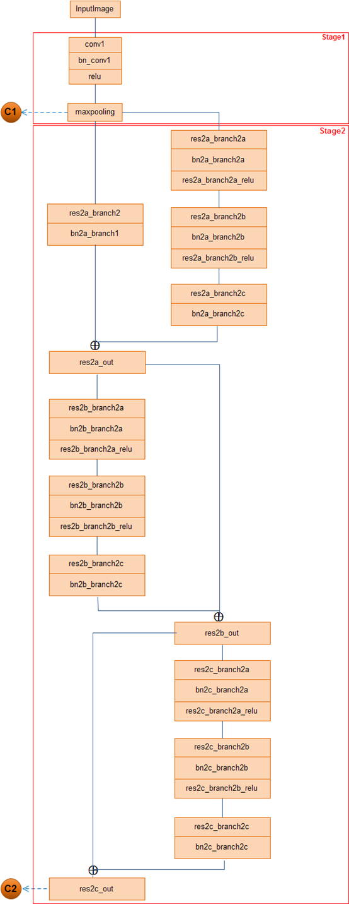

### ROI Align计算细节？？？

<https://blog.csdn.net/qq_14845119/article/details/86378389>

<https://mc.ai/mask-r-cnn-unmasked/>

不进行2次quantized 操作 对于每个RoI进行划分为M*N个bin，每个bin分4块，每块中心pixel 按最靠近4点pixel双线性插值计算得出，最后对bin中4块做max pooling

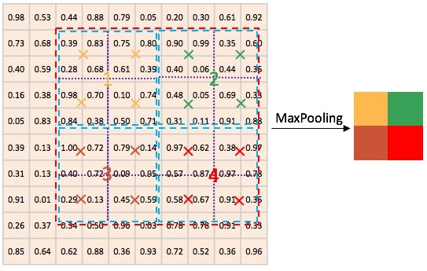

### Mask branch

## YOLOv3

<https://towardsdatascience.com/yolo-v3-object-detection-53fb7d3bfe6b>

<https://blog.csdn.net/leviopku/article/details/82660381>

<https://zhuanlan.zhihu.com/p/49556105>

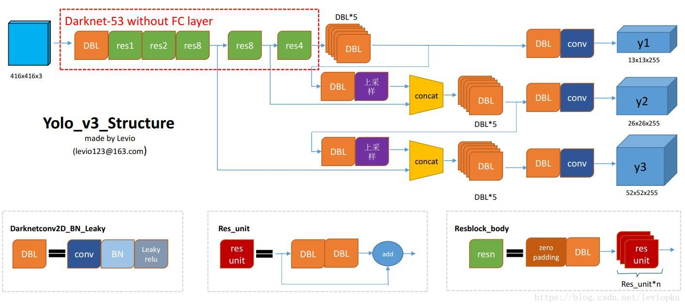

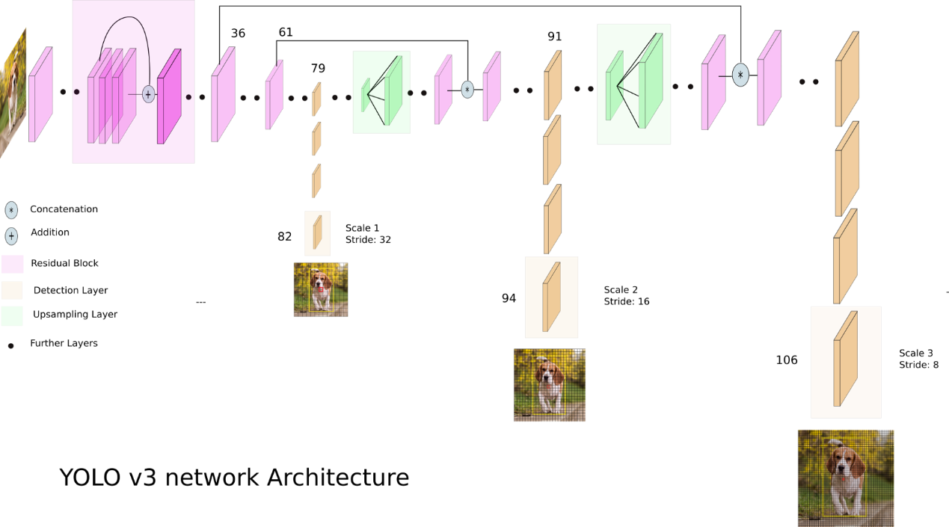

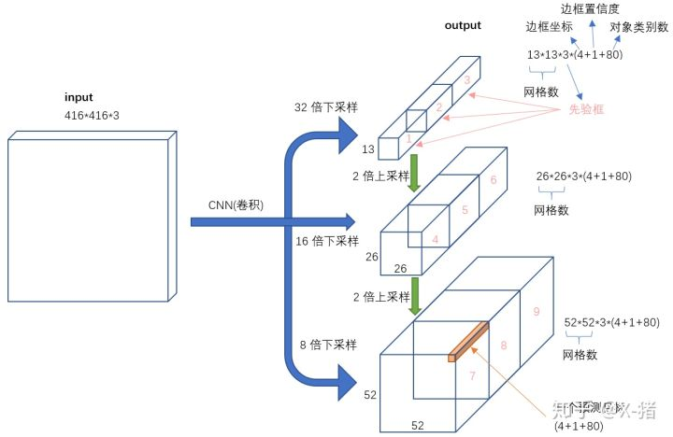

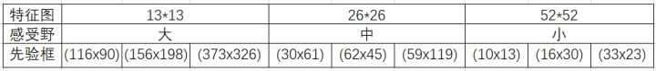

## Refinedet

<https://www.cnblogs.com/hellcat/p/10357220.html>

<https://blog.csdn.net/u014380165/article/details/79502308>

<http://www.baiyifan.cn/2019/03/10/RefineDet/>

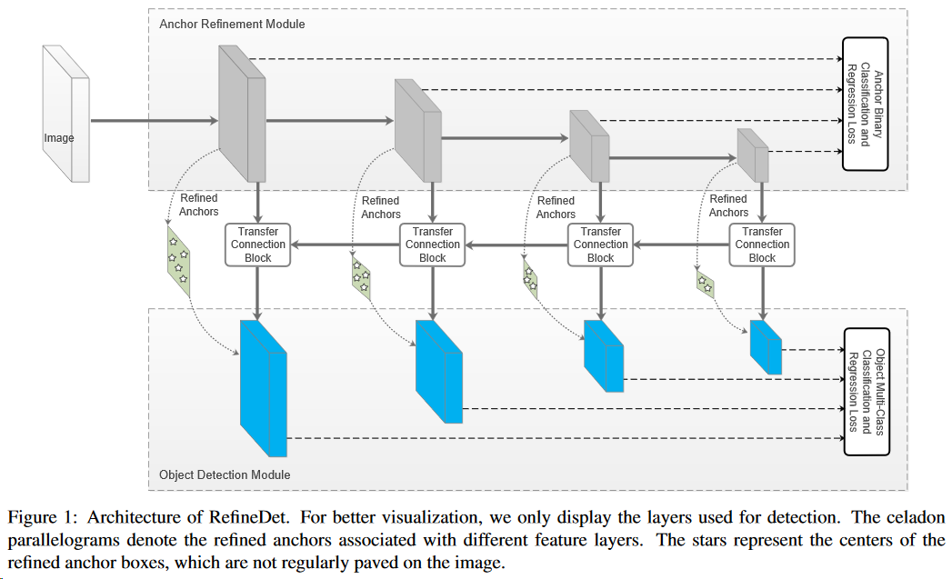

# Keras

## 快速上手

### 框架：

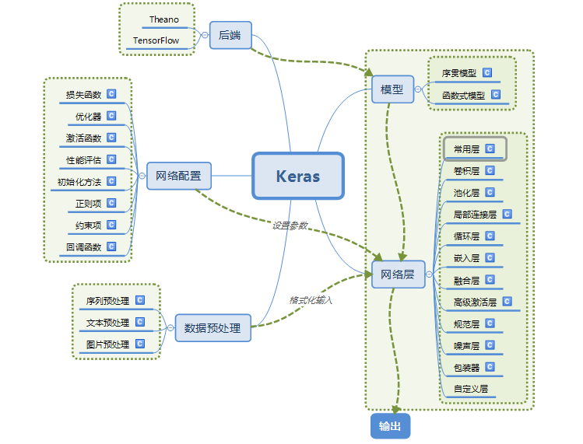

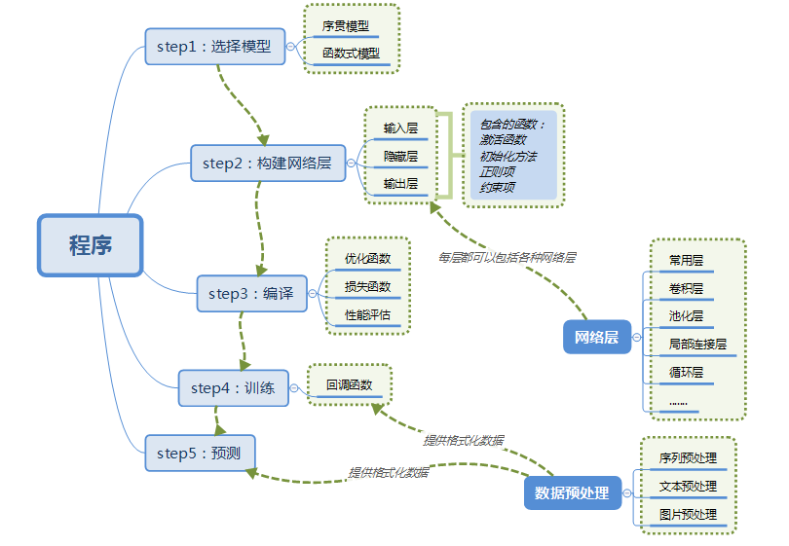

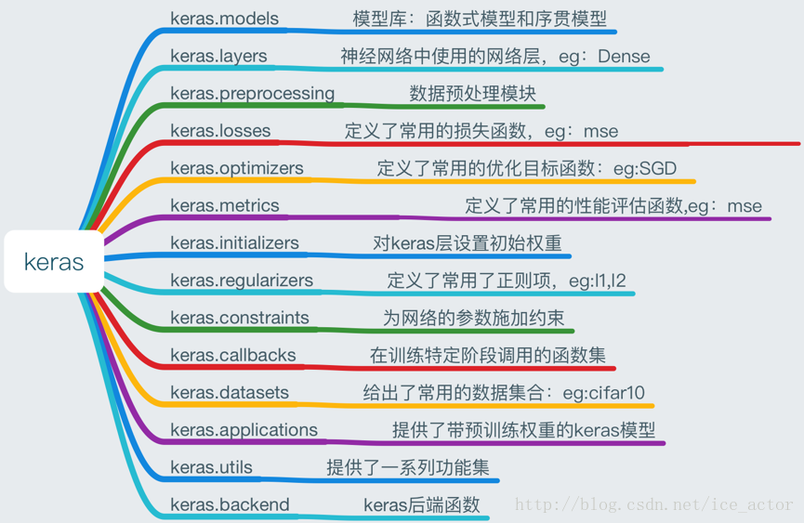

## 评估标准matrics

#评估标准 metrics ['accuracy']

多分类：categorical_crossentropy

二分类: binary_crossentropy

回归：mse

*# 自定义评估标准函数*

**import** keras.backend **as** K

**def** **mean_pred**(y_true, y_pred):

**return** K.mean(y_pred)

model.compile(optimizer='rmsprop',

loss='binary_crossentropy',

metrics=['accuracy', mean_pred])

## 常用层结构

<https://zxth93.github.io/2017/09/02/Keras%E5%AD%A6%E4%B9%A0%E7%AC%94%E8%AE%B0III-%E7%BD%91%E7%BB%9C%E5%B1%82/>

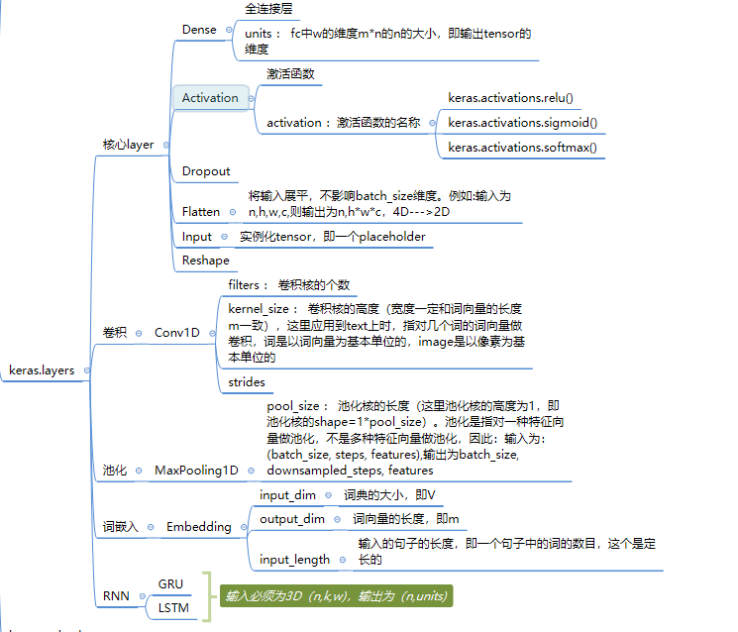

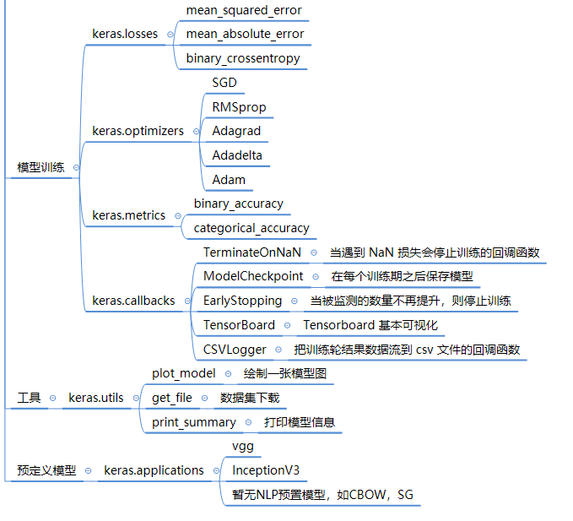

## 函数式编程

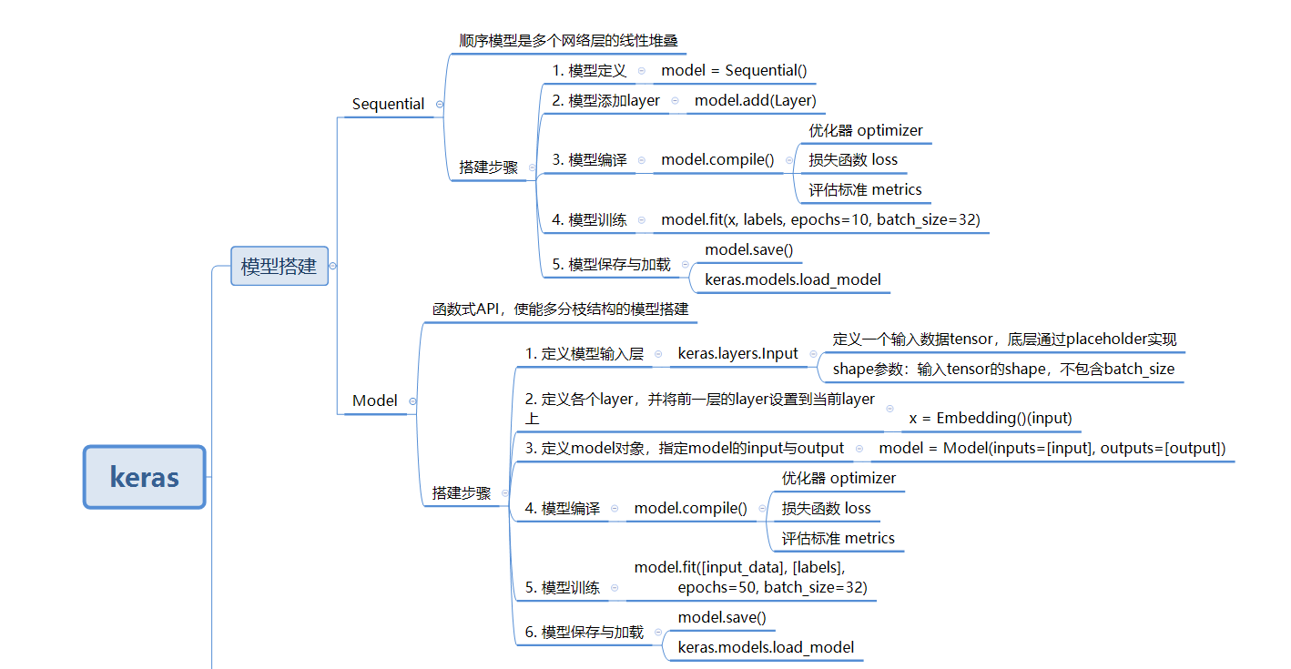

#多层连接

x = keras.layers.concatenate([lstm_out,auxiliary_input])

#多输入，输出

model=Model(inputs = [main_input,auxiliary_input],outputs = [main_output,auxiliary_output])

### 共享网络层？？？

<https://keras.io/zh/getting-started/functional-api-guide/>

## 常见问题解答：

<https://keras.io/zh/getting-started/faq/>

* [如何引用 Keras?](https://keras.io/zh/getting-started/faq/#how-should-i-cite-keras)
* [如何在 GPU 上运行 Keras?](https://keras.io/zh/getting-started/faq/#how-can-i-run-keras-on-gpu)
* [如何在多 GPU 上运行 Keras 模型？](https://keras.io/zh/getting-started/faq/#how-can-i-run-a-keras-model-on-multiple-gpus)
* ["sample", "batch", "epoch" 分别是什么？](https://keras.io/zh/getting-started/faq/#what-does-sample-batch-epoch-mean)
* [如何保存 Keras 模型？](https://keras.io/zh/getting-started/faq/#how-can-i-save-a-keras-model)
* [为什么训练集误差比测试集的误差高很多？](https://keras.io/zh/getting-started/faq/#why-is-the-training-loss-much-higher-than-the-testing-loss)
* [如何获取中间层的输出？](https://keras.io/zh/getting-started/faq/#how-can-i-obtain-the-output-of-an-intermediate-layer)
* [如何用 Keras 处理超过内存的数据集？](https://keras.io/zh/getting-started/faq/#how-can-i-use-keras-with-datasets-that-dont-fit-in-memory)
* [在验证集的误差不再下降时，如何中断训练？](https://keras.io/zh/getting-started/faq/#how-can-i-interrupt-training-when-the-validation-loss-isnt-decreasing-anymore)
* [验证集划分是如何计算的？](https://keras.io/zh/getting-started/faq/#how-is-the-validation-split-computed)
* [在训练过程中数据是否会混洗？](https://keras.io/zh/getting-started/faq/#is-the-data-shuffled-during-training)
* [如何在每个 epoch 后记录训练集和验证集的误差和准确率？](https://keras.io/zh/getting-started/faq/#how-can-i-record-the-training-validation-loss-accuracy-at-each-epoch)
* [如何「冻结」网络层？](https://keras.io/zh/getting-started/faq/#how-can-i-freeze-keras-layers)
* [如何使用状态 RNNs (stateful RNNs)?](https://keras.io/zh/getting-started/faq/#how-can-i-use-stateful-rnns)
* [如何从 Sequential 模型中移除一个层？](https://keras.io/zh/getting-started/faq/#how-can-i-remove-a-layer-from-a-sequential-model)
* [如何在 Keras 中使用预训练的模型？](https://keras.io/zh/getting-started/faq/#how-can-i-use-pre-trained-models-in-keras)
* [如何在 Keras 中使用 HDF5 输入？](https://keras.io/zh/getting-started/faq/#how-can-i-use-hdf5-inputs-with-keras)
* [Keras 配置文件保存在哪里？](https://keras.io/zh/getting-started/faq/#where-is-the-keras-configuration-file-stored)
* [如何在 Keras 开发过程中获取可复现的结果？](https://keras.io/zh/getting-started/faq/#how-can-i-obtain-reproducible-results-using-keras-during-development)
* [如何在 Keras 中安装 HDF5 或 h5py 来保存我的模型？](https://keras.io/zh/getting-started/faq/#how-can-i-install-HDF5-or-h5py-to-save-my-models-in-Keras)

## Sequential 模型方法

<https://keras.io/zh/models/sequential/>

|  |  |  |
| --- | --- | --- |
| compile | fit | evaluate |
| predict | Train_on_batch | Test_on_batch |
| Predict_on_batch | Fit_generator | Evaluate_generator |
| Predict_generator | Get_layer |  |

## Model类模型方法

<https://keras.io/zh/models/model/>

## layers

### 核心层

<https://keras.io/zh/layers/core/>

|  |  |  |
| --- | --- | --- |
| Dense | Activation | Dropout |
| Flatten | Input | Reshape |
| Permute | RepeatVector | Lambda |
| ActivityRegularization | Masking | SpatialDropout1D |
| SpatialDropout2D | SpatialDropout3D |  |

### 卷积层

<https://keras.io/zh/layers/convolutional/>

|  |  |  |
| --- | --- | --- |
| Conv1D | Conv2D | SeparableConv1D |
| SeparableConv2D | DepthwiseConv2D | Conv2Dtranspose |
| Conv3D | Conv3DTranspose | Cropping1D |
| Cropping2D | Cropping3D | UpSampling1D |
| UpSampling2D | UpSampling3D | ZeroPadding1D |
| ZeroPadding2D | ZeroPadding3D |  |

### 池化层

<https://keras.io/zh/layers/pooling/>

|  |  |  |
| --- | --- | --- |
| MaxingPooling1D | MaxingPooling2D | MaxingPooling3D |
| AveragePooling1D | AveragePooling2D | AveragePooling3D |
| GlobalMaxPooling1D | GlobalMaxPooling2D | GlobalMaxPooling3D |
| GlobalAveragePooling1D | GlobalAveragePooling2D | GlobalAveragePooling3D |

### 局部连接层

<https://keras.io/zh/layers/local/>

|  |  |  |
| --- | --- | --- |
| LocallyConnetctd1D | LocallyConnetctd2D |  |

### 循环层recurrent

<https://keras.io/zh/layers/recurrent/>

**cuDNN**（CUDA Deep Neural Network library）：是NVIDIA打造的针对深度神经网络的加速库，是一个用于深层神经网络的GPU加速库。

|  |  |  |
| --- | --- | --- |
| RNN | SimpleRNN | GRU |
| LSTM | ConvLSTM2D | SimpleRNNCell |
| GRUCell | LSTMCell | CuDNNGRU |
| CuDNNLSTM |  |  |

### 嵌入层Embedding

<https://keras.io/zh/layers/embeddings/>

### 运算

<https://keras.io/zh/layers/merge/>

|  |  |  |
| --- | --- | --- |
| Add | Subtract | Multiply |
| Average | Maximum | Convcatenate |
| Dot |  |  |

### 高级激活层 Advanced Activations

<https://keras.io/zh/layers/advanced-activations/>

|  |  |  |
| --- | --- | --- |
| LeakyReLU | PReLU | ELU |
| ThresholdedReLU | Softmax | ReLU |

### BatchNormalization

<https://keras.io/zh/layers/normalization/>

### 噪声层Noise

<https://keras.io/zh/layers/noise/>

高斯噪声是指噪声数据服从高斯分布。一般图像处理都是用高斯噪声过滤器进行过滤，而此处加入噪声是为了防止过拟合现象。

|  |  |  |
| --- | --- | --- |
| GaussianNoise | GaussianDropout | AlphaDropout |

### 层封装器wrappers

<https://keras.io/zh/layers/wrappers/>

|  |  |  |
| --- | --- | --- |
| TimeDistributed | Bidirectional |  |

## 数据预处理

### 时间序列

<https://keras.io/zh/preprocessing/sequence/>

|  |  |  |
| --- | --- | --- |
| TimeseriesGenerator | pad_sequences | skipgrams |
| Make_sampling_table |  |  |

### 文本

<https://keras.io/zh/preprocessing/text/>

keras.preprocessing.text.

|  |  |  |
| --- | --- | --- |
| tokenizer | hashing_trick | one_hot |
| text_to_word_sequence |  |  |

### 图像

<https://keras.io/zh/preprocessing/image/>

keras.preprocessing.image.

|  |  |  |
| --- | --- | --- |
| ImageDataGenerator | .apply_transform | .fit |
| .flow | .flow_from_dataframe | .flow_from_directory |
| .get_random_transform | .random_transform | .standardize |
|  |  |  |

## loss

<https://keras.io/zh/losses/>

model.compile(loss = ‘ ’)

|  |  |  |
| --- | --- | --- |
| mean_squared_error | mean_absolute_error | mean_absolute_percentage_error |
| mean_squared_logarithmic_error | squared_hinge | hinge |
| categorical_hinge | logcosh | categorical_crossentropy |
| sparse_categorical_crossentropy | binary_crossentropy | kullback_leibler_divergence |
| poisson | cosine_proximity |  |

## Metrics

<https://keras.io/zh/metrics/>

model.compile(metrics = [‘’])

|  |  |  |
| --- | --- | --- |
| binary_accuracy | categorical_accuracy | sparse_categorical_accuracy |
| top_k_categorical_accuracy | 自定义 |  |

## optimizer

<https://keras.io/zh/optimizers/>

keras.optimizer.

model.compile(optimizer = )

|  |  |  |
| --- | --- | --- |
| SGD | RMSprop | Adagrad |
| Adadelta | Adam | Adamax |
| Nadam |  |  |

## activation

<https://keras.io/zh/activations/>

Dense(activation = ‘’)

|  |  |  |
| --- | --- | --- |
| softmax | elu | selu |
| softplus | softsign | relu |
| tanh | sigmoid | hard_sigmoid |
| exponential | linear |  |

## callbacks

<https://keras.io/zh/callbacks/>

keras.callbacks.

|  |  |  |
| --- | --- | --- |
| Callback | BaseLogger | TerminateIOnNaN |
| ProgbarLogger | History | ModelCheckpoint |
| EarlyStopping | RemoteMonitor | LearningRateScheduler |
| TensorBoard | ReduceLROnPlateau | CSVLogger |
| LambdaCallback | 自定义 |  |

## 常用数据集

<https://keras.io/zh/datasets/>

from keras.datasets import

|  |  |  |
| --- | --- | --- |
| cifar10 | cifar100 | imdb |
| reuters | mnist | fashion_mnist |
| boston_housing |  |  |

## 经典框架 applications

<https://keras.io/zh/applications/>

**from** keras.applications.resnet50 **import** ResNet50

|  |  |  |
| --- | --- | --- |
| Xception | VGG16 | VGG19 |
| ResNet50 | InceptionV3 | InceptionResNetV2 |
| MobileNet | DenseNet | NASNet |
| MobileNetV2 |  |  |

## 后端backend

向量基本运算和向量属性的后台

keras.backend.

<https://keras.io/zh/backend/>

|  |  |  |
| --- | --- | --- |
| epsilon | set_epsilon | floatx |
| set_floatx | cast_to_floatx | image_data_format |
| set_image_data_format | rest_uids | get_uid |
| clear_session | manual_variable_initialization | learning_phase |
| set_learning_phase | is_sparse | to_dense |
| variable | constant | is_keras_tensor |
| is_tensor | placeholder | is_placeholder |
| shape | int_shape | ndim |
| dtype | eval | zeros |
| ones | eye | zeros_like |
| ones_like | identity | random_uniform_variable |
| random_normal_variable | count_params | cast |
| update | update_add | update_sub |
| moving_average_update | dot | batch_dot |
| transpose | gather | max |
| min | sum | prod |
| cumsum | cumpord | var |
| std | mean | any |
| all | argmax | argmin |
| square | abs | sqrt |
| exp | log | logsumexp |
| round | sign | pow |
| clip | equal | not_equal |
| greater | greater_aqual | less |
| less_equal | maximum | minimun |
| sin | cos | normalize_batch_in_training |
| batch_normalization | concatenate | reshape |
| permute_dimensions | resize_images | resize_volumes |
| repeat_elements | repeat | arange |
| tile | flatten | batch_flatten |
| expand_dims | squeeze | temporal_padding |
| spatial_2d_padding | spatial_3d_padding | stack |
| ont_hot | reverse | slice |
| get_value | batch_get_value | set_value |
| batch_set_value | print_tensor | function |
| gradients | stop_gradient | rnn |
| switch | in_train_phase | in_test_phase |
| relu | elu | softmax |
| softplus | softsign | categorical_crossentropy |
| sparse_categorical_crossentropy | binary_crossentropy | sigmoid |
| hard_sigmoid | tanh | dropout |
| l2_normalize | in_top_k | conv1d |
| conv2d | separable_conv1d | separable_conv2d |
| depthwise_conv2d | conv3d | conv3d_transpose |
| pool2d | pool3d | bias_add |
| random_normal | random_uniform | random_binomial |
| truncated_normal | ctc_label_dense_to_sparse | ctc_batch_cost |
| ctc_decode | map_fn | foldl |
| foldr | local_conv1d | local_conv2d |
| backend |  |  |

## 参数初始化initializers

<https://keras.io/zh/initializers/>

keras.initializers.

|  |  |  |
| --- | --- | --- |
| Initializer | Zeros | Ones |
| Constant | RandomNormal | RandomUniform |
| TruncatedNormal | VarianceScaling | Orthogonal |
| Idnetity | lecun_uniform | glorot_normal |
| glorot_uniform | he_normal | lecun_normal |
| he_uniform | 自定义 |  |

## 正则化 Regularizers

<https://keras.io/zh/regularizers/>

from keras import regularizers

Dense(kernel_regularizer = ,activity ragularizer = )

## 约束项 constraints

<https://keras.io/zh/constraints/>

keras.constraints.

Dense(kernel_constraints = )

|  |  |  |
| --- | --- | --- |
| MaxNorm | NonNeg | UnitNorm |
| MinMaxNorm |  |  |

## 可视化 Visualization

<https://keras.io/zh/visualization/>

keras.utils.

## Scikit-Learn API 封装器

<https://keras.io/zh/scikit-learn-api/>

## 工具

<https://keras.io/zh/utils/>

keras.utils.

|  |  |  |
| --- | --- | --- |
| CustomObjectScope | HDF5Matrix | Sequence |
| to_categorical | normalizer | get_file |
| print_summary | plot_model | multi_gpu_model |

# PyTorch

## 指导教程

### Geting started

#### 新建torch tensor

torch.

|  |  |  |
| --- | --- | --- |
| empty（） | rand() | zeros() |
| tensor([4,4]) |  |  |

#### 改变已有

x = x.new_ones(4,5,dtype=)

x = torch.randn_like(x,dtype=)

#### 输出size

x.size()

#### tensor reshape

x.view()

#### tensor与numpy的转换 a:tensor b:numpy

b = a.numpy()

a = torch.from_numpy(b)

#### 使用cuda

device = torch.device(‘cuda’)

a.to(device)

b = torch.ones_like(a,device=device)

### 自动微分

开启对x的求导

x = torch.ones(2,2,requires_grad=True) or x.requires_grad = True

y = f(x)

y.backward()

x.grad

y.backward()搞清楚什么时候需要传参数：

<http://www.linzehui.me/2018/09/16/%E7%A2%8E%E7%89%87%E7%9F%A5%E8%AF%86/Pytorch%20backward()%E6%B5%85%E6%9E%90/>

当Y标量则不用传gradient参数，当 $\vec{Y}$ 是矢量传gradient指明对 $\vec{Y}$ 中的哪些标量求导。

### Neural Network

Define the network: 1.structure 2.forward

Loss Function: criterion

Backprop: loss.backword

Update weights: f.data.sub_(), torch.optim

### Training a classifier

更多训练：<https://pytorch.org/tutorials/beginner/blitz/cifar10_tutorial.html#training-an-image-classifier>

变换方式：torchvision.transforms.Compose()

导入设置：torchvision.datasets.CIFAR10()

导入数据:torch.utils.data.DataLoader()

Define a convolutional neural network：__init__,forward

Define a loss function and optimizer： criterion, optimizer

Train the network

Test the network on the test data

### Data parallel 多线GPU

<https://pytorch.org/tutorials/beginner/blitz/data_parallel_tutorial.html>

用gpu：device = torch.device(‘cuda 0’ if torch.cuda.is_avaliable() else ‘cpu’)

GPU数：torch.cuda.device_count()

多线：model = nn.DataParallel(model)

model gpu 驱动：model.to(device)

数据 GPU 驱动：data.to(device)

### csv data loading and processing

<https://pytorch.org/tutorials/beginner/data_loading_tutorial.html>

.reshape(-1,2): every 2 element as a row

Rescaler: short edge in the origin picture eauql desired, using the proportion of long/short

to recover another edge of desired

RandomCrop: random choose top-left coordinate to shape desired photo.

function as enumerate parameter：

**for** i, tsfrm **in** enumerate([scale, crop, composed]):

transformed_sample **=** tsfrm(sample)

with torch.no_grad():

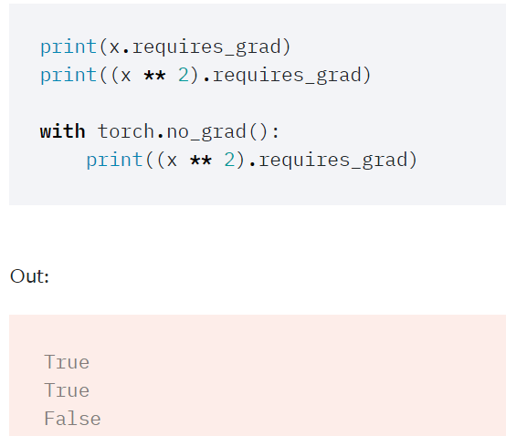

### constructing NN

__init__: building NN structure such as layer，neural number。

forward：forward pass of the model

prepare data ——> model——> criterion ——> loss.backward———>optimizer

### Transfer learning Fine-tune

<https://flyyufelix.github.io/2016/10/03/fine-tuning-in-keras-part1.html>

why: Training a covnet on a small dataset(data less than the number of parameter) greatly affects the covnet’s ability to generalize, often result in overfiting.

when: we have a similar classification problem and our datasets are related to pretrain model datasets.

Fine-tuning Techniques

**To truncate the last layer** (softmax layer) of the per-trained network and replace it with out new sofamax layer that are relevant to our problem

**Use a smaller learning rate** to train the network. Since we think the pre-trained weights to be quite goog already as compared to randomly initialized weight.

**Freezing the weights of the first few layers** of the pre-trained netwark. They are use to capture universal features. we will get the nerwork to focus on learning our datasets specific features in the subsequent layers.

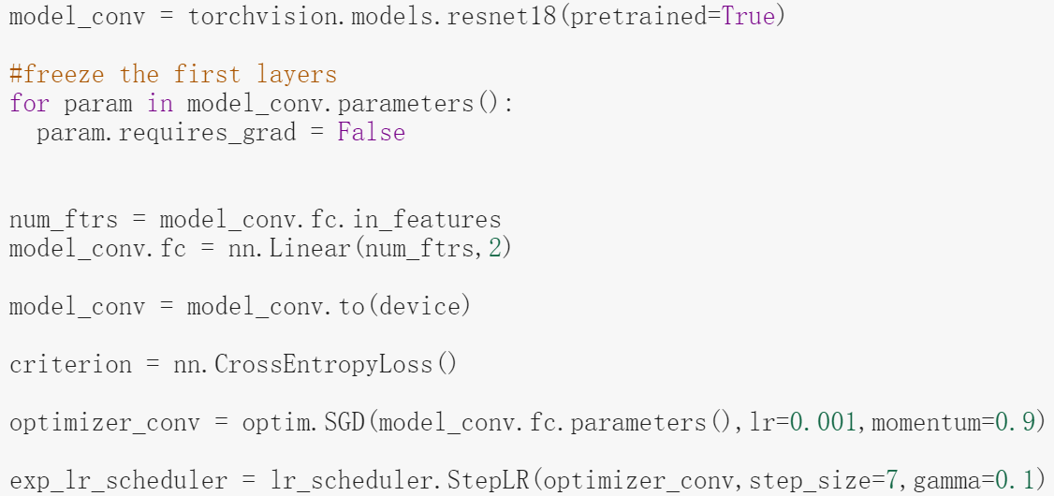

### pytorch TensorBoard

<https://zhuanlan.zhihu.com/p/66748652>

### save and load model

<https://pytorch.org/tutorials/beginner/saving_loading_models.html>

### Using URL load data

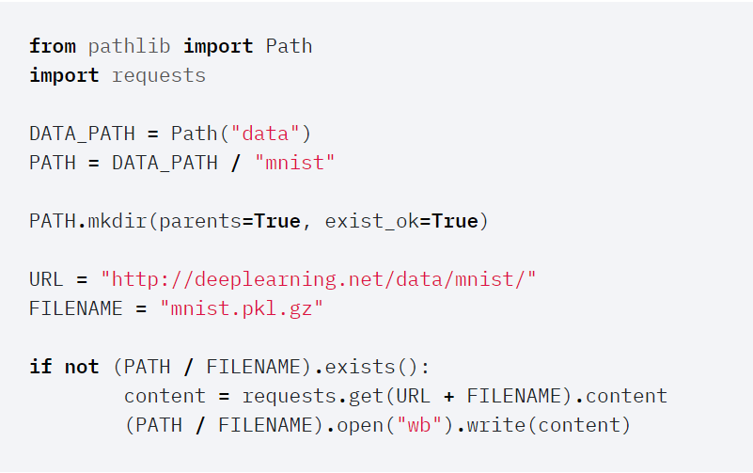

## torch package

### torch

<https://pytorch.org/docs/stable/torch.html>

data structures of tensor and mathematical operation

|  |
| --- |
| torch.tensor(data, dtype=None, device=None, requires_grad=False, pin_memory=False) → Tensor |
| torch.randn(*size, out=None, dtype=None, layout=torch.strided, device=None, requires_grad=False) → Tensor |
| torch.from_numpy(ndarray) → Tensor |
|  |
|  |
|  |
|  |
|  |

### torch attributes

<https://pytorch.org/docs/stable/tensor_attributes.html>

|  |
| --- |
| torch.device('cuda' if torch.cuda.is_available() else 'cpu') |
|  |
|  |
|  |
|  |
|  |

### torch.Tensor

### torch.sparse

### torch.cuda

### torch.Storage

### torch.nn

[https://pytorch.org/docs/stable/nn.html#containers](https://pytorch.org/docs/stable/nn.html" \l "containers)

all component of neural network

|  |
| --- |
| torch.nn.Linear(in_features, out_features, bias=True) |
| torch.nn.MSELoss(size_average=None, reduce=None, reduction='mean') |
| torch.nn.Sequential(*args) |
| torch.nn.Conv2d(in_channels, out_channels, kernel_size, stride=1, padding=0, dilation=1, groups=1, bias=True, padding_mode='zeros') |
| torch.nn.BatchNorm2d(num_features, eps=1e-05, momentum=0.1, affine=True, track_running_stats=True) |
| torch.nn.ReLU(inplace=False) |
| torch.nn.AvgPool2d(kernel_size, stride=None, padding=0, ceil_mode=False, count_include_pad=True, divisor_override=None) |
|  |
|  |
|  |

### torch.nn.functional

### torch.nn.int

### torch.optim

<https://pytorch.org/docs/stable/optim.html>

|  |
| --- |
| torch.optim.SGD(params, lr=<required parameter>, momentum=0, dampening=0, weight_decay=0, nesterov=False) |
|  |
|  |
|  |
|  |

### torch.autograd

### torch.distributed

### totch.distributions

### torch.hub

### torch.jit

### torch.multiprocessing

### torch.random

### torch.utils.bottleneck

### torch.utils.checkpoint

### torch.utils.cpp_extension

### torch.utils.data

<https://pytorch.org/docs/stable/data.html>

|  |
| --- |
| torch.utils.data.DataLoader(dataset, batch_size=1, shuffle=False, sampler=None, batch_sampler=None, num_workers=0, collate_fn=None, pin_memory=False, drop_last=False, timeout=0, worker_init_fn=None, multiprocessing_context=None) |
|  |
|  |
|  |

### torch.utils.dlpack

### torch.utils.model_zoo

### torch.utils.tensorboard

### torch.__config__

## torchvision

<https://pytorch.org/docs/stable/torchvision/index.html>

consist of popular datasets，model architecture，and common image transform for computer vision

### torchvision.datasets

[https://pytorch.org/docs/stable/torchvision/datasets.html#cifar](https://pytorch.org/docs/stable/torchvision/datasets.html" \l "cifar)

|  |
| --- |
| torchvision.datasets.CIFAR10(root, train=True, transform=None, target_transform=None, download=False) |
|  |
|  |
|  |
|  |

### torchvision.io

### torchvision.models

<https://pytorch.org/docs/stable/torchvision/models.html>

|  |
| --- |
| torchvision.models.resnet18(pretrained=False, progress=True, **kwargs) |
|  |
|  |
|  |
|  |

### torchvision.ops

### torchvision.transforms

<https://pytorch.org/docs/stable/torchvision/transforms.html>

|  |
| --- |
| torchvision.transforms.ToTensor |
| torchvision.transforms.Compose(transforms)  <https://pytorch-cn.readthedocs.io/zh/latest/torchvision/torchvision-transform/> |
|  |
|  |
|  |

### torchvision.utils

<https://pytorch.org/docs/stable/torchvision/utils.html>

|  |
| --- |
| torchvision.utils.save_image(tensor, filename, nrow=8, padding=2, normalize=False, range=None, scale_each=False, pad_value=0) |
|  |
|  |
|  |
|  |
|  |

## detach() and torch.no_grad

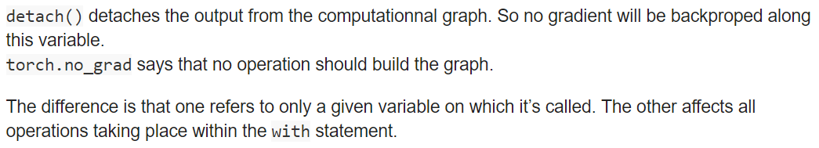

# Python

## os.path()

<https://www.runoob.com/python/python-os-path.html>

## =,copy,deepcopy

a = [1,2,[3,4]]

a = b : a,b是同一个id，a改变b随之改变

b = copy.copy(a) : a,b不同id，a，b外层独立即[1,2,[3,4]]

b = copy.deepcopy(a):a,b不同id，a,b完全独立即[1,2,[3,4]]

## super（class，self）

http://funhacks.net/explore-python/Class/super.html

子类调用父类的同名方法

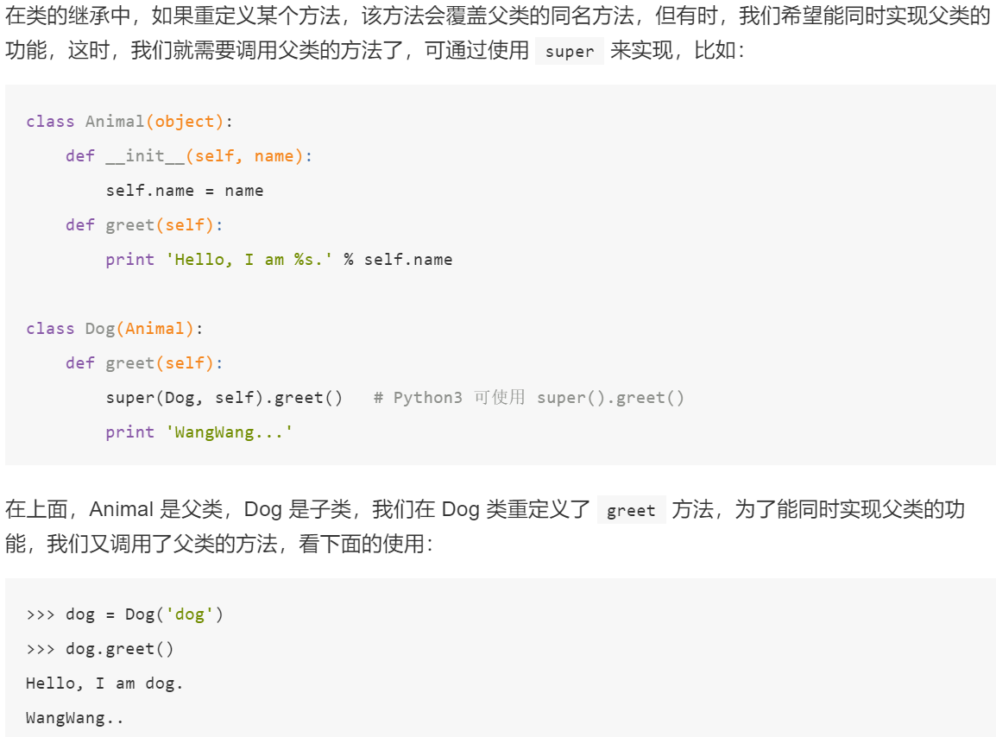

## class self

用self是因为当有多个实例时，需要知道更新哪个实例的属性，于是把实例当做变量传入实例函数。

<https://medium.com/quick-code/understanding-self-in-python-a3704319e5f0>

class SomeClass:  
def __init__(self):  
self.arr = []   
#All SomeClass objects will have an array arr by default  
  
def insert_to_arr(self, value):  
self.arr.append(value)

obj1 = SomeClass()  
obj2 = SomeClass()  
obj1.insert_to_arr(6) 等同于SomeClass.inseart_to_arr(obj1, 6)

## numpy

<https://numpy.org/devdocs/user/quickstart.html>

### array

<https://www.runoob.com/numpy/numpy-ndarray-object.html>

numpy.array(object, dtype = None, copy = True, order = None, subok = False, ndmin = 0)

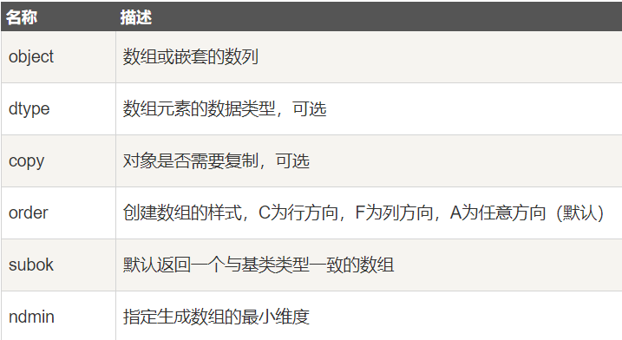

### dtype

<https://www.runoob.com/numpy/numpy-dtype.html>

numpy.dtype(object, align, copy)

### array的属性

<https://www.runoob.com/numpy/numpy-array-attributes.html>

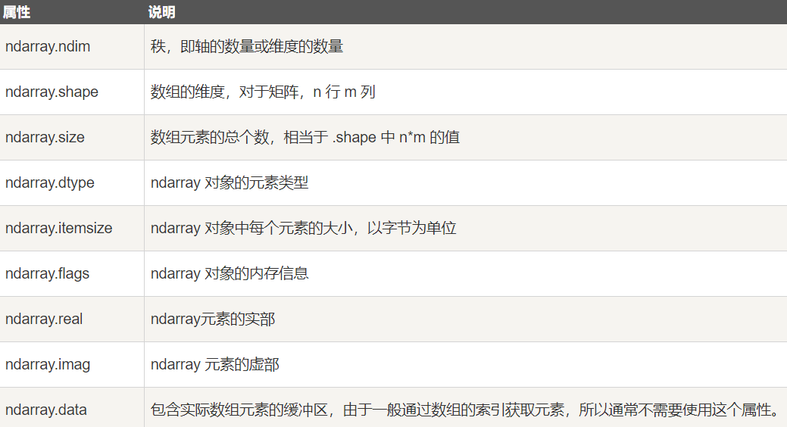

### 创建array矩阵

<https://www.runoob.com/numpy/numpy-array-creation.html>

numpy.empty(shape, dtype = float, order = 'C')

numpy.zeros(shape, dtype = float, order = 'C')

numpy.ones(shape, dtype = None, order = 'C')

### 数值范围创建array

<https://www.runoob.com/numpy/numpy-array-from-numerical-ranges.html>

numpy.arange(start, stop, step, dtype)

np.linspace(start, stop, num=50, endpoint=True, retstep=False, dtype=None)

在范围内建立等比array，公比由数量决定

np.logspace(start, stop, num=50, endpoint=True, base=10.0, dtype=None)

### array索引

~取反

<https://www.runoob.com/numpy/numpy-advanced-indexing.html>

### broadcast

shape对应位置：相等or不相等时只能是1

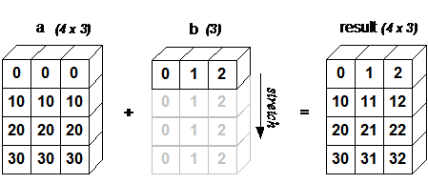

### 迭代器访问array

<https://www.runoob.com/numpy/numpy-terating-over-array.html>

### array操作

#### 修改数组形状

<https://www.runoob.com/numpy/numpy-array-manipulation.html>

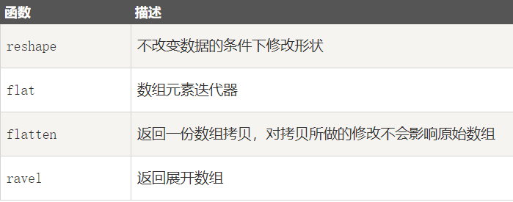

 numpy.reshape(arr, newshape, order='C')

array.flat

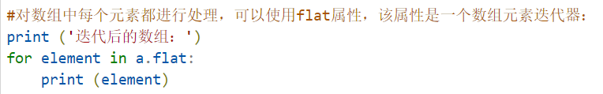

ndarray.flatten 返回一份数组拷贝，对拷贝所做的修改不会影响原始数组.

ndarray.flatten(order='C')

#### 翻转

rollaxis：将指定轴插入指定位置

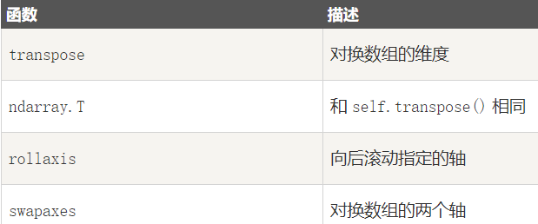

numpy.transpose(arr, axes)

numpy.rollaxis(arr, axis, start)

numpy.swapaxes(arr, axis1, axis2)

#### 修改数组维度

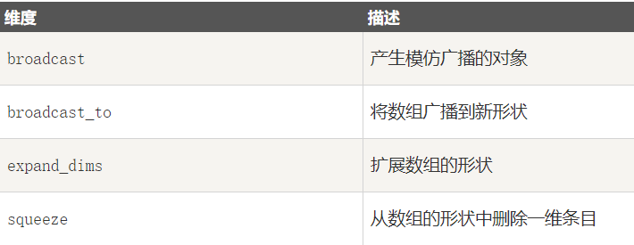

numpy.expand_dims(arr, axis)

numpy.squeeze(arr, axis)

#### 数组连接

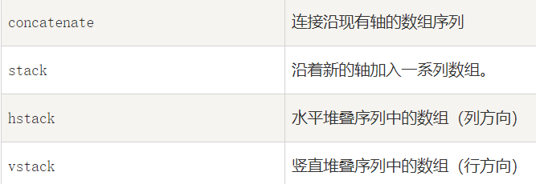

concatenate会合到一块

numpy.concatenate((a1, a2, ...), axis)

stack不同块堆叠

numpy.stack(arrays, axis)

v=0，h=1 vstack和hstack也会合到一块

#### 数组分割

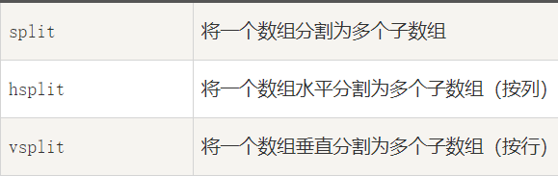

parameter 3：等分成3份 【x,y,z】:按所给位置分割

numpy.split(ary, indices_or_sections, axis)

#### 数组元素添加与删除

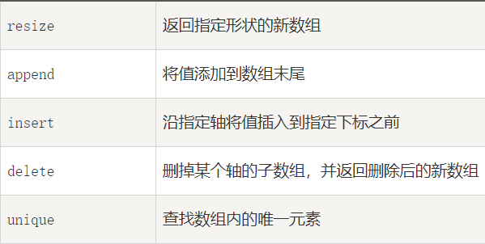

numpy.resize(arr, shape)

用指导array元素按左右上下顺序轮番去填新shape array

numpy.append(arr, values, axis=None)

axis = None：添加到尾端返回一个1维数组

axis = 0：index方向从尾端添加

axis = 1：column方向从尾端添加

numpy.insert(arr, obj, values, axis)

在obj前插入values（数量要一致or插入一个元素则进行broadcast）

axis = None：返回1维数组

numpy.delete(arr, obj, axis)

删除obj位置元素

axis = None：删除后返回一个1维数组

### 位运算？？？？

<https://www.runoob.com/numpy/numpy-binary-operators.html>

### 字符串运算

<https://www.runoob.com/numpy/numpy-string-functions.html>

numpy.char.add

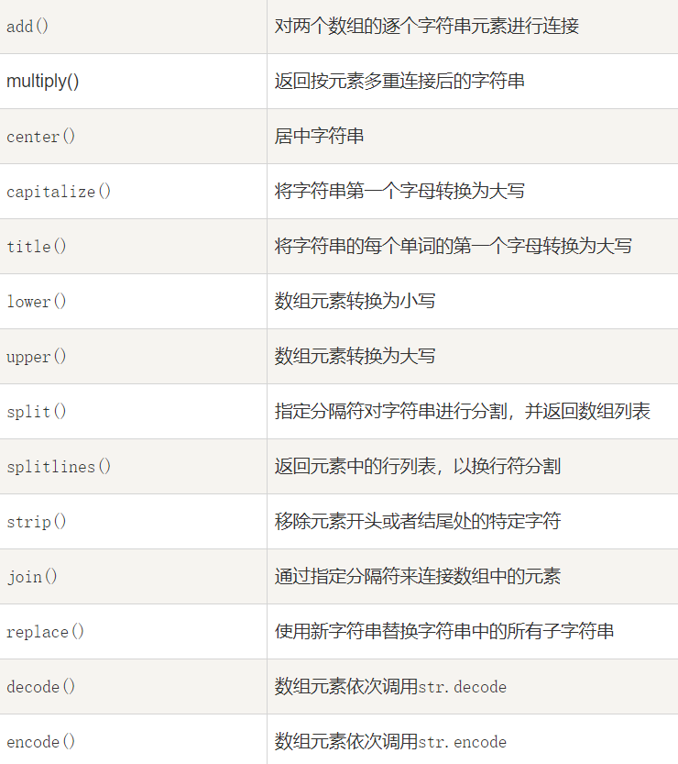

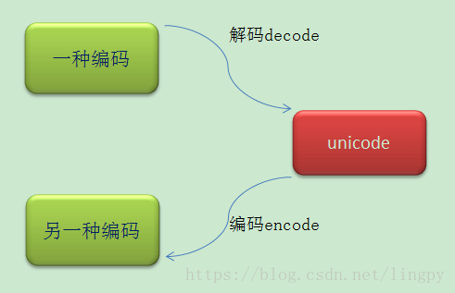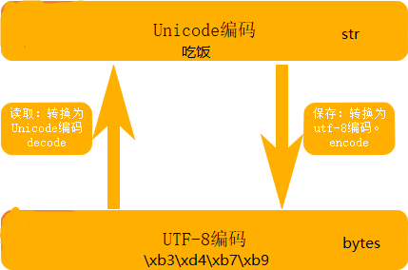

### 舍入函数

<https://www.runoob.com/numpy/numpy-mathematical-functions.html>

numpy.around(a,decimals)

四舍五入，decimals：位数

numpy.floor()：下入 numpy.tial():下入

### 算数函数

<https://www.runoob.com/numpy/numpy-arithmetic-operations.html>

Numpy.add(a,b) .substact() .multiply() .divide()

求倒数：numpy.reciprocal(a)

求幂次：numpy.power(a,2)

求余数：numpy.model(a,b)

### 统计函数

<https://www.runoob.com/numpy/numpy-statistical-functions.html>

给出axis则按照指定轴求值，未给则求全部数据

最值：numpy.amin(a,axis=0) numpy.amax()

极差： numpy.ptp(a,axis=0)

分位数：numpy.percentile(a,q,axis=0)

中位数：numpy.median(a,axis=0)

均值：numpy.mean(a,axis=0)

加权平均：np.average(data, axis=1, weights=[1./4, 3./4])

计算时每个数值给出对应权重

标准差：numpy.std()

方差：numpy.var()

### 排序，条件筛选

<https://www.runoob.com/numpy/numpy-sort-search.html>

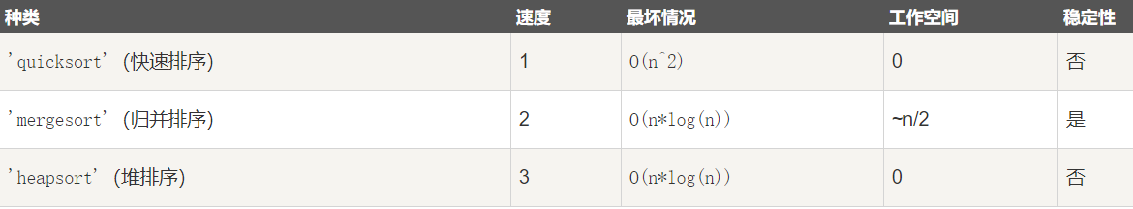

numpy.sort(a, axis, kind, order)

numpy.argsort()：求数组值从小到大的索引值

result = numpy.lexsort(A,B)：求index_A = argsort（A）,按index_A取B中的数组成C，C的数值与index_A一一对应，将C中数值的从小到大顺序，取每个值对应的index_A组成result

#### ？？？？msort、sort_complex、partition、argpartition

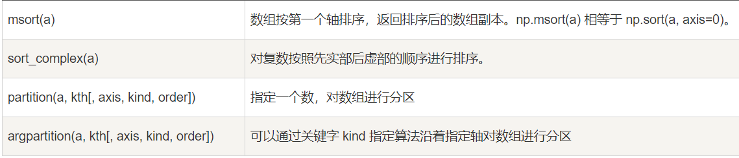

numpy.argmax() 和 numpy.argmin()函数分别沿给定轴返回最大和最小元素的索引。

numpy.nonzero() 函数返回输入数组中非零元素的索引。

numpy.where() 函数返回输入数组中满足给定条件的元素的索引。

Numpy.where(array>3)

numpy.extract() 函数根据某个条件从数组中抽取元素，返回满条件的元素。

np.extract(np.mod(array>3),array)

### 字节交换？？？

<https://www.runoob.com/numpy/numpy-byte-swapping.html>

### 副本和视图？？？

<https://www.runoob.com/numpy/numpy-copies-and-views.html>

### numpy矩阵库

<https://www.runoob.com/numpy/numpy-matrix.html>

numpy.matlib.empty(shape, dtype, order)

numpy.matlib.zeros() 函数创建一个以 0 填充的矩阵。

numpy.matlib.ones()函数创建一个以 1 填充的矩阵。

numpy.matlib.eye() 函数返回一个矩阵，对角线元素为 1，其他位置为零。不一定方阵

numpy.matlib.identity() 函数返回给定大小的单位矩阵。

numpy.matlib.rand() 函数创建一个给定大小的矩阵，数据是随机填充的。

### 线性代数操作

<https://www.runoob.com/numpy/numpy-linear-algebra.html>

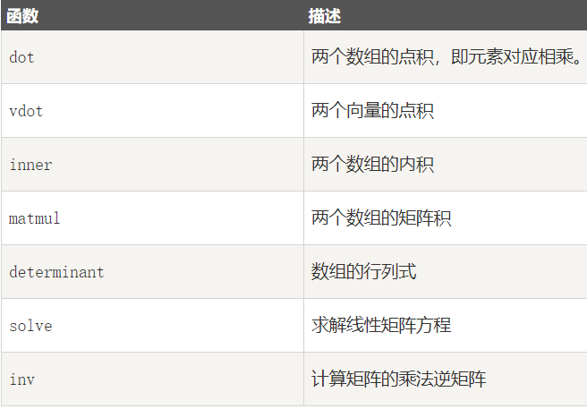

numpy.dot(a,b,out=None)

numpy.linalg.det() 函数计算输入矩阵的行列式。

numpy.linalg.solve() 函数给出了矩阵形式的线性方程的解。

numpy.linalg.inv() 函数计算矩阵的乘法逆矩阵。

## scipy

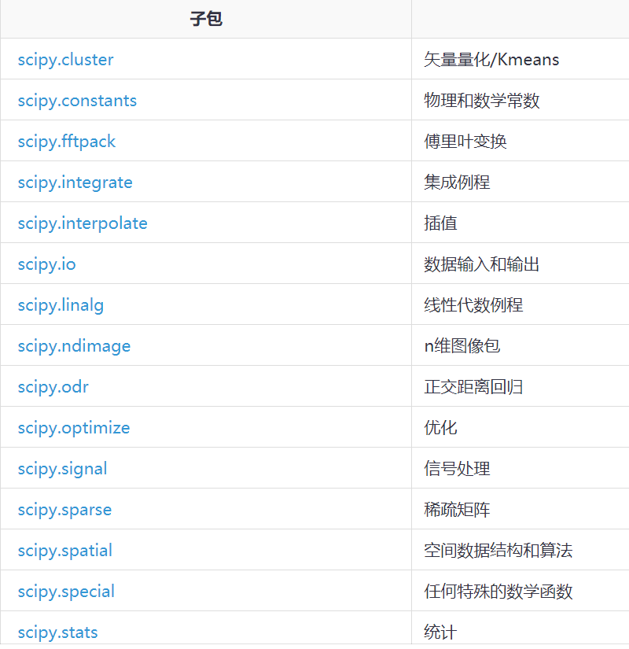

### K-means 聚类

<http://codingdict.com/article/8255>

from SciPy.cluster.vq import kmeans,vq,whiten

数据—>白化—>计算质心—>聚类

### 常量

<http://codingdict.com/article/8256>

from scipy.constants import pi

### 傅里叶变换，离散余弦变换

<http://codingdict.com/article/8257>

from scipy.fftpack import fft

y = fft(array)

from scipy.fftpack import dct

dct(np.array([4., 3., 5., 10., 5., 3.]))

### 计算积分

<http://codingdict.com/article/8258>

import scipy.integrate

from numpy import exp

f= lambda x:exp(-x**2)

scipy.integrate.quad(f, 0, 1)

### 插值算法

<http://codingdict.com/article/8259>

from scipy import interpolate

### IO操作

<http://codingdict.com/article/8260>

Scipy.io（输入和输出）包提供了多种功能来解决不同格式的文件。

### 线性代数计算

<https://docs.scipy.org/doc/scipy/reference/linalg.html#module-scipy.linalg>

from scipy import linalg

linalg.solve(a, b)

linalg.det(A)

l, v = linalg.eig(A)

U, s, Vh = linalg.svd(a)

### 图像处理

<https://docs.scipy.org/doc/scipy/reference/ndimage.html#module-scipy.ndimage>

### 解方程，优化问题

<https://docs.scipy.org/doc/scipy/reference/optimize.html#module-scipy.optimize>

### 概率统计函数

<https://docs.scipy.org/doc/scipy/reference/stats.html#module-scipy.stats>

### 稀疏矩阵，图操作

<https://docs.scipy.org/doc/scipy/reference/sparse.html#module-scipy.sparse>

<https://docs.scipy.org/doc/scipy/reference/sparse.csgraph.html#module-scipy.sparse.csgraph>

### 空间数据计算

<https://docs.scipy.org/doc/scipy/reference/spatial.html#module-scipy.spatial>

### 正交距离回归？？

<https://docs.scipy.org/doc/scipy/reference/spatial.html#module-scipy.spatial>

### 数学计算

<http://codingdict.com/article/8268>

<https://docs.scipy.org/doc/scipy/reference/special.html#module-scipy.special>

### 信号处理

<https://docs.scipy.org/doc/scipy/reference/signal.html#module-scipy.signal>

## advance

### __init__ vs __call__

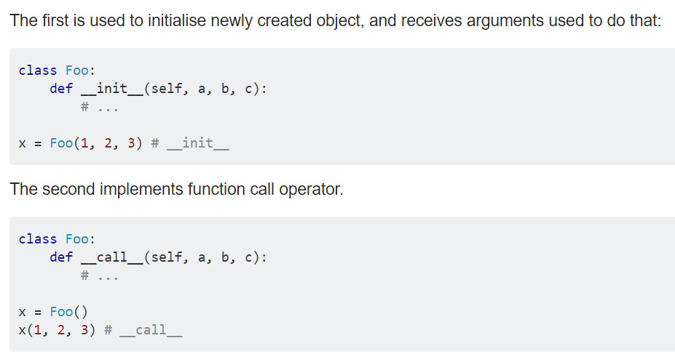

# GAN系列

generative adversarial network

<https://towardsdatascience.com/understanding-generative-adversarial-networks-gans-cd6e4651a29>

目标函数式如何完成G error 最大化和D error最小化

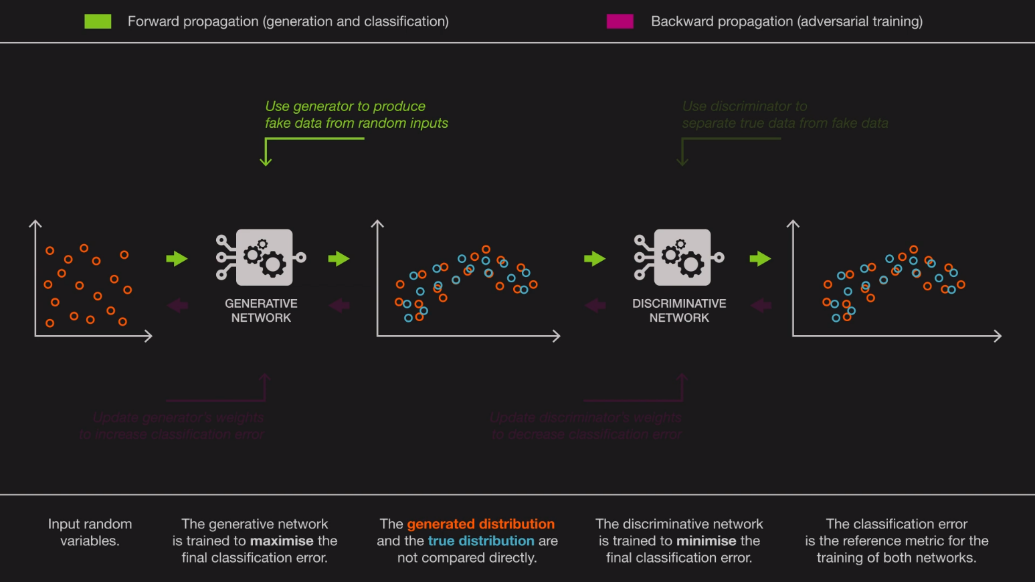 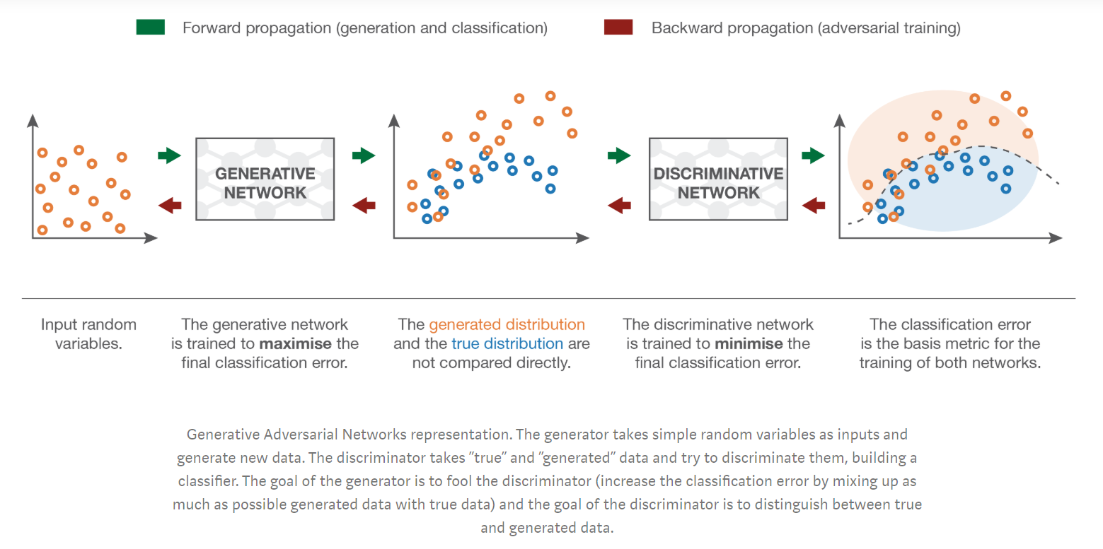

# variational autoencoders

autoencoder：obtaining a low-dimensional representation of highter level input

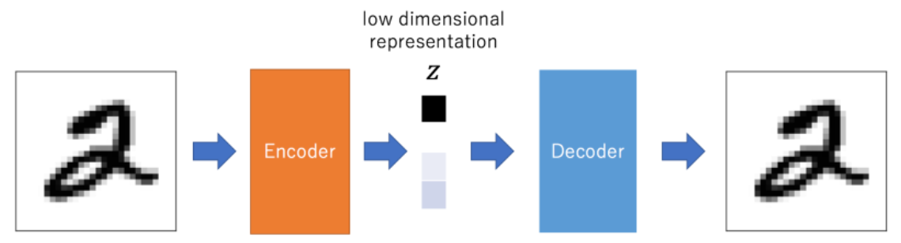

problem of autoencoder: not all vactor feed in to decoder can get a reasonable output

VAEs: very encoding can be decode to produce reasonable outputs.

## KL Divergence

<https://medium.com/@cotra.marko/making-sense-of-the-kullback-leibler-kl-divergence-b0d57ee10e0a>

<http://www.fanyeong.com/2018/06/01/vae/>

Likelihood Ratio:

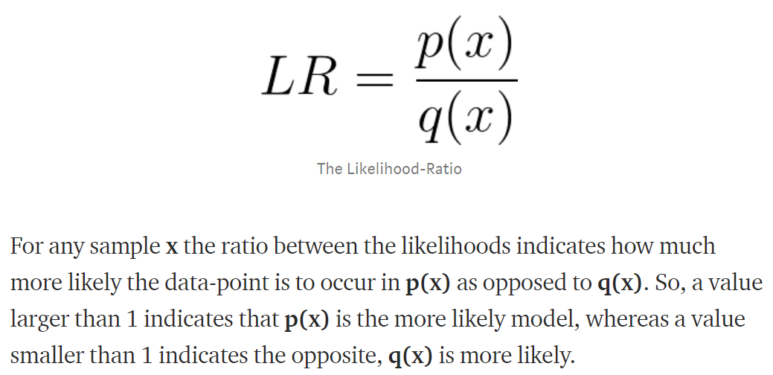

For entire dataset(x1,x2,….xn):

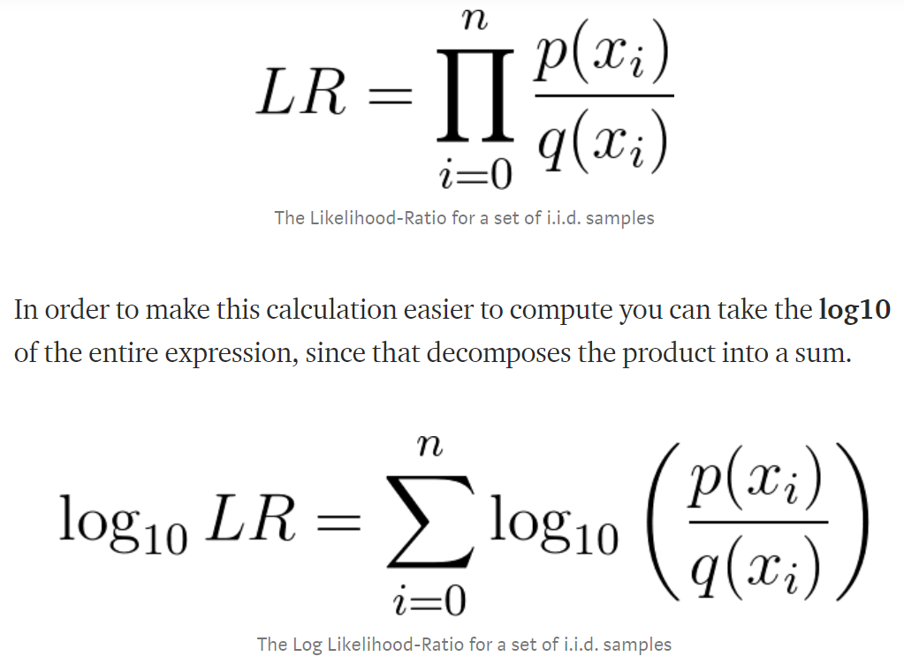

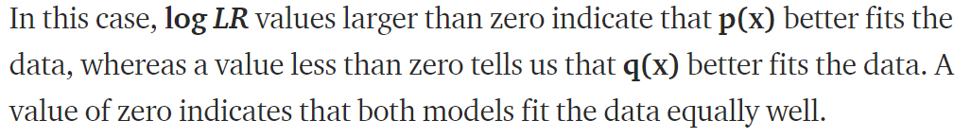

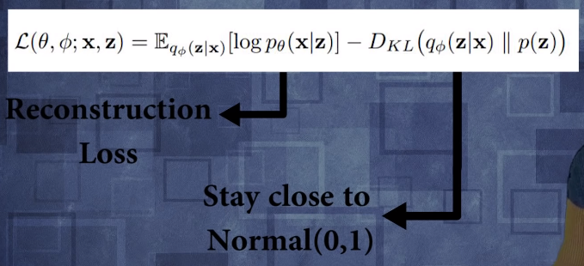

为什么使用 reparameter trick？

disentangled variational autoencoders

<https://kexue.fm/search/%E5%8F%98%E5%88%86%E8%87%AA%E7%BC%96%E7%A0%81%E5%99%A8/>

用NN生成每个Xi­­的正态后验概率分布

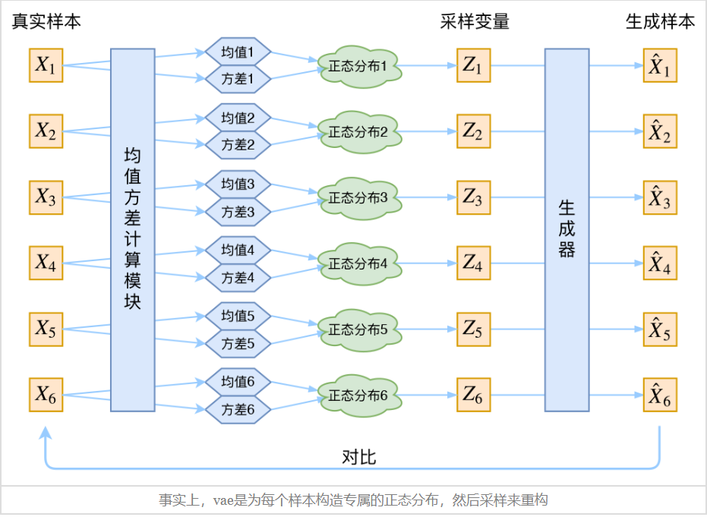

# reinforcement learning

policy network and policy gradients

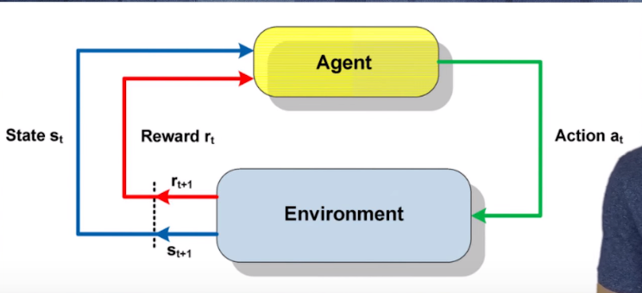

Credit Assignment problem，reward shaping，the alignment problem